ACTIVE DIRECTORY BRUTE-FORCE DETECTION USING SPLUNK SIEM

**Summary:**

This project involved deploying a Windows Active Directory environment with domain-joined endpoints and forwarding security event logs to a centralized Splunk server. An attacker machine was used to simulate a brute-force attack against a domain user. Using Splunk, I analyzed the attack chain, identified key indicators, and visualized the data through custom dashboards. I implemented smart detection logic and configured scheduled alerts to flag brute-force patterns in real time. The project showcased Active Directory configuration, effective log analysis, threat detection, and incident response using Splunk.

**Contents:**

* Project Summary
* Tools & Technologies Used
* Network Diagram
* Downloading and Installing Images & Servers
* Configuring Networking for Virtual Machines
* Setting Up Splunk on Ubuntu Server
* Setting Up Splunk Universal Forwarder and Sysmon on Windows
* Setting Up Splunk Universal Forwarder and Sysmon on Windows Active Directory Server
* Installing And Configuring Active Directory on Windows Server
* Adding Windows Machine (TARGET-PC) to Domain
* Simulating Brute force Attack
* Investigating attack logs in Splunk
* Visualizing Brute-Force Activity in Dashboards
* Creating and Implementing Custom Alerts
* Challenges Faced

**Tools & Technologies Used:**

VirtualBox, Ubuntu Server, Windows 10, Kali Linux, Windows Server, Splunk Enterprise, Splunk Universal Forwarder, Sysmon, Windows Active Directory Domain Services

**Project Network Diagram:**

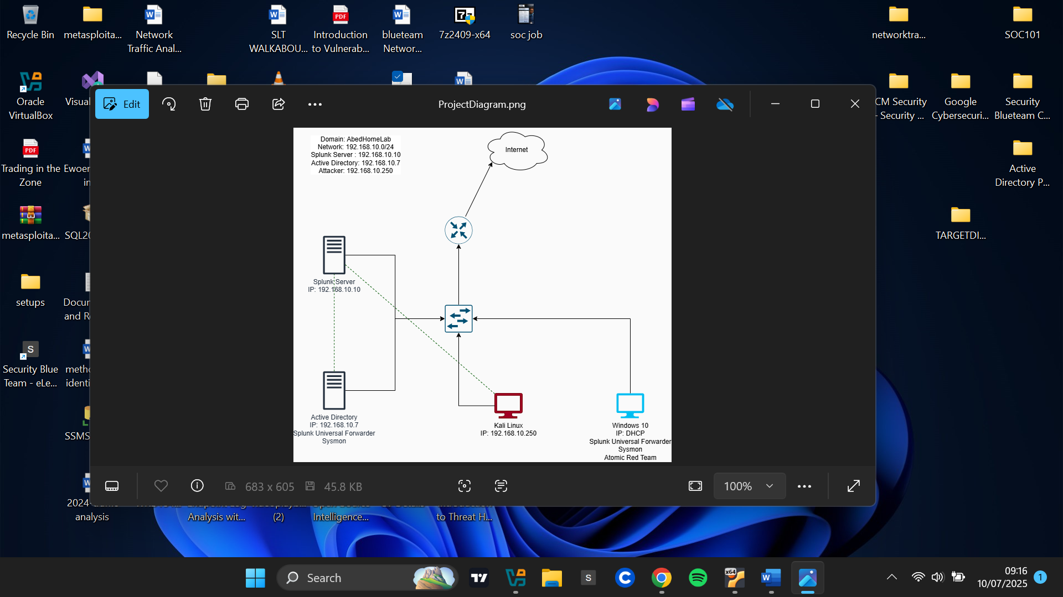

**Downloading and Installing Images & Servers:**

I downloaded ISO images for Windows 10, Kali Linux, Ubuntu Server, and Windows Server from the official sources and added them to my VirtualBox environment.

**Windows 10**

Download link: <https://www.microsoft.com/en-us/software-download/windows10>   
I downloaded the Windows 10 installation media ISO file and, during installation, selected **"**Windows 10 Pro**"** as the operating system version.

**Kali Linux**

Download link: <https://www.kali.org/docs/introduction/download-official-kali-linux-images/>   
I downloaded the installer image ISO file appropriate for my computer’s architecture. Kali also provides prebuilt virtual machines that can be imported into VirtualBox or other virtualization tools.

**Windows Server 2022**

Download link: <https://www.microsoft.com/en-us/evalcenter/download-windows-server-2022>   
While installing Windows Server, I selected **"Windows Server 2022 Standard Evaluation (Desktop Experience)"** to ensure I had access to a graphical user interface. The alternative installation only provides a command-line interface, which is less convenient for this project.

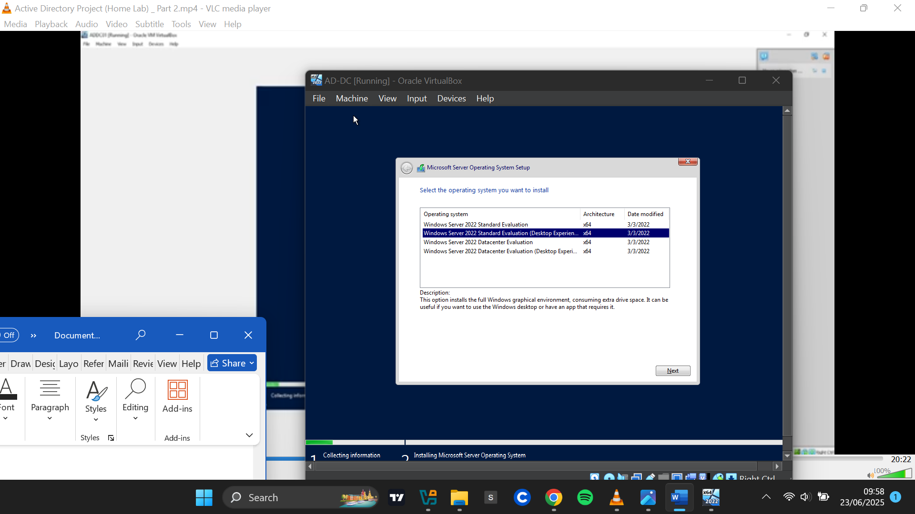

After installation, I set a password for the Administrator account and used those credentials to log in successfully.

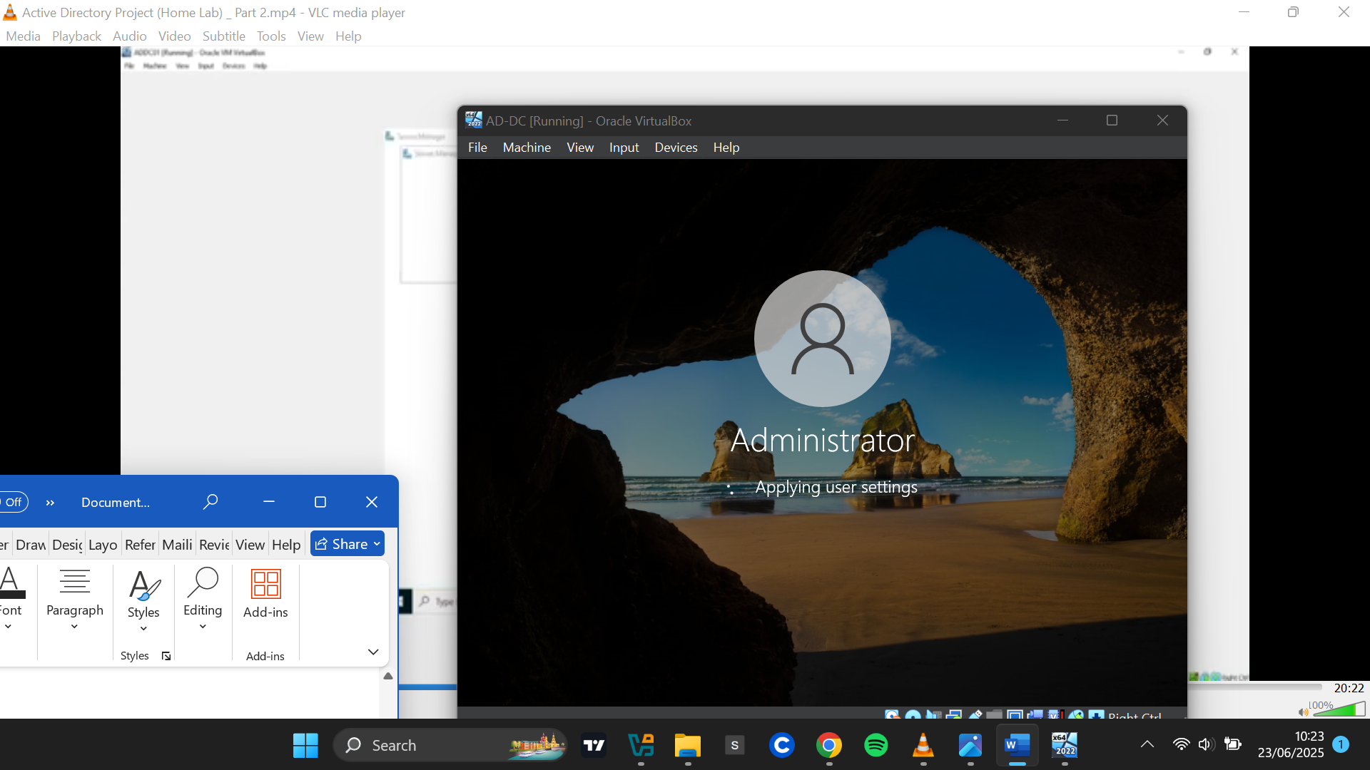

**Ubuntu Server**

Download link: https://ubuntu.com/server  
I downloaded **Ubuntu Server 22.04 LTS** and installed it in VirtualBox.

During installation, I followed the guided setup, providing my name, server name, username, and password. I named the server **"Splunk"** because it would host the Splunk instance. After completing the installation, I rebooted the system.

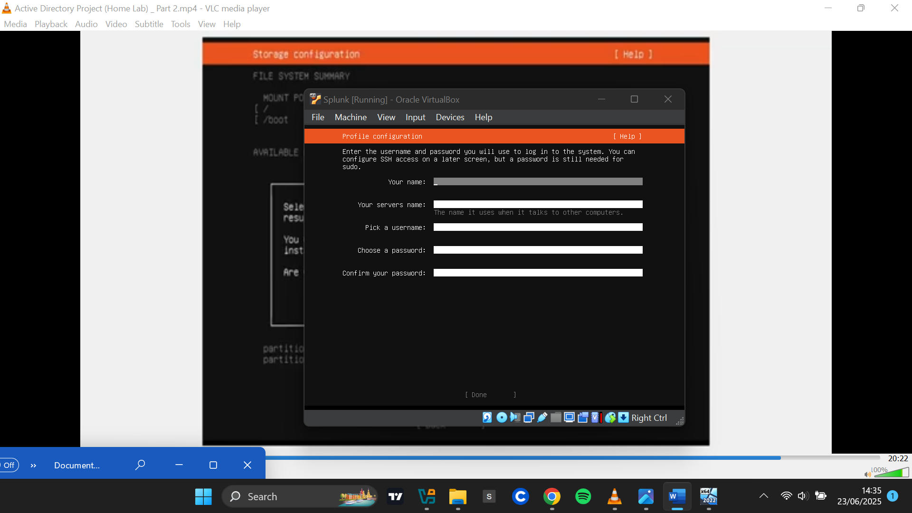

Upon reboot, I was presented with the login screen, where I logged in using the credentials created earlier. I then ran system updates using the apt update and apt upgrade commands.

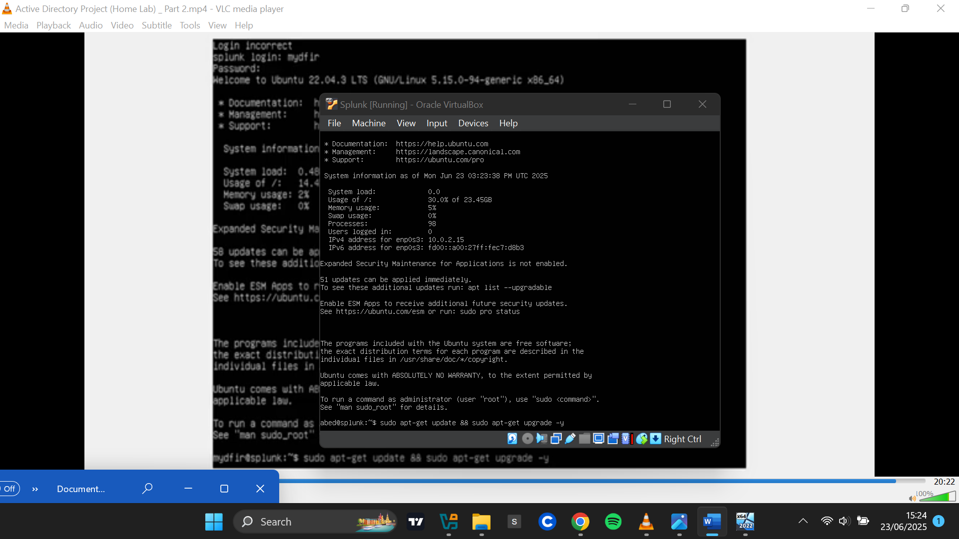

**Configuring Networking for Virtual Machines**

To ensure all virtual machines could communicate with one another, I created a new NAT network named **"MyHomeLab"** in VirtualBox. I configured its IPv4 prefix as 192.168.10.0/24 to standardize the internal IP range.

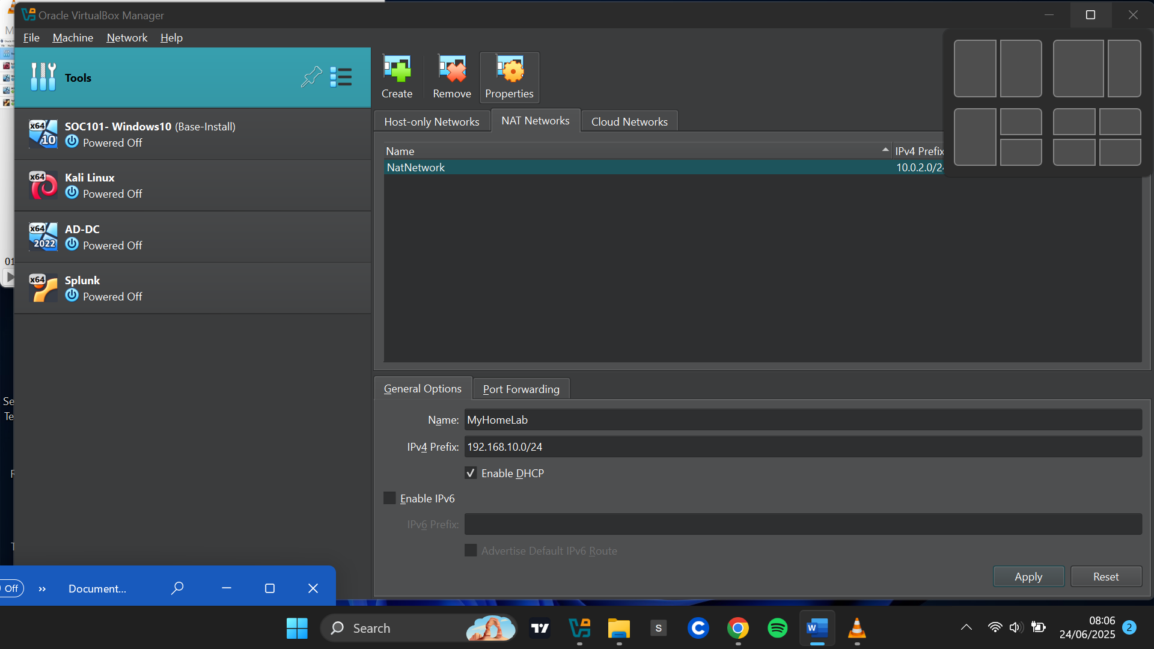

Each virtual machine was then configured to use this NAT network.

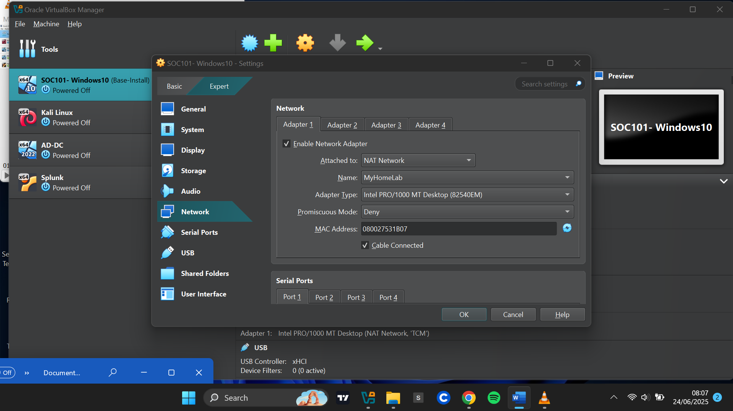

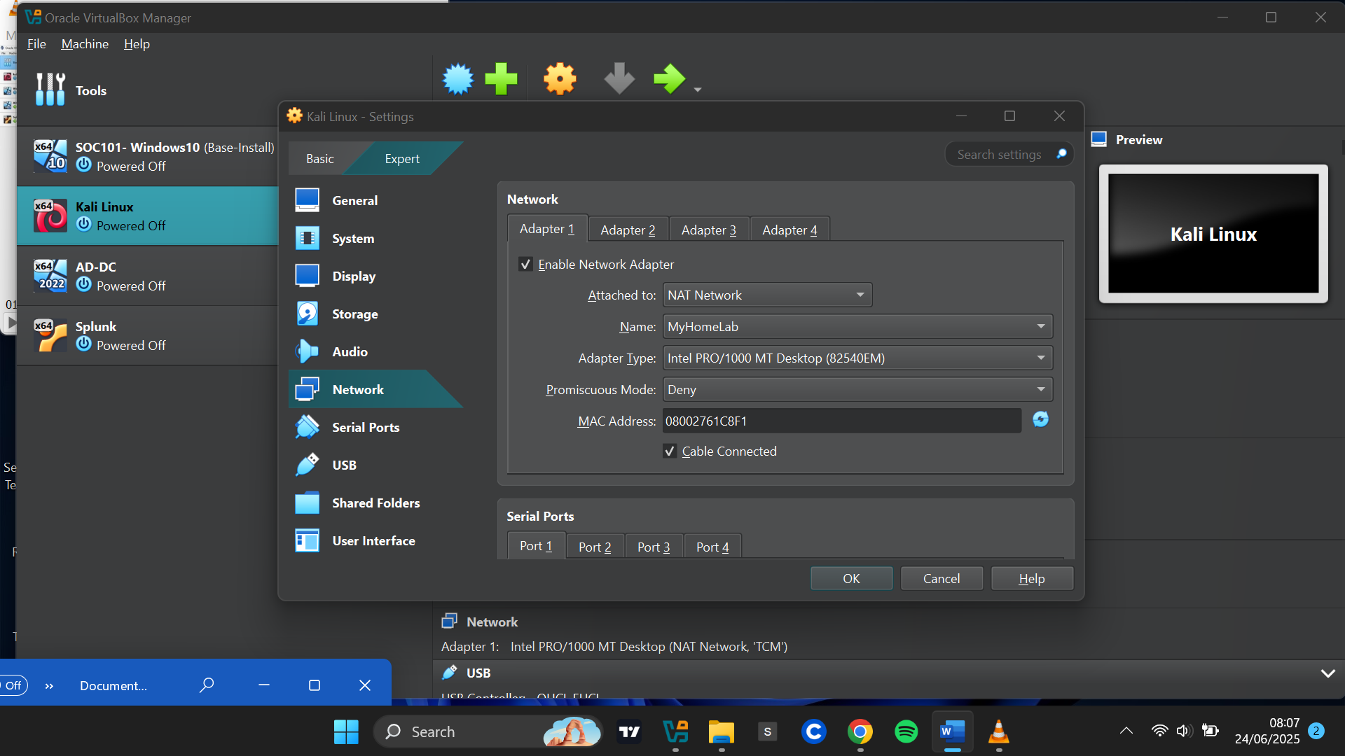

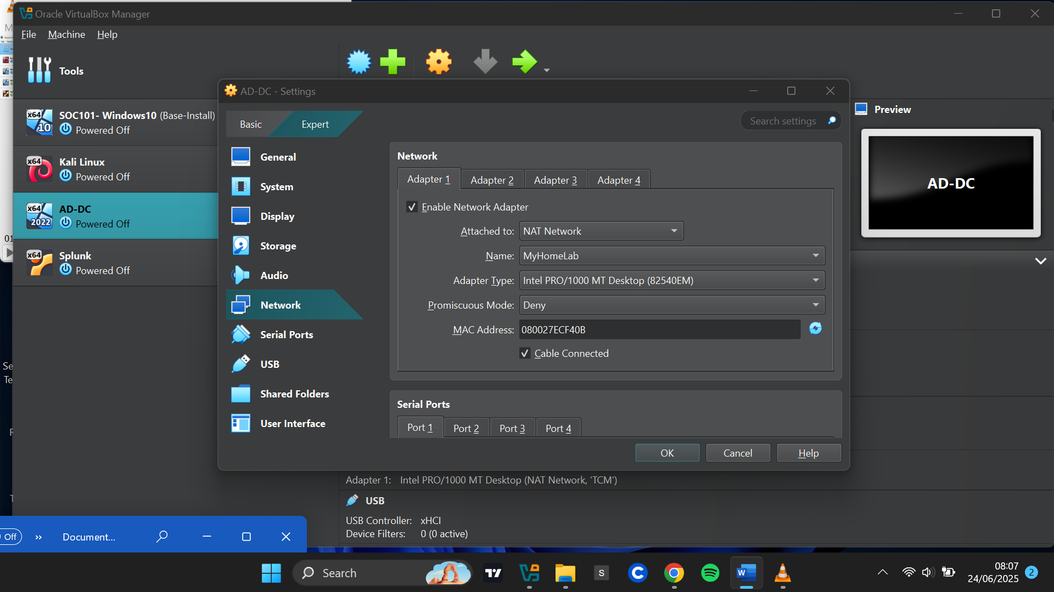

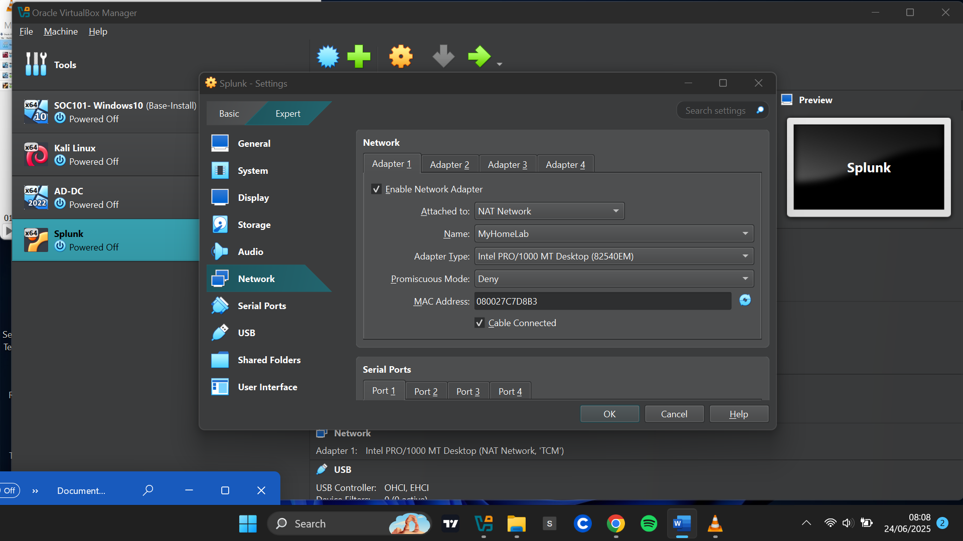

**Setting Up Splunk on Ubuntu Server**

**Assigning Static IP**

I assigned a static IP address of 192.168.10.10/24 to the Ubuntu Server:

I Checked the dynamically assigned IP, edited the Netplan network configuration file, disabled DHCP, assigned the new IP address (192.168.10.10/24), set Google’s DNS (8.8.8.8), and defined the default gateway (192.168.10.1).

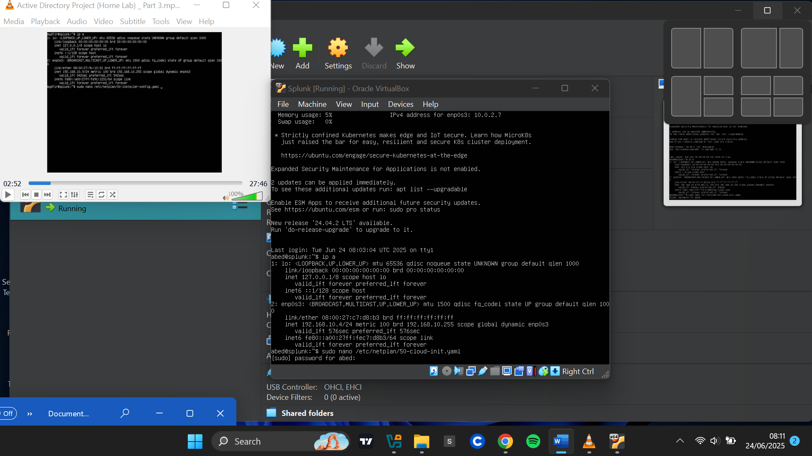

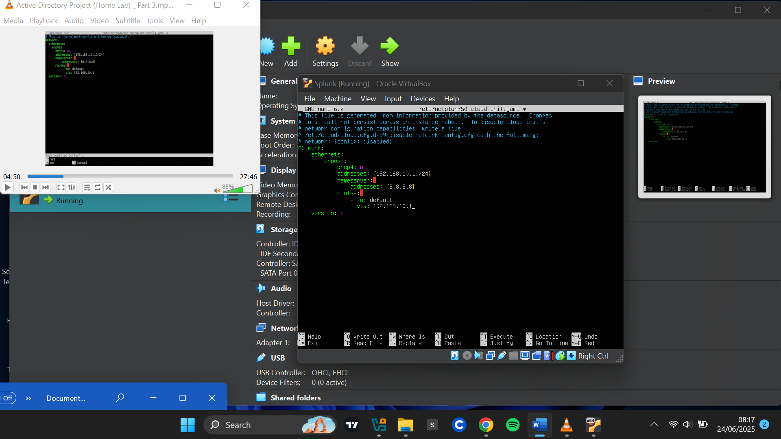

After saving and applying the changes, I confirmed the static IP was correctly set to 192.168.10.10/24.

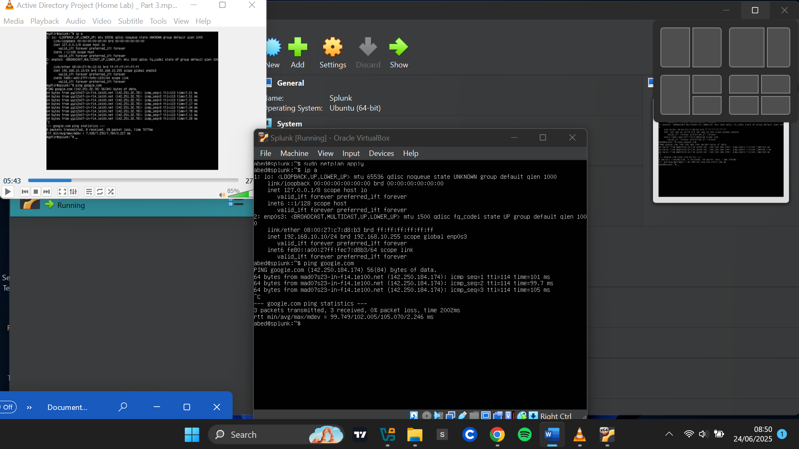

**Downloading Splunk Installer**

Link: <https://www.splunk.com/en_us/download/splunk-enterprise.html>   
On my host PC, I downloaded the Splunk Enterprise .deb package for Linux and saved it in a directory named "Active Directory Project" to prepare it for sharing with the Ubuntu Server.

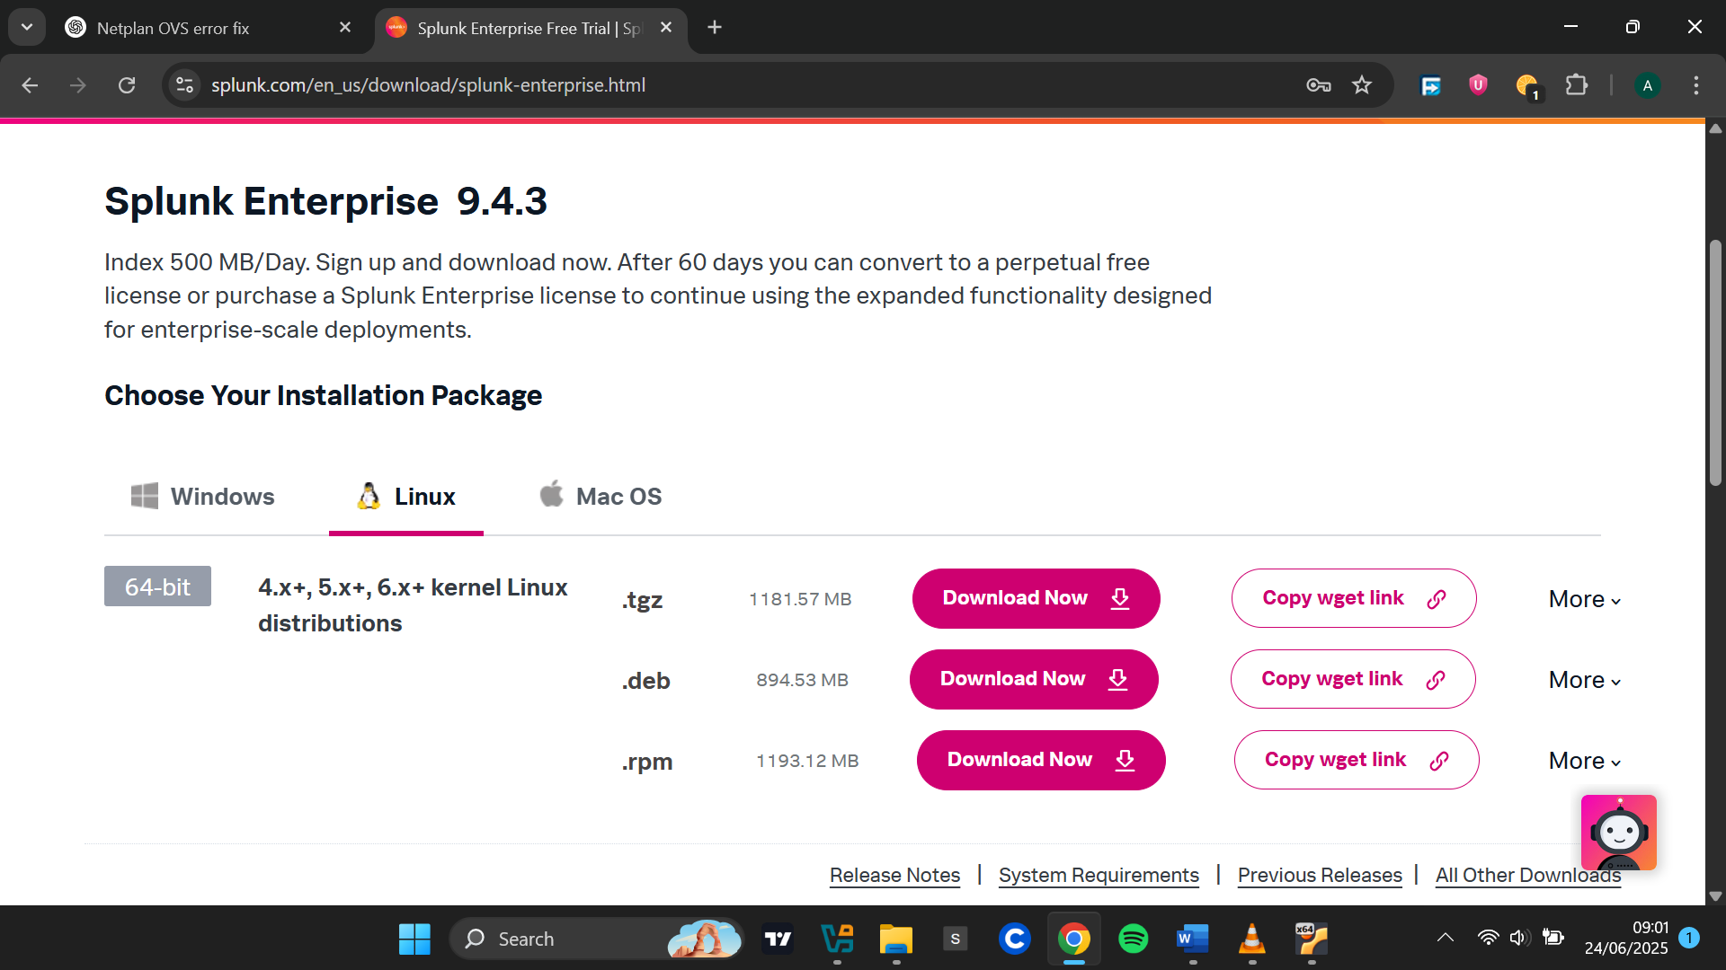

**Setting Up Shared Folder to Transfer Splunk Installer**

**Installing VirtualBox Guest Additions**

I installed virtualbox-guest-additions-iso and virtualbox-guest-utils packages on the Ubuntu Server to support shared folders.

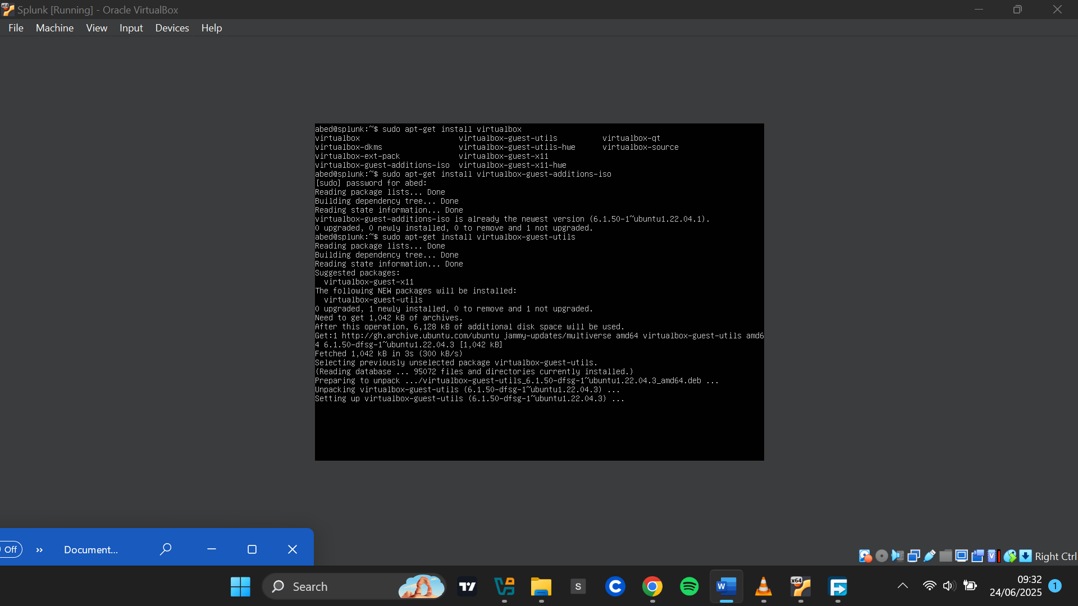

**Adding a Shared Folder**

In VirtualBox: **Devices > Shared Folders > Shared Folder Settings**

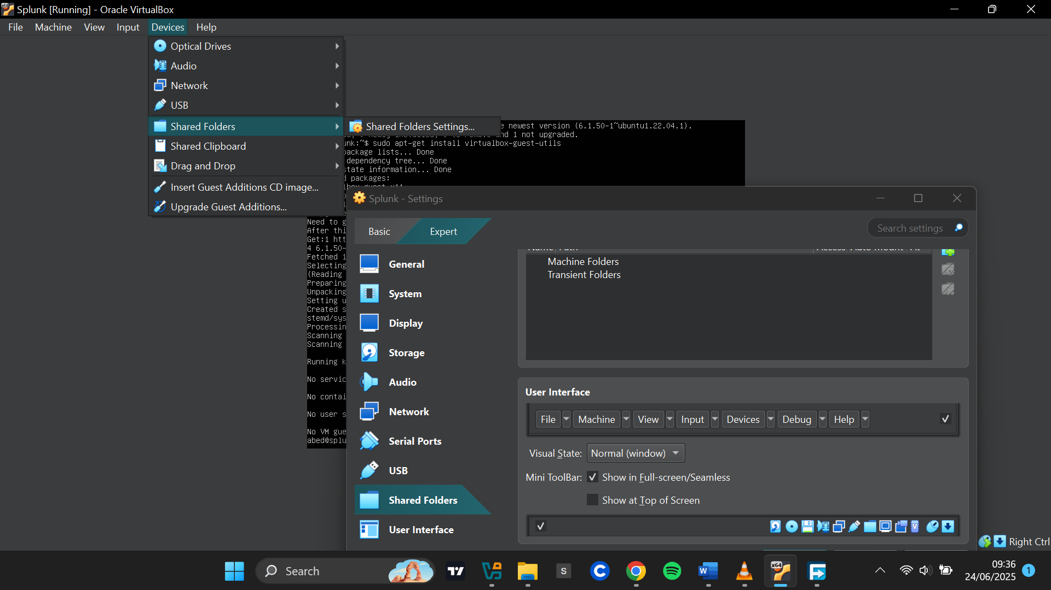

I Clicked the **Add Folder** icon, Set the folder path to where the Splunk .deb file was stored, enabled **Read-only**, **Auto-mount**, and **Make Permanent.**

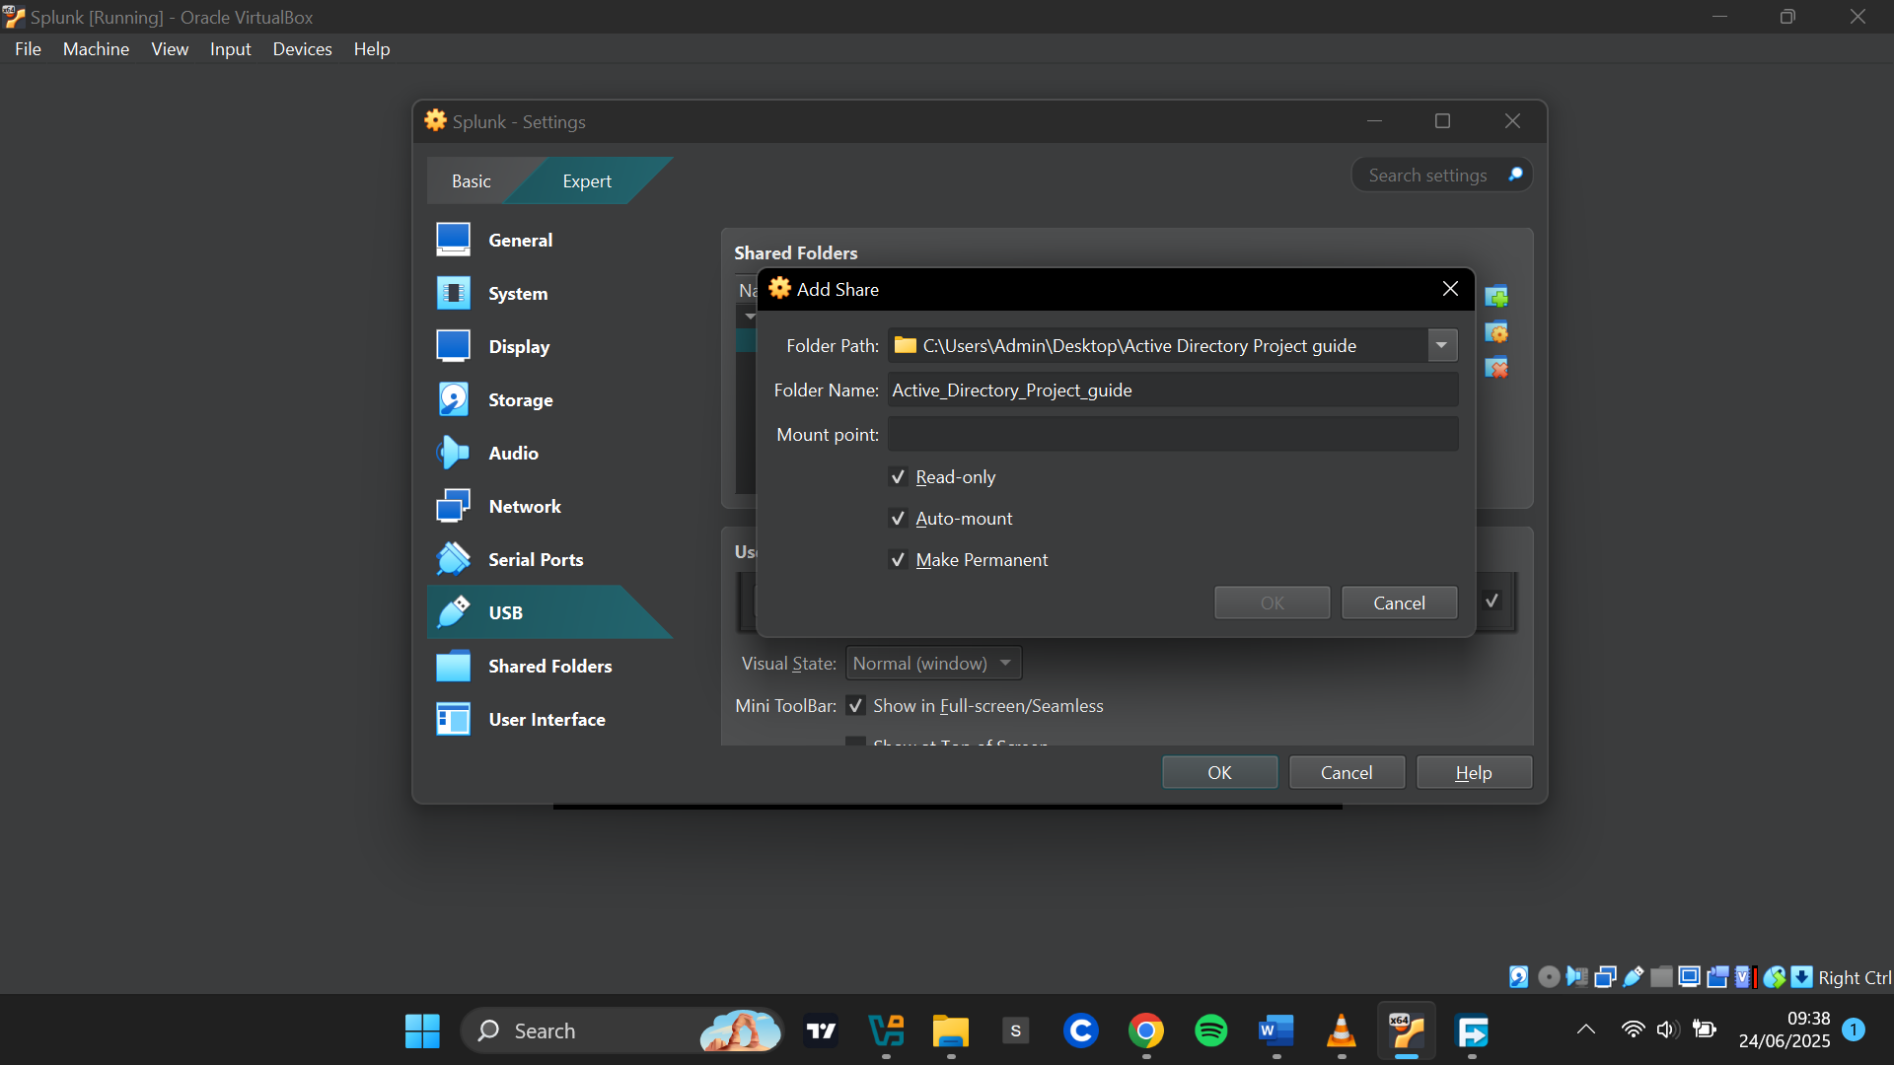

**Adding User to vboxsf Group**

After rebooting, I added my server user to the vboxsf group to grant access to the shared folder.

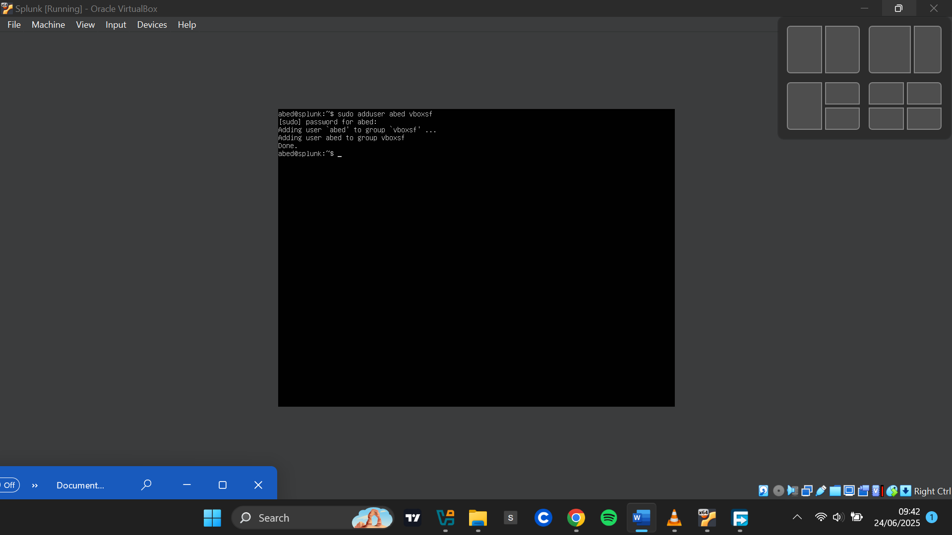

**Mounting the Shared Folder**

I created a new directory called share, mounted the shared folder to it, and verified the Splunk installer was accessible by listing the contents of the directory.

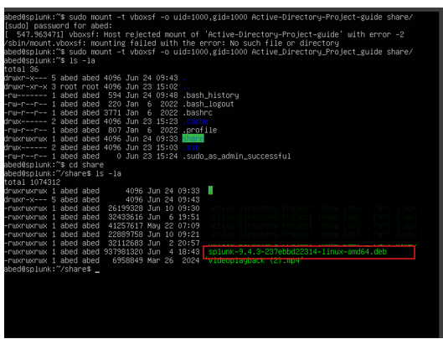

**Installing Splunk on Ubuntu Server**

I navigated to the mounted directory and ran the command to install the Splunk .deb package.

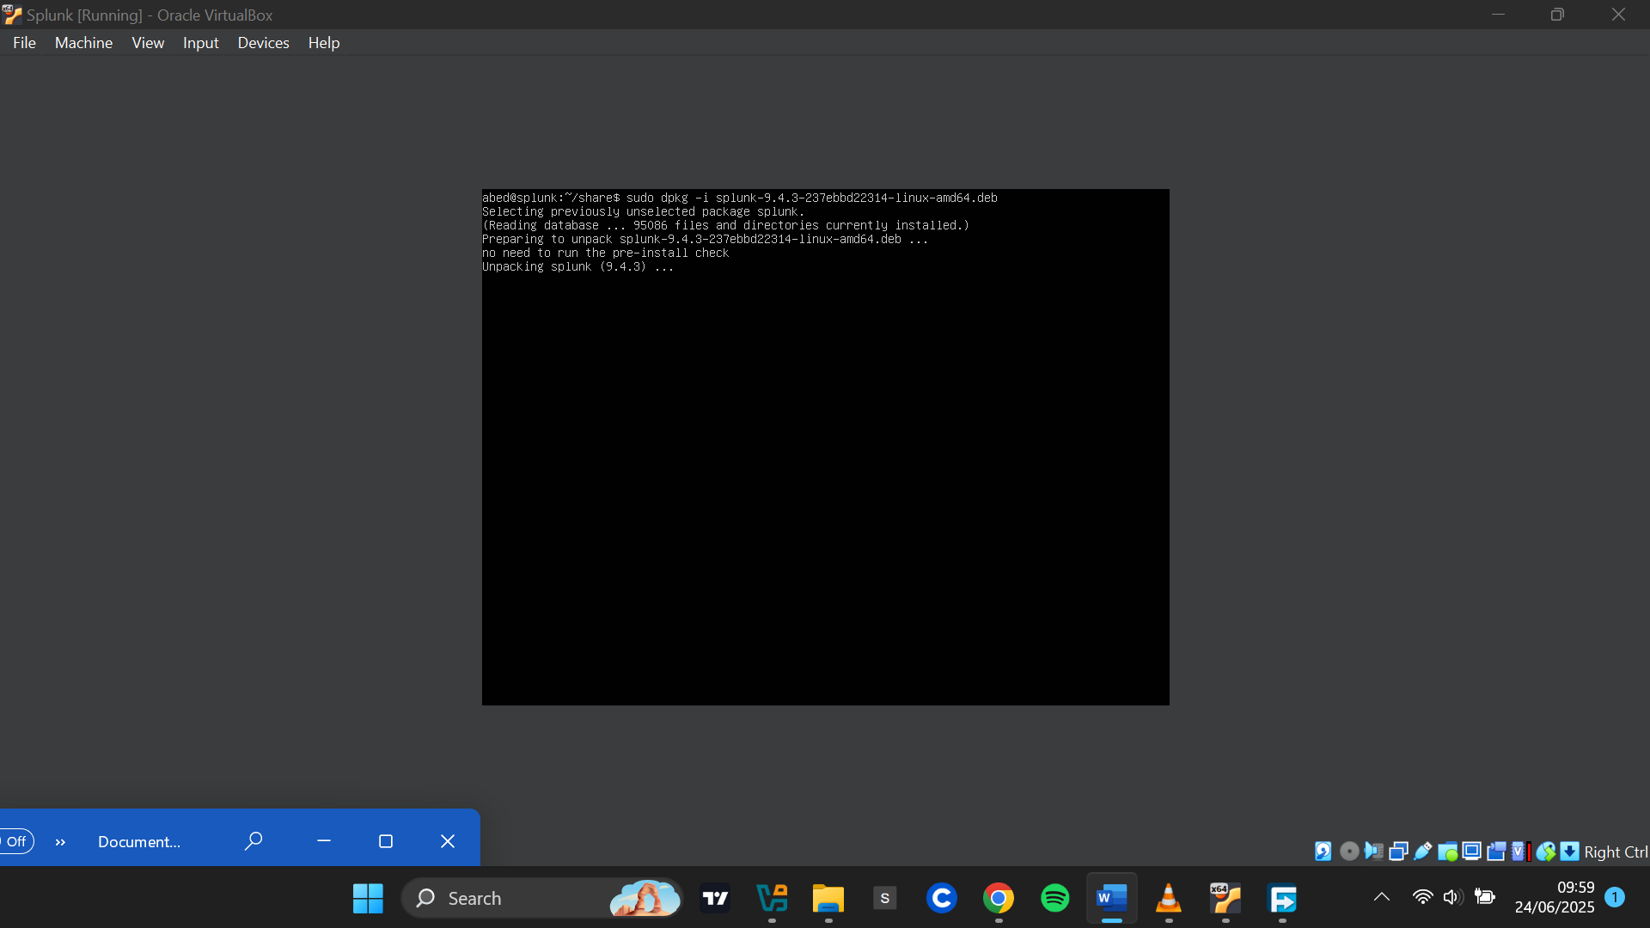

After installation, I switched to the splunk user and navigated to the /opt/splunk/bin directory, where Splunk binaries reside. I then ran the ./splunk command to start the Splunk instance.

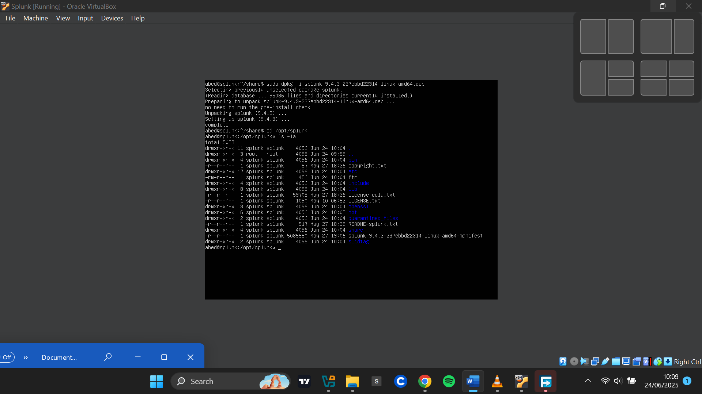

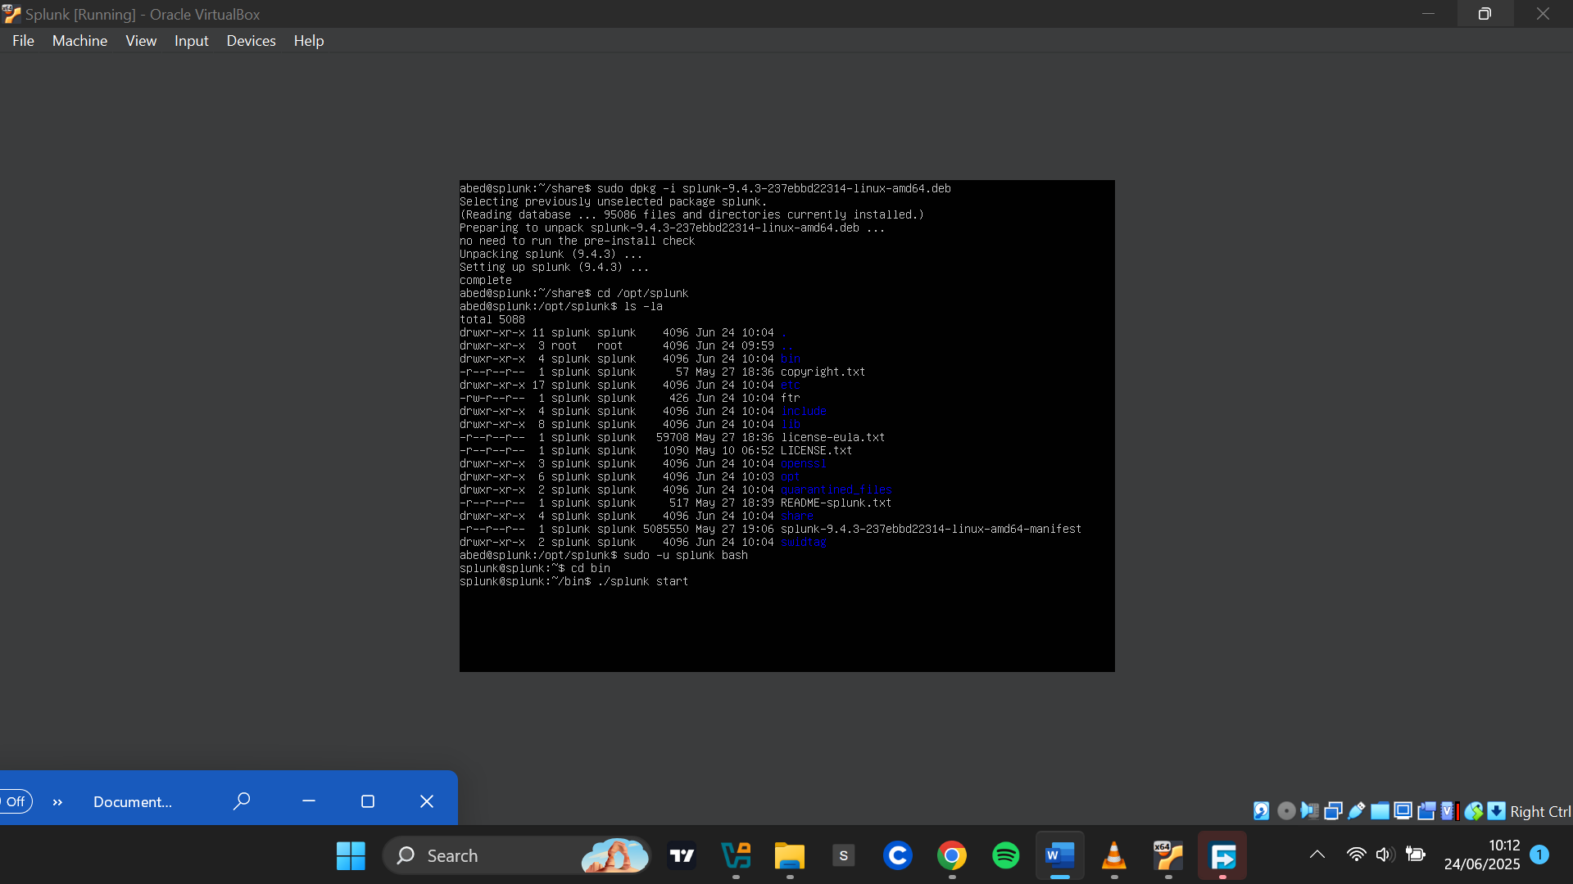

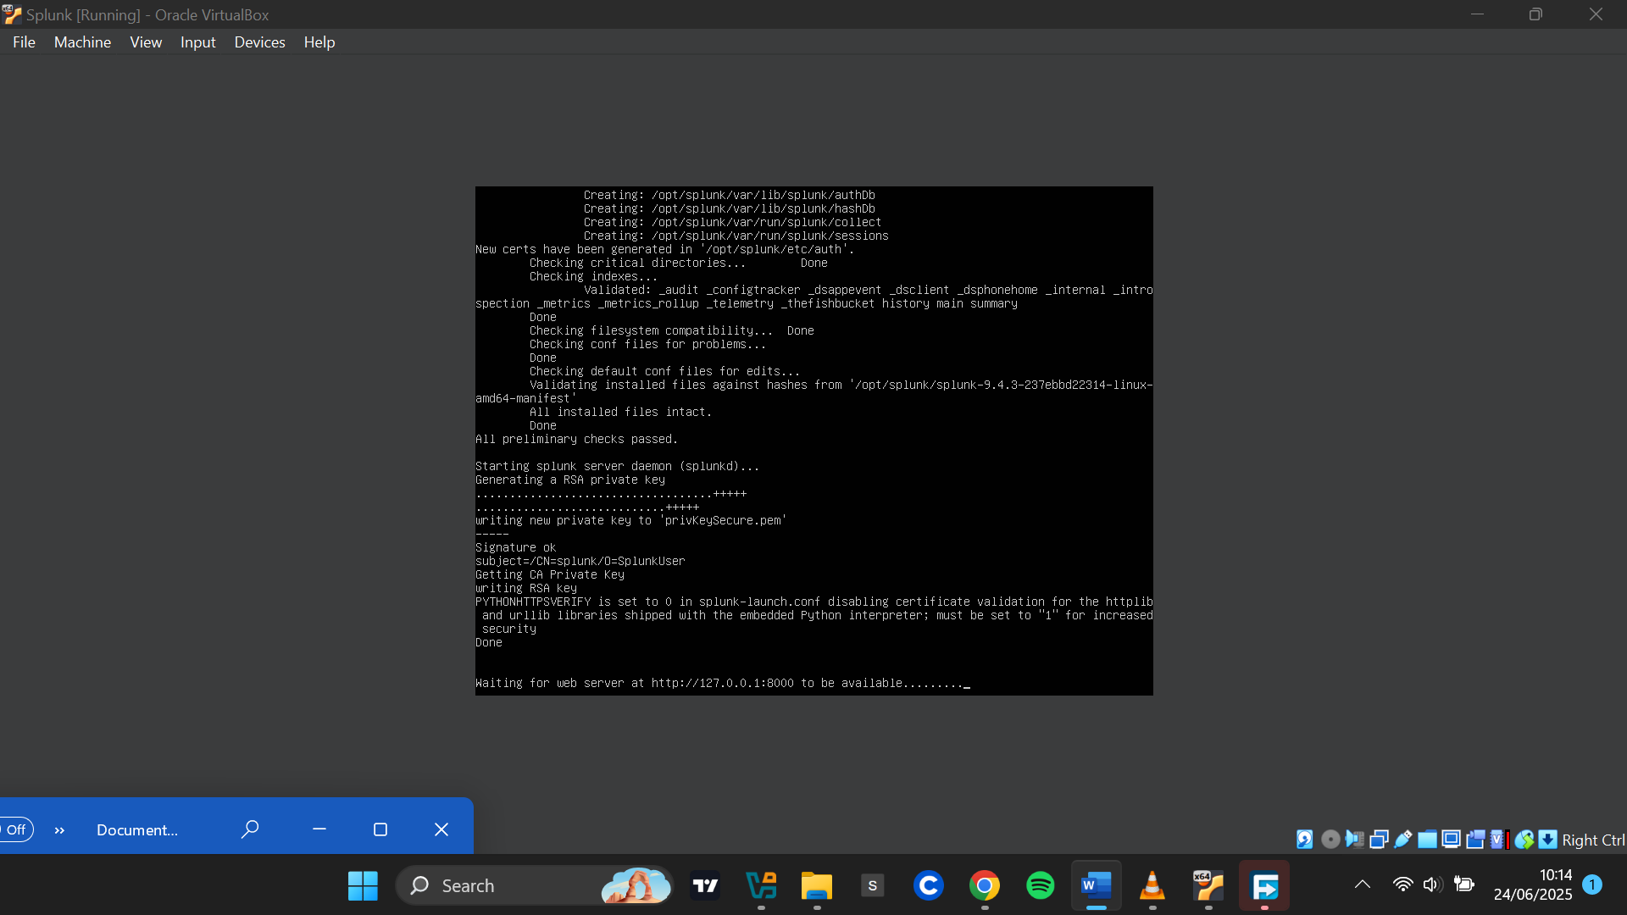

**Enabling Splunk to Start on Boot**

I ran the appropriate command to ensure Splunk starts automatically every time the Ubuntu VM reboots:

sudo /opt/splunk/bin/splunk enable boot-start

This completed the Splunk setup on the Ubuntu server.

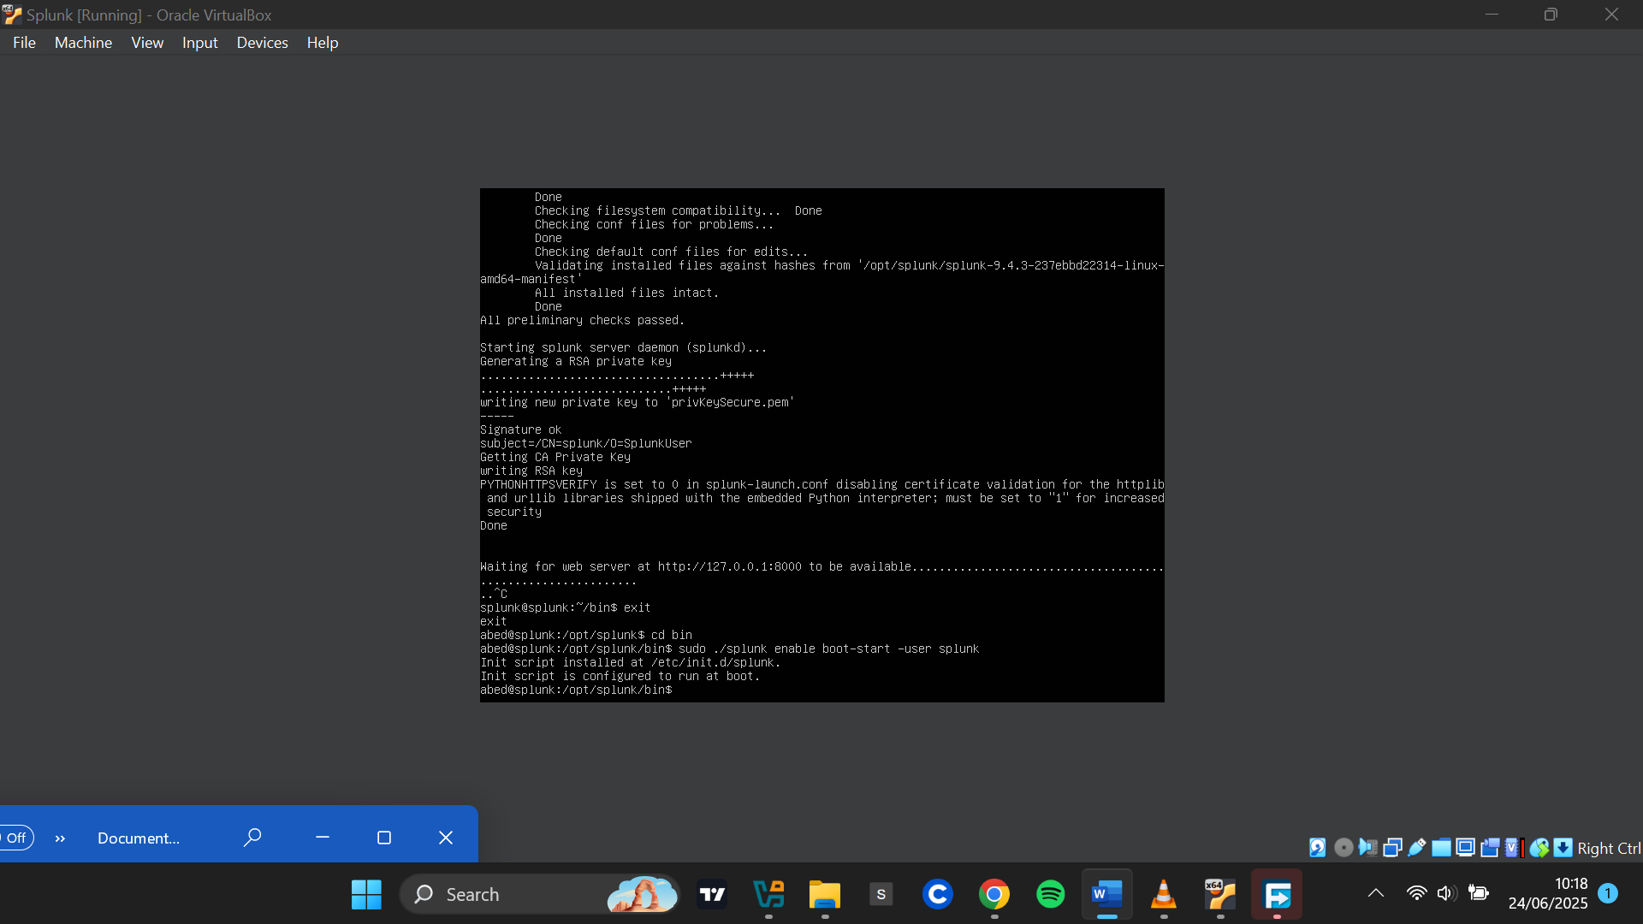

**Setting Up Splunk Universal Forwarder and Sysmon on Windows**

**Renaming the Target Machine**

First, I renamed the Windows machine to **"TARGET-PC"**.

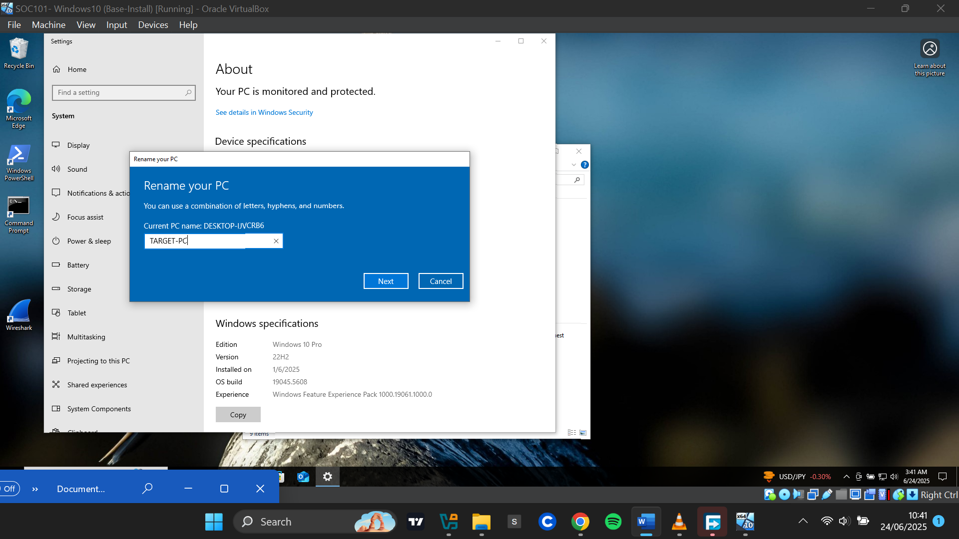

**Setting a Static IP Address**

Next, I assigned a static IP address of 192.168.10.100 to the Windows target machine and confirmed that it had successfully picked up the new IP address.

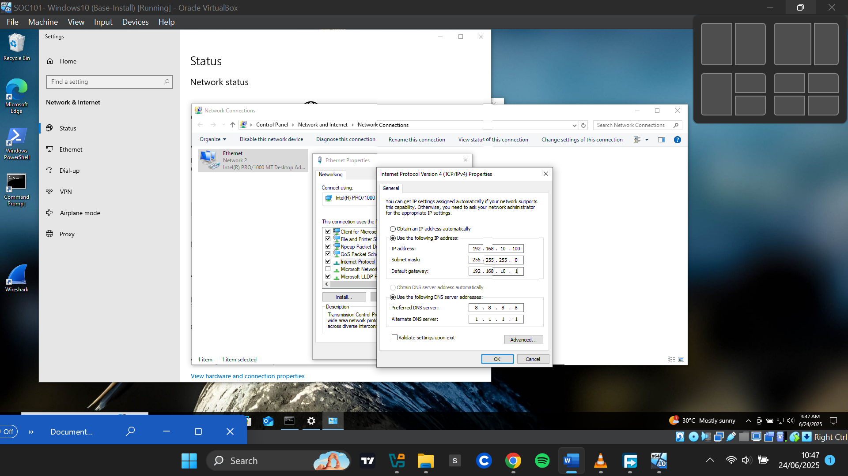

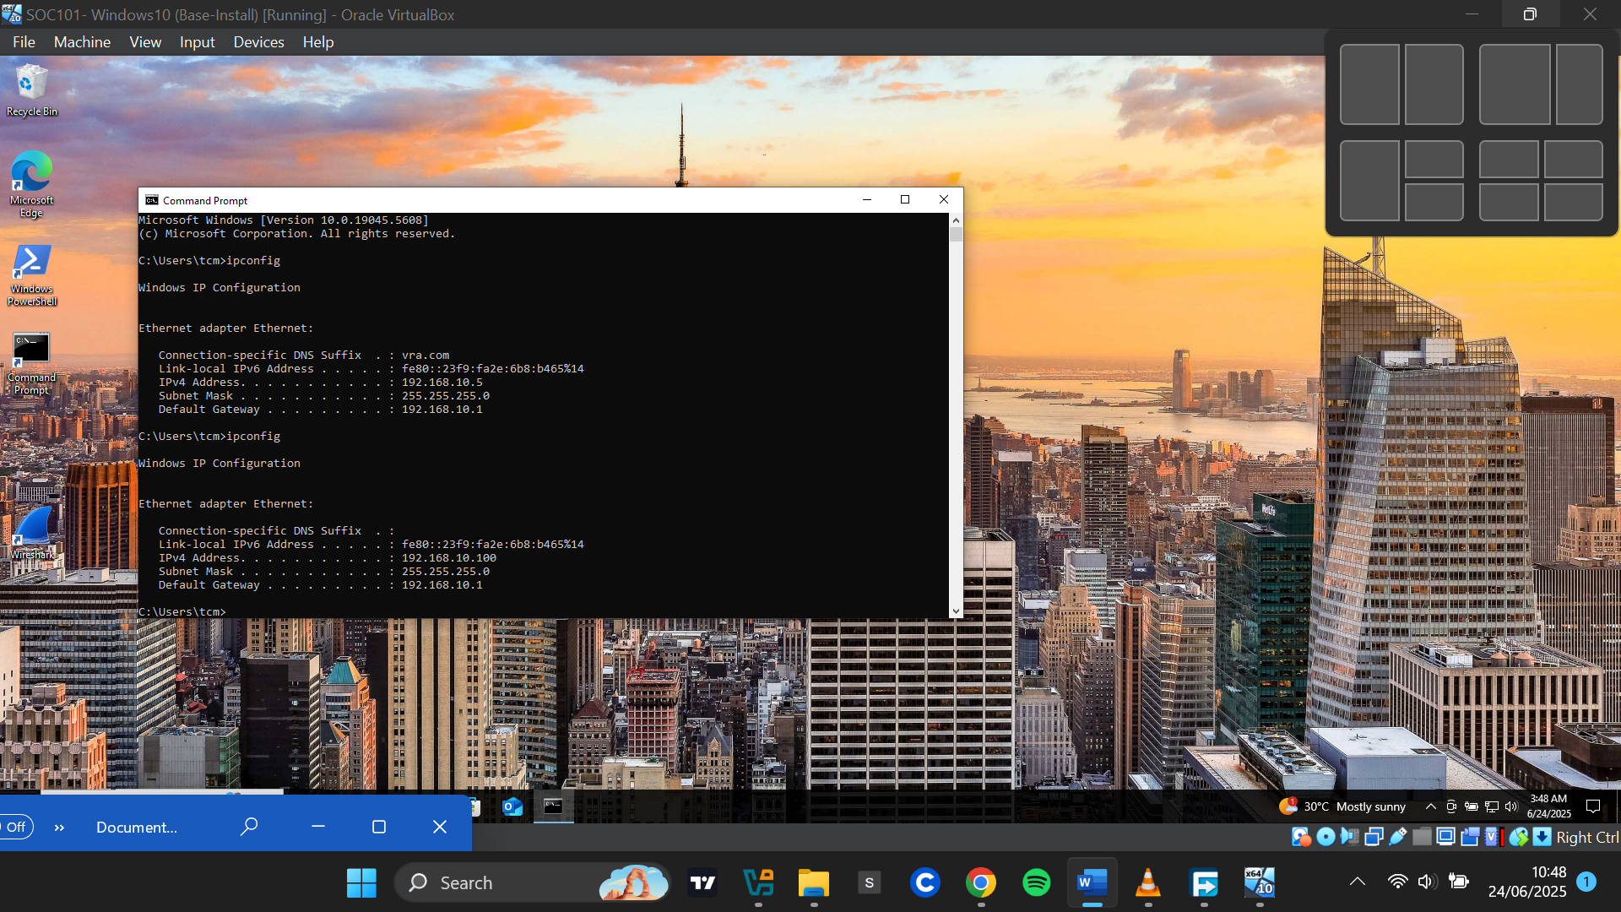

**Downloading and Installing Splunk Universal Forwarder**

I downloaded the Splunk Universal Forwarder for Windows from the official Splunk site and ran the installer. During setup, I selected **"An on-premises Splunk Enterprise Instance"**, then set a username and password for the Splunk forwarder.

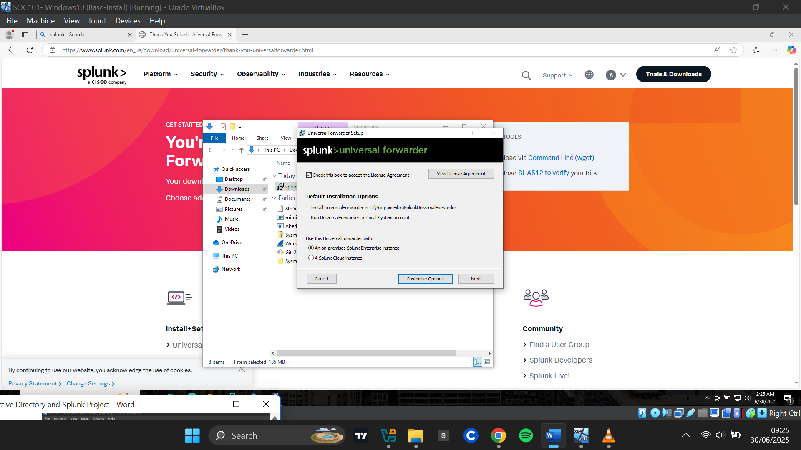

I skipped the deployment server step, and for the receiving indexer configuration, I entered the IP address of my Splunk Server (192.168.10.10) and used the default receiving port 9997. I then completed the installation.

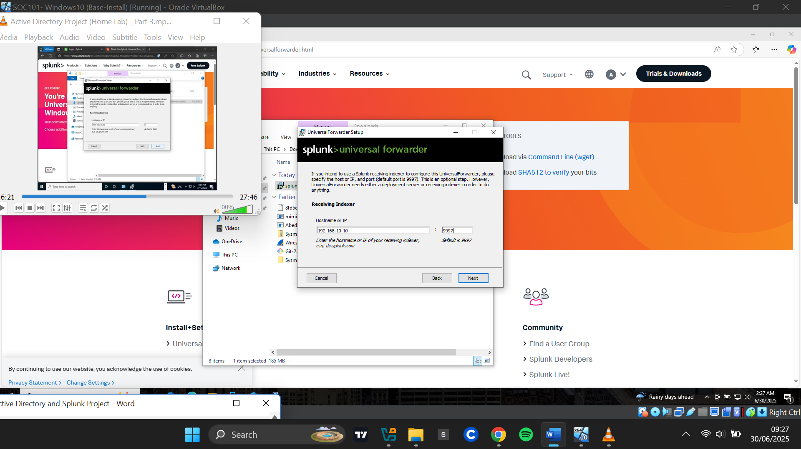

**Downloading and Installing Sysmon**

I downloaded Sysmon from [Sysmon - Sysinternals | Microsoft Learn](https://learn.microsoft.com/en-us/sysinternals/downloads/sysmon)

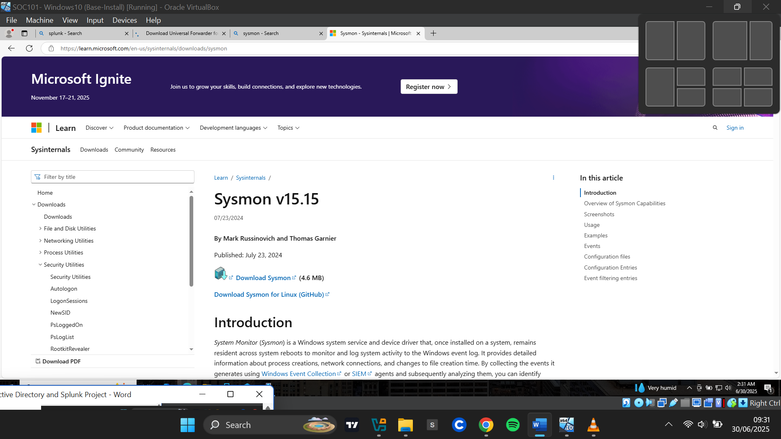

I also downloaded a Sysmon configuration file from the GitHub repository:

[GitHub - olafhartong/sysmon-modular: A repository of sysmon configuration modules](https://github.com/olafhartong/sysmon-modular)

To retrieve the configuration file:I navigated to the repository, scrolled down and selected sysmonconfig.xml, clicked Raw, then right-clicked and saved the file

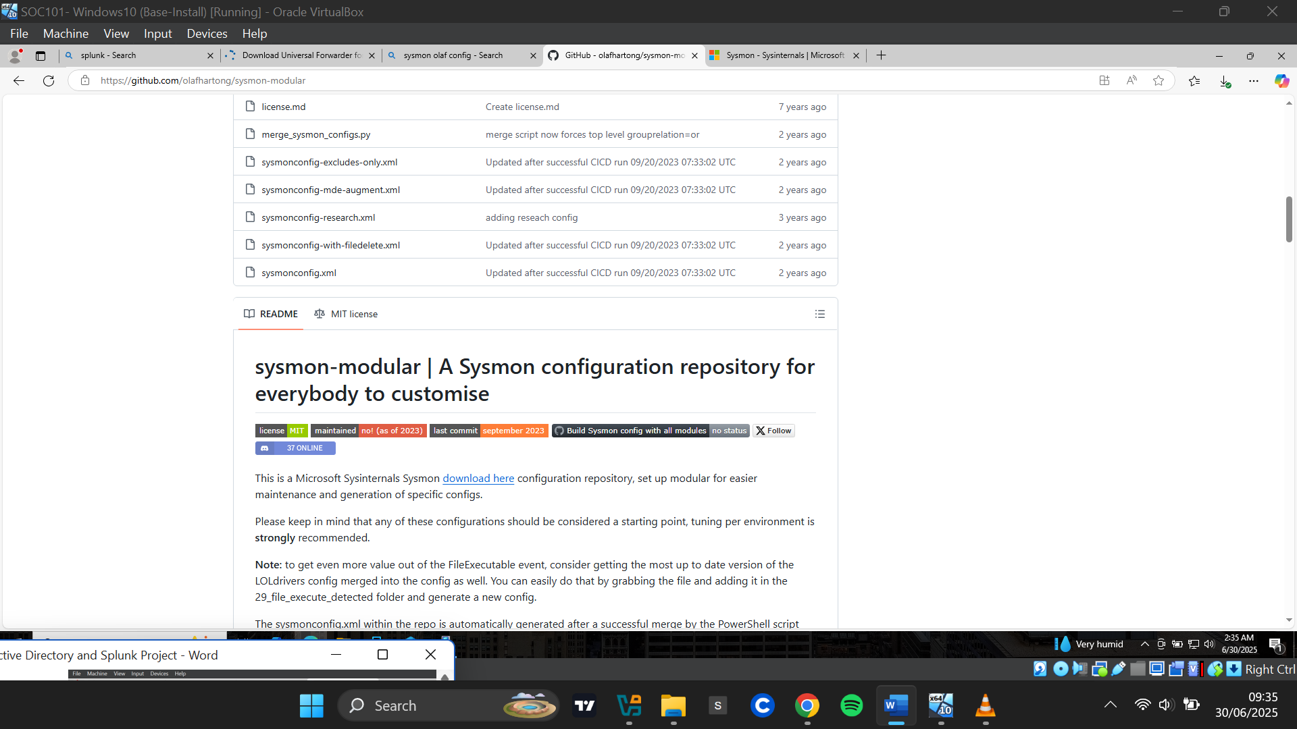

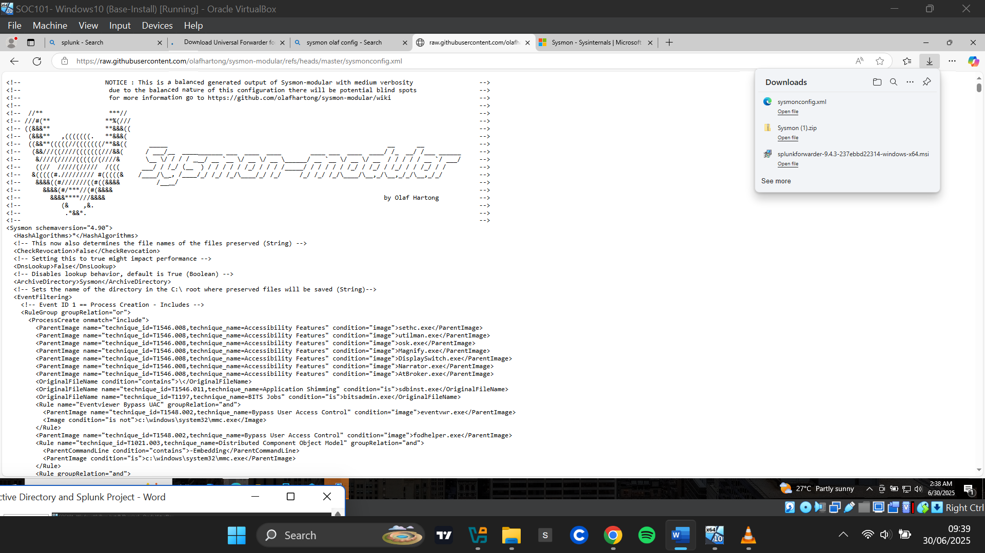

I extracted the downloaded Sysmon ZIP file, copied the file path, and opened PowerShell with administrator privileges. I navigated to the extracted directory using the copied path and installed Sysmon using the configuration file.

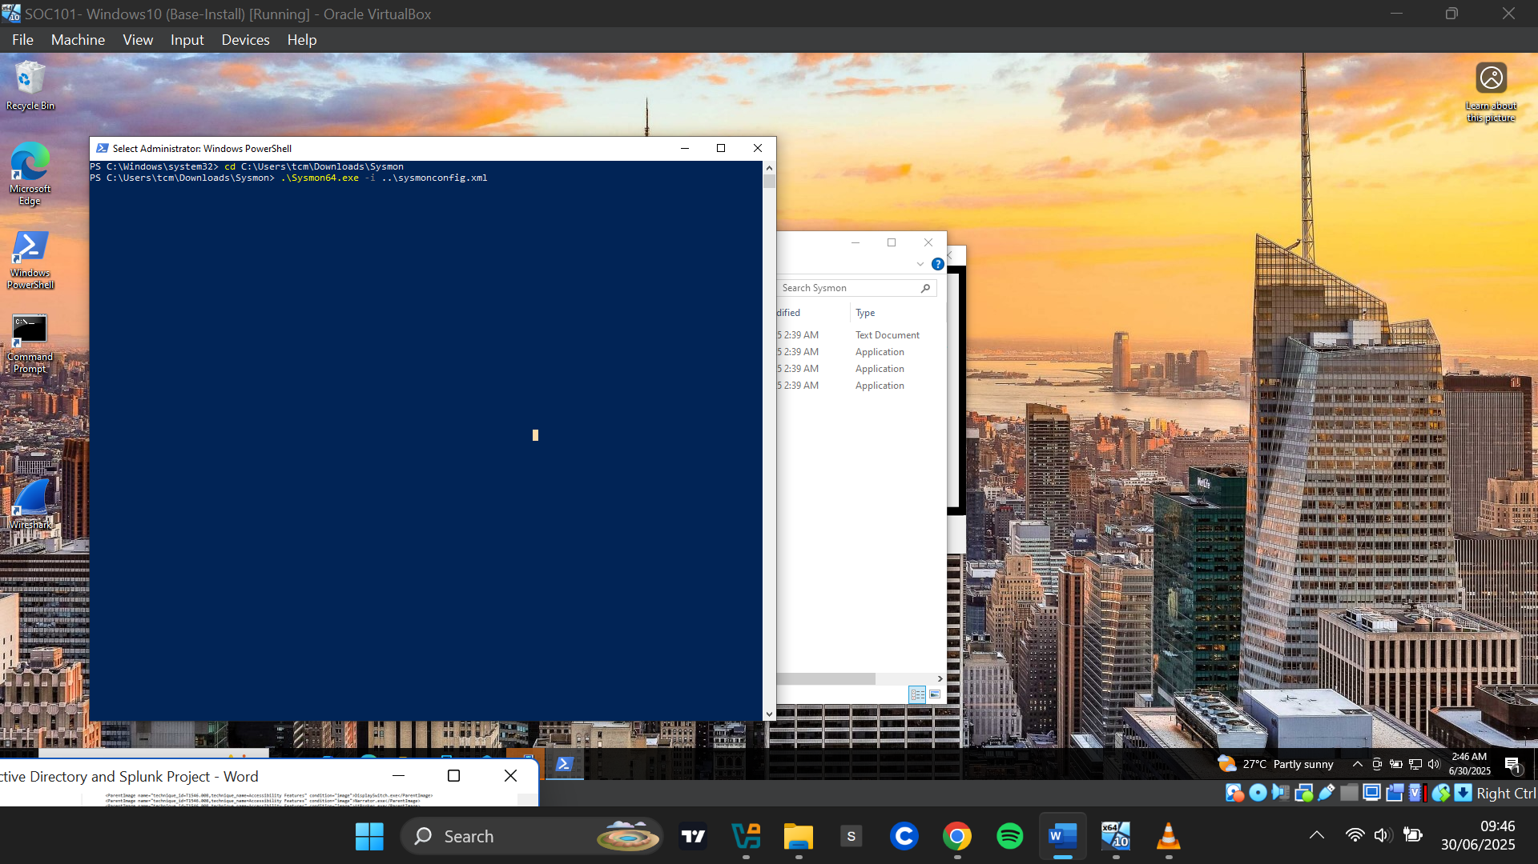

**Configuring the Splunk Forwarder**

C:>Program Files>Splunk Universal Forwarder>etc>system>default>inputs.conf

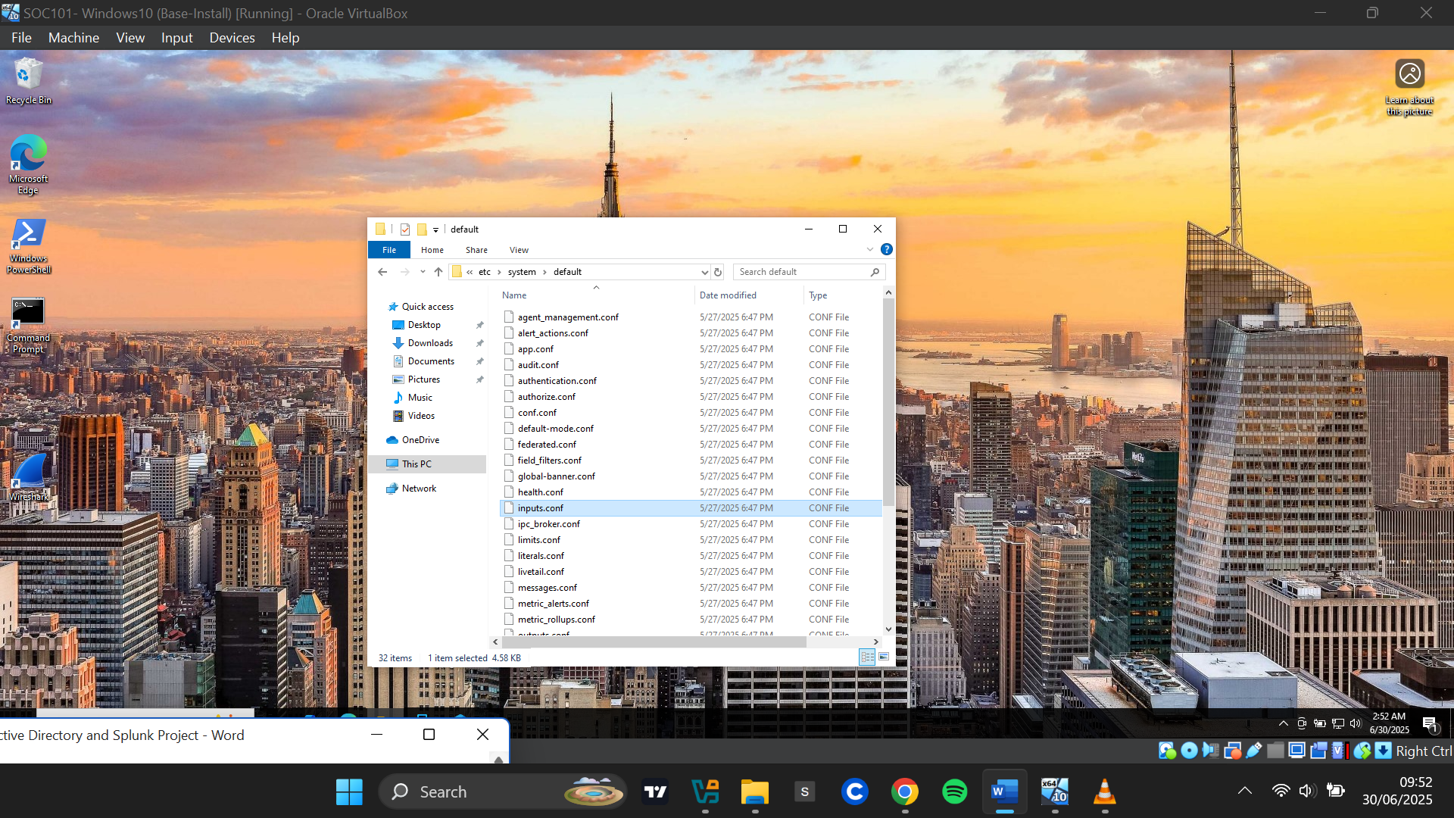

The Default config file path: C:\Program Files\Splunk Universal Forwarder\etc\system\default\inputs.conf is not edited directly. It acts as a fallback.

**C:>Program Files>Splunk Universal Forwarder>etc>system>local**

Instead, I created a new inputs.conf file in:  
C:\Program Files\Splunk Universal Forwarder\etc\system\local

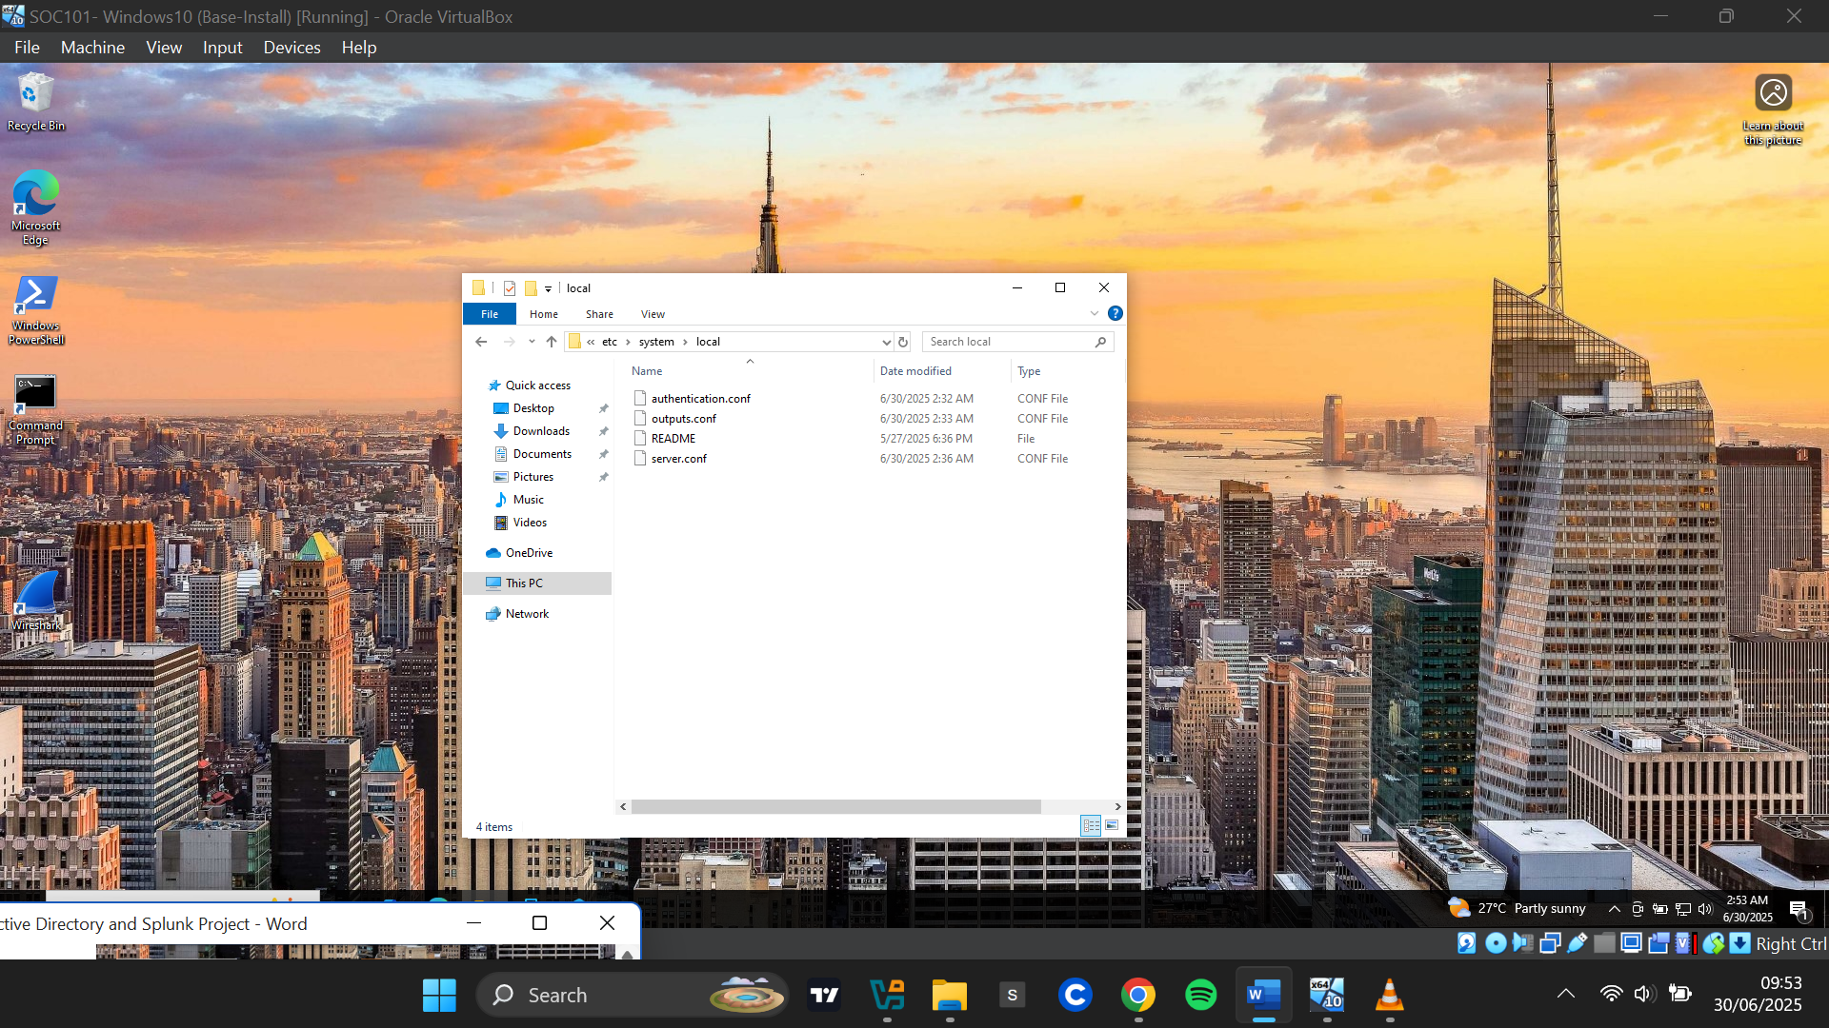

Because administrative privileges are required, I opened Notepad as an administrator. I configured the file to forward logs from the **Application**, **Security**, **System**, and **Sysmon** event logs. All logs were pointed to an index named **"endpoint"**.

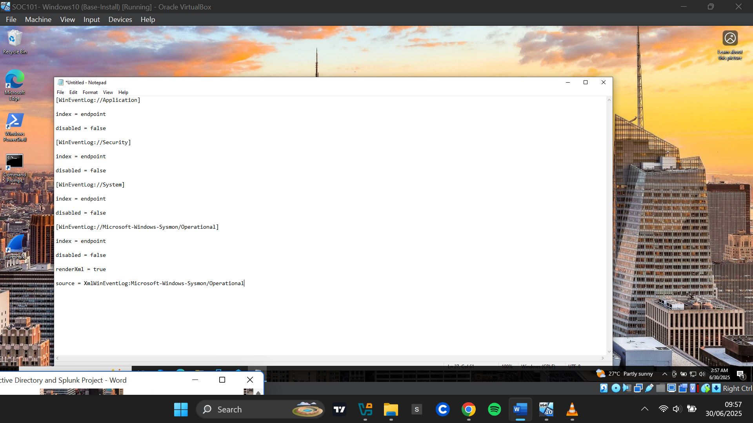

I saved the file as inputs.conf with "All Files" selected in the save dialog.

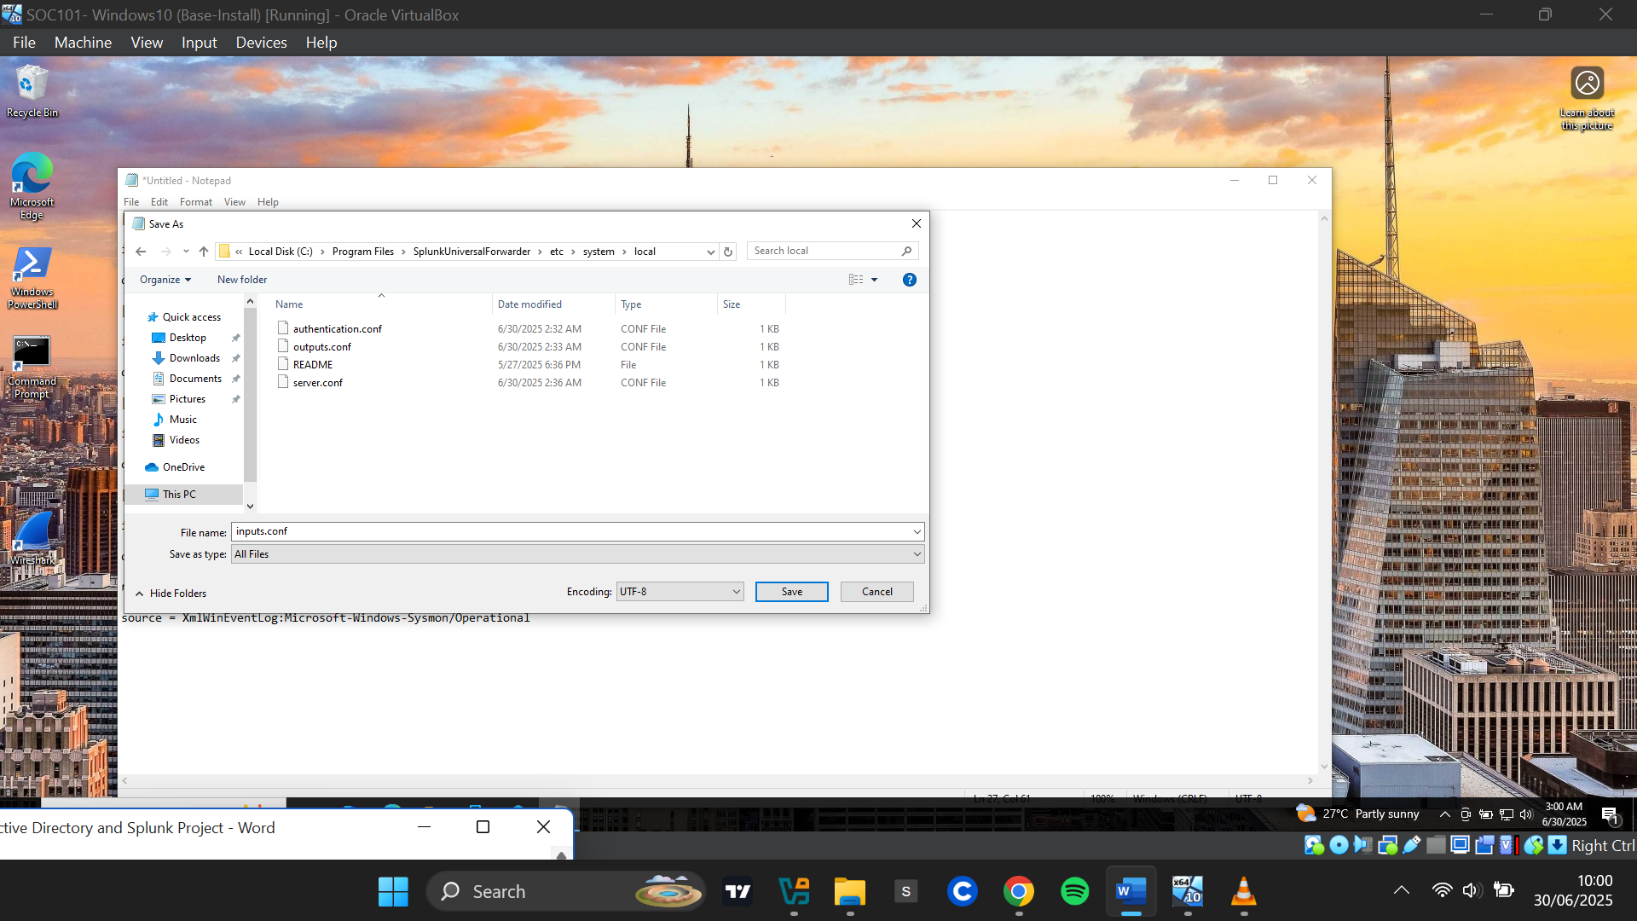

After saving the configuration, I restarted the **Splunk Universal Forwarder service** for the changes to take effect.

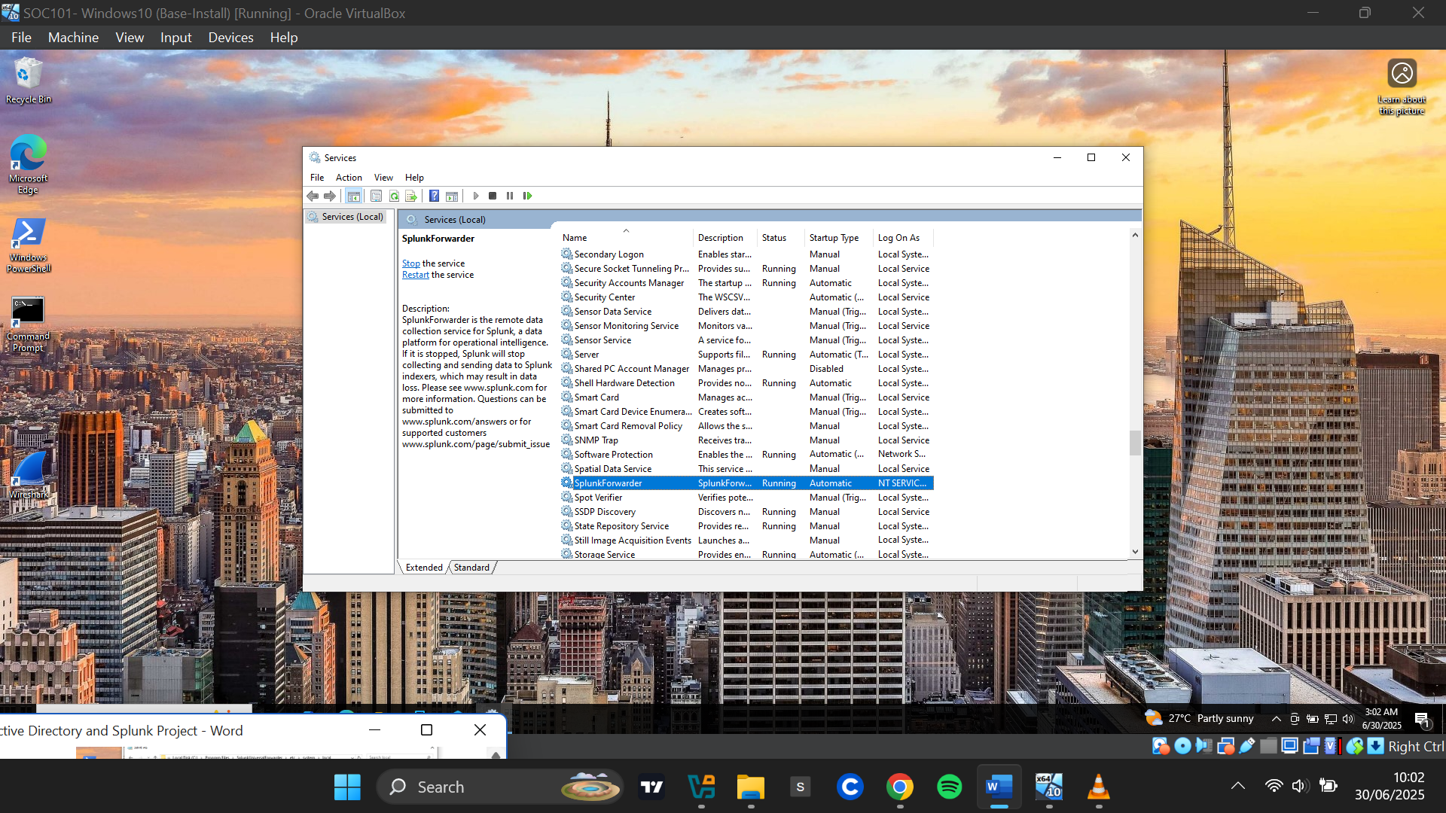

To ensure log collection permissions, I modified the **"Log On As"** property of the service:

I opened **Services.msc** and located **Splunk Universal Forwarder.** Under the **Log On** tab, I changed from NT SERVICE\SplunkForwarder to **Local System Account**. Applied the changes and restarted the service

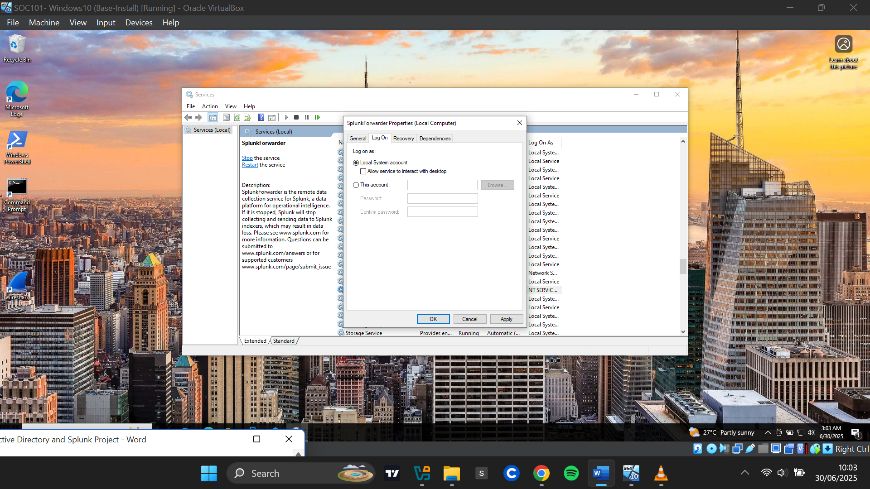

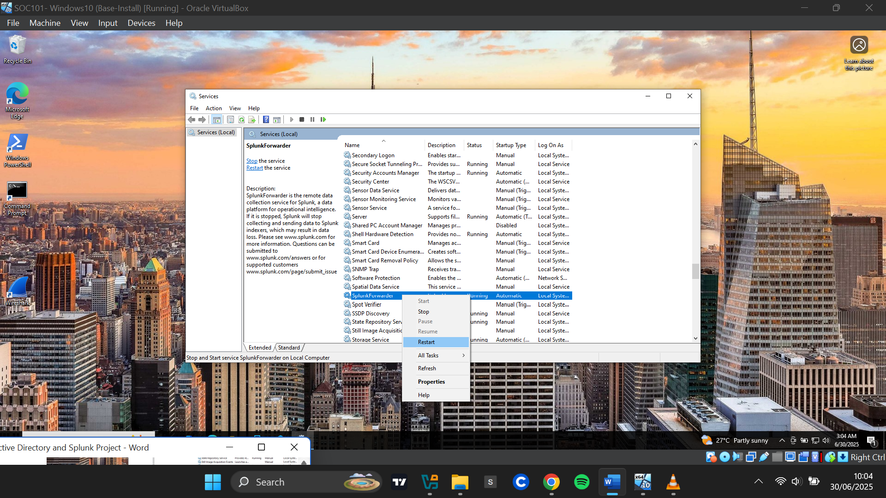

**Configuring the Splunk Server to Receive Inputs**

**Logging into Splunk**

I accessed the Splunk web interface via <http://192.168.10.10:8000> and logged in using the credentials created during installation.

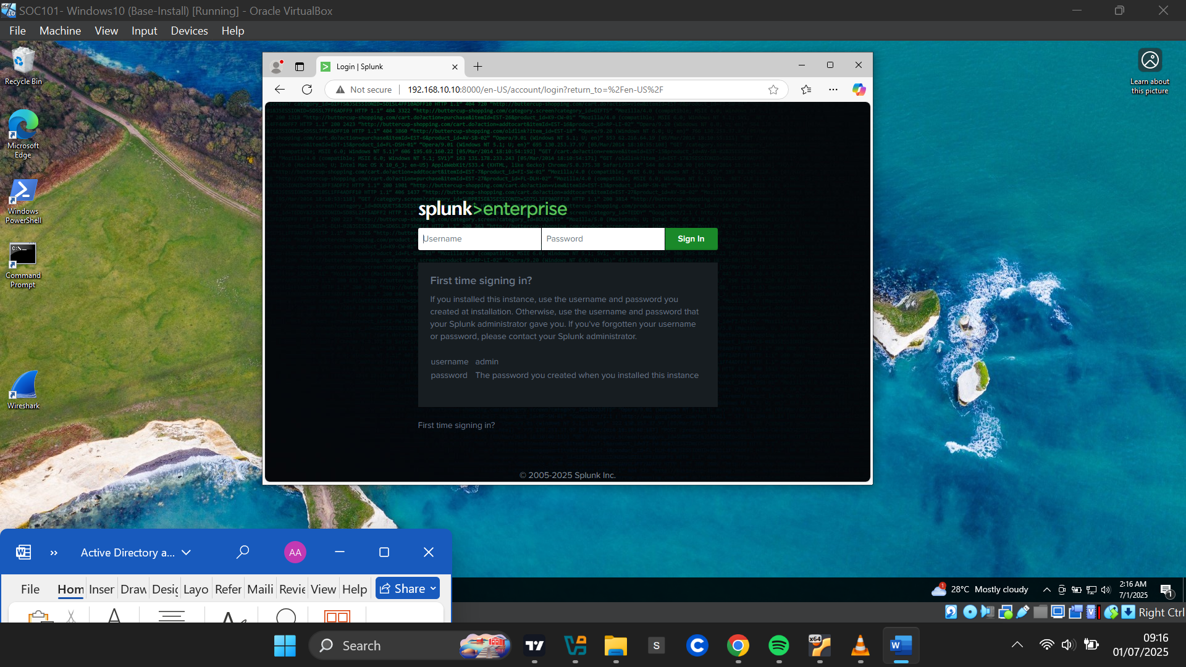

**Creating the "endpoint" Index**

* Navigated to **Settings > Indexes**
* I clicked **New Index**
* Named the index **"endpoint"** (matching the forwarder's configuration)
* Saved the configuration

.

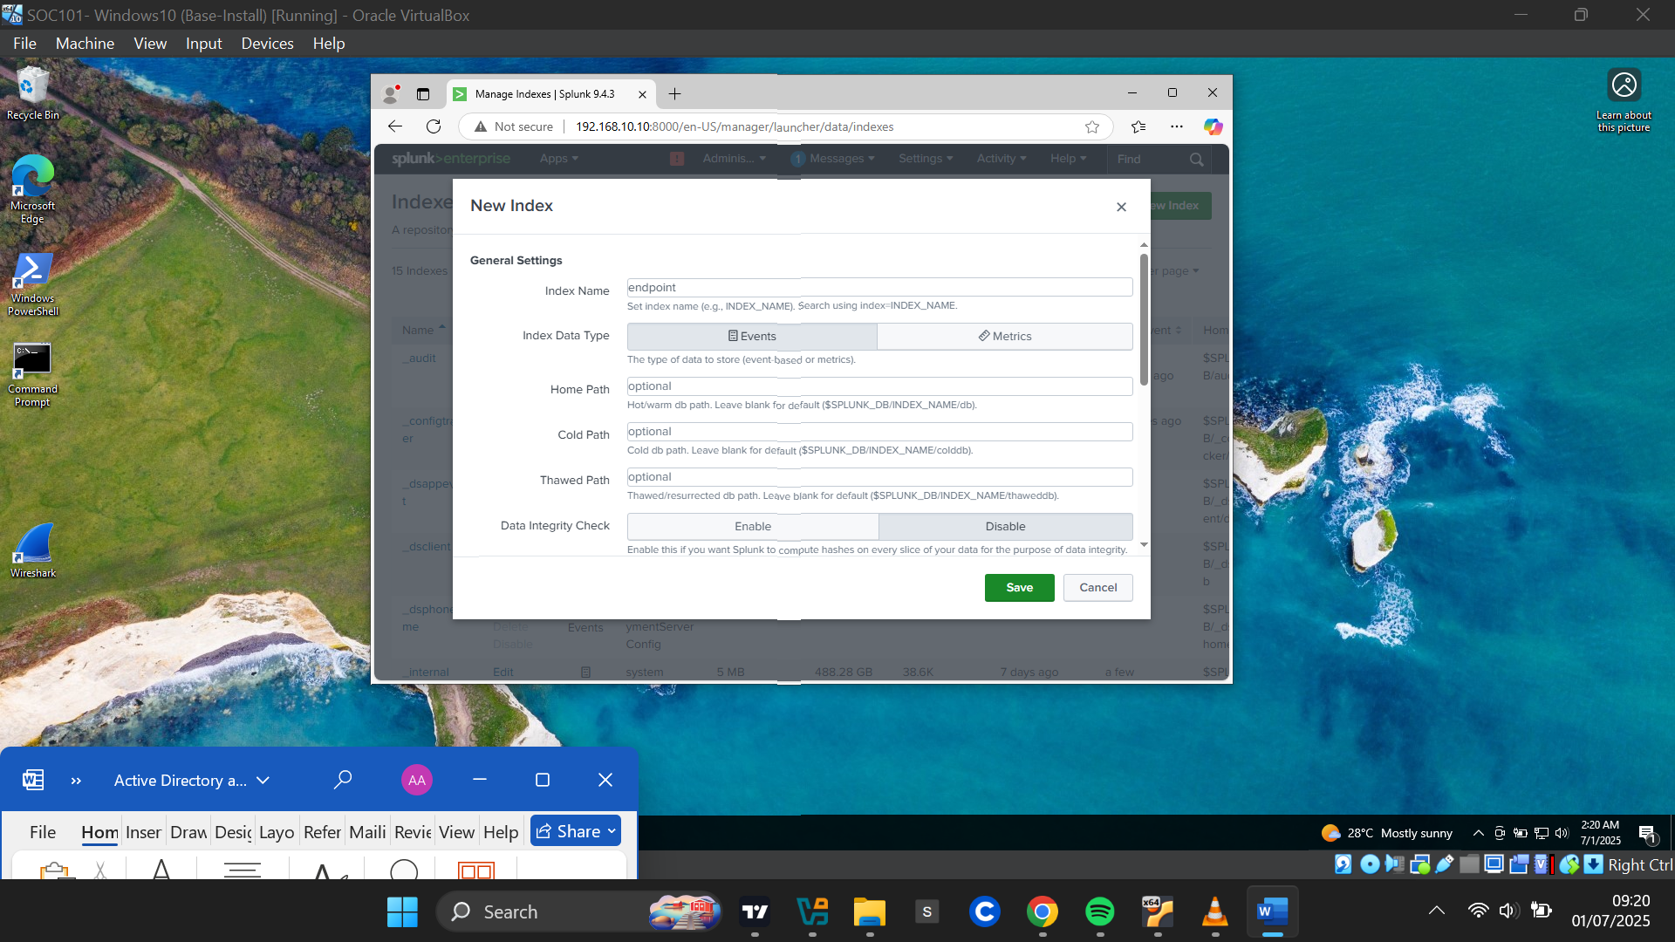

**Enabling the Splunk Server to Receive Data**

Settings>Forwarding and receiving

I clicked on Settings and selected “Forwarding and receiving” from the drop down menu list. Under Receive data , I clicked “Configure Receiving”

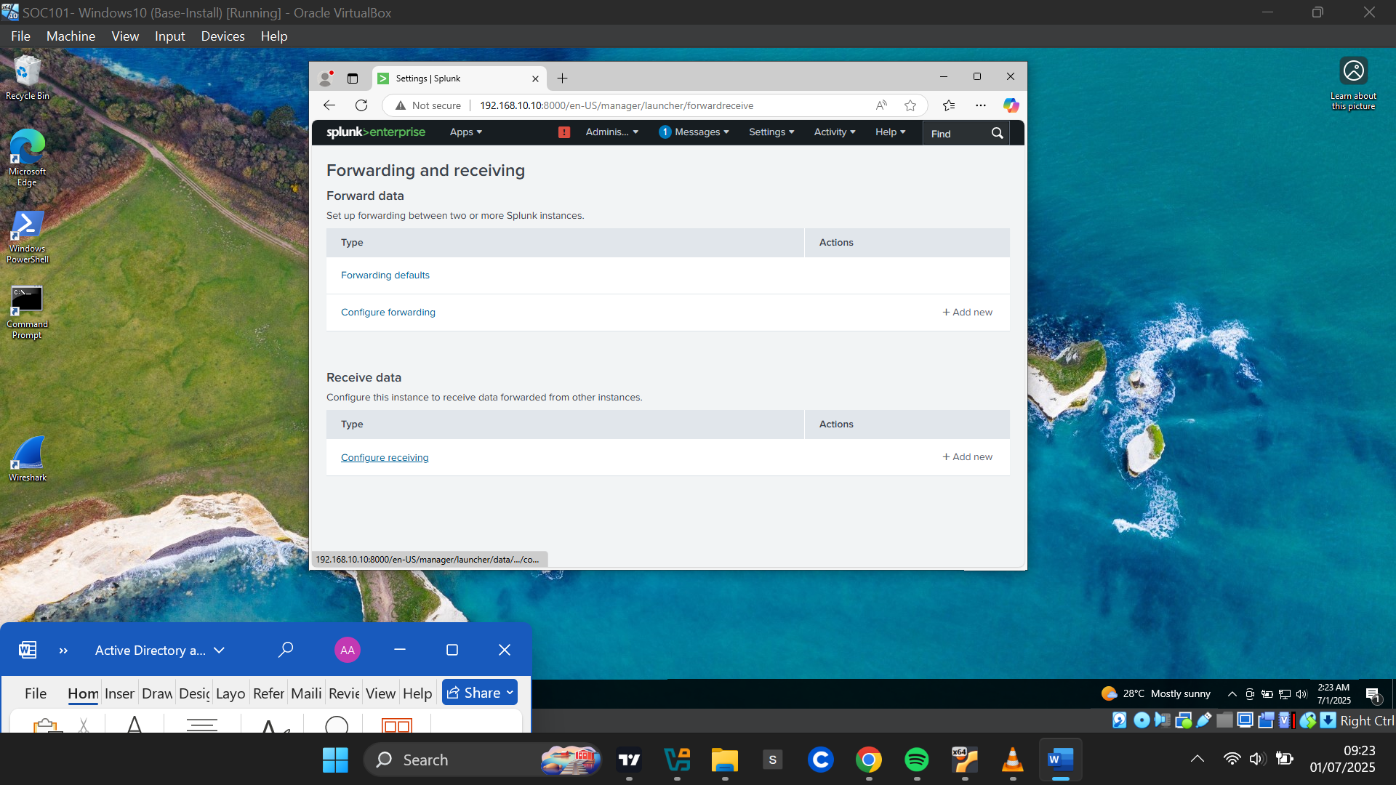

Clicking on Configure receiving took me to the Receive data page. I clicked the **New Receiving Port** button at the top right corner. I entered the port number 9997 as used as the default receiving port during the setup. I Saved the settings, which displayed a message: "Successfully saved 9997".

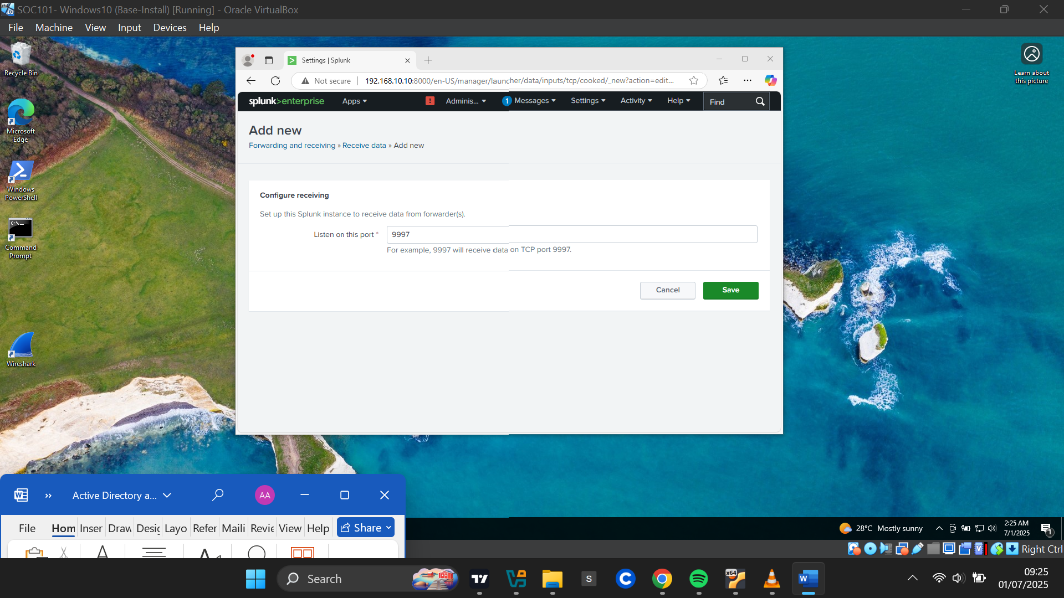

**Confirming Data Flow**

The listening port was listed. I then went on to test my configurations by heading to Search & Reporting .

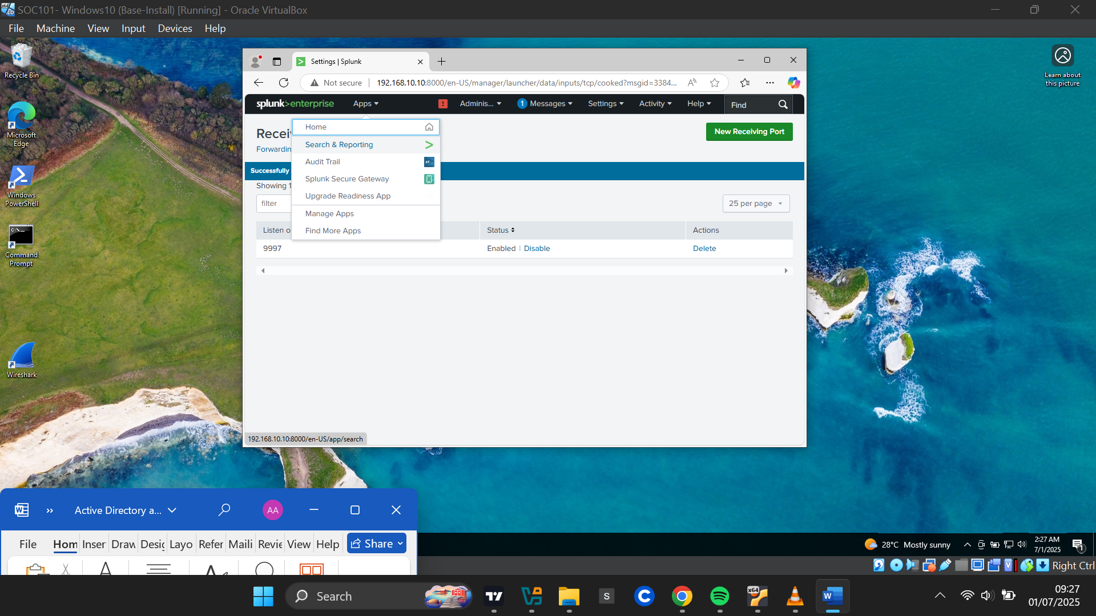

I queried the endpoint index, and adjusted the time range to **Last 24 Hours**.

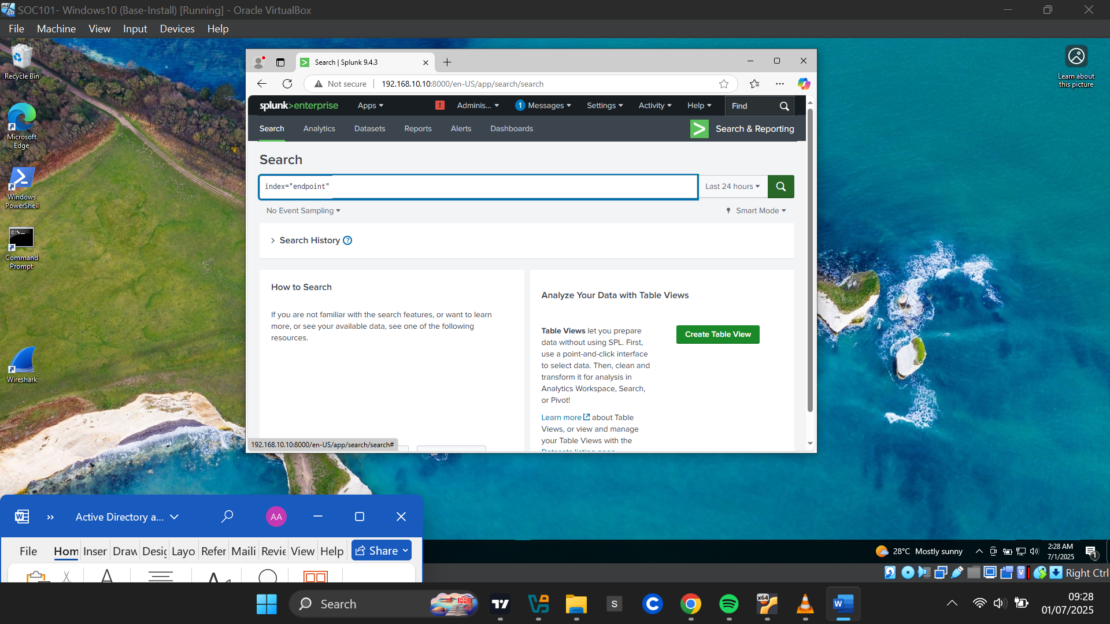

I received events confirming data flow from the Windows machine. The host field showed TARGET-PC, confirming successful forwarding.

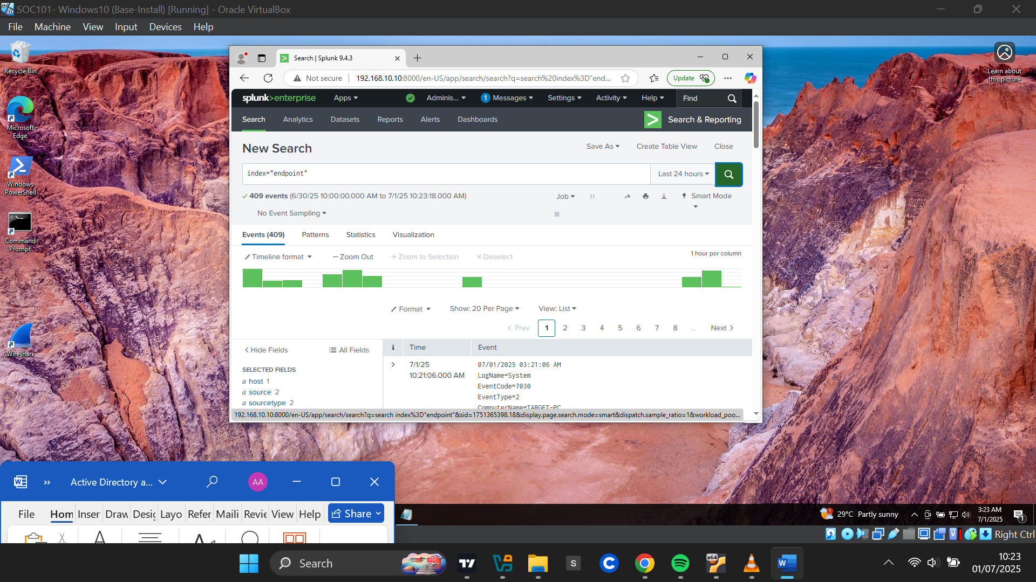

**Setting Up Splunk Universal Forwarder and Sysmon on Windows Active Directory Server**

I went through the same steps as before to set up Splunk Universal forwarder and Sysmon on my Active Directory Server.

**Renaming the AD Server**

I renamed the Active Directory server to **"ADDC01"** (Active Directory Domain Controller 1).

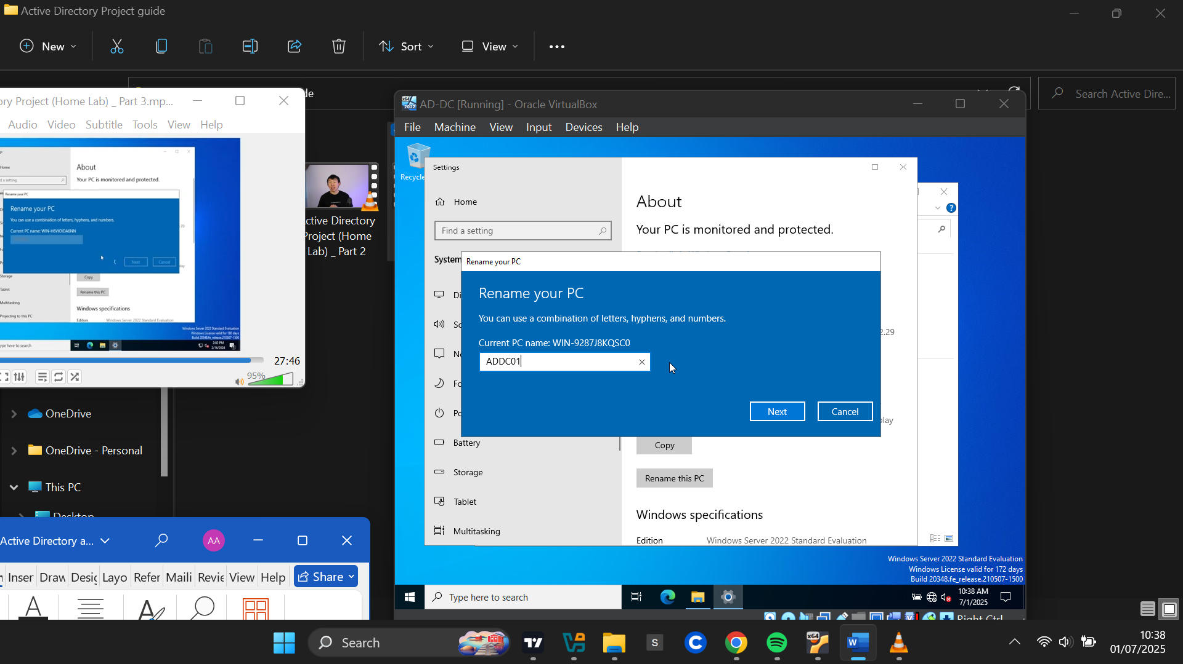

**Assigning a Static IP**

Using the following path:  
**Network and Adapter Settings > Network Connections > Ethernet Properties > IPv4 Properties**

I disabled automatic IP assignment and set a static IP of 192.168.10.7, then saved and confirmed the settings.

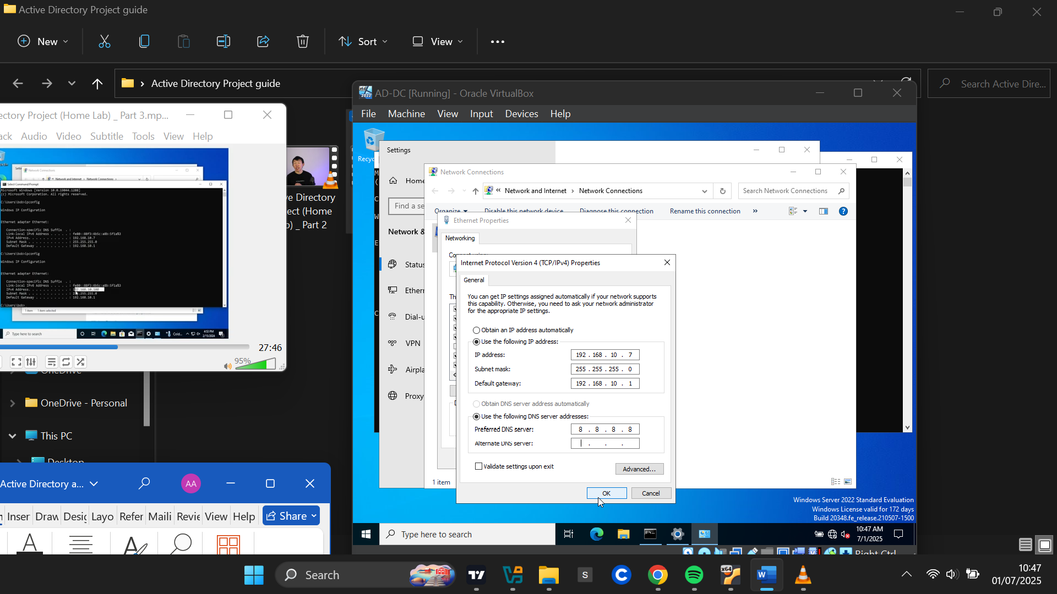

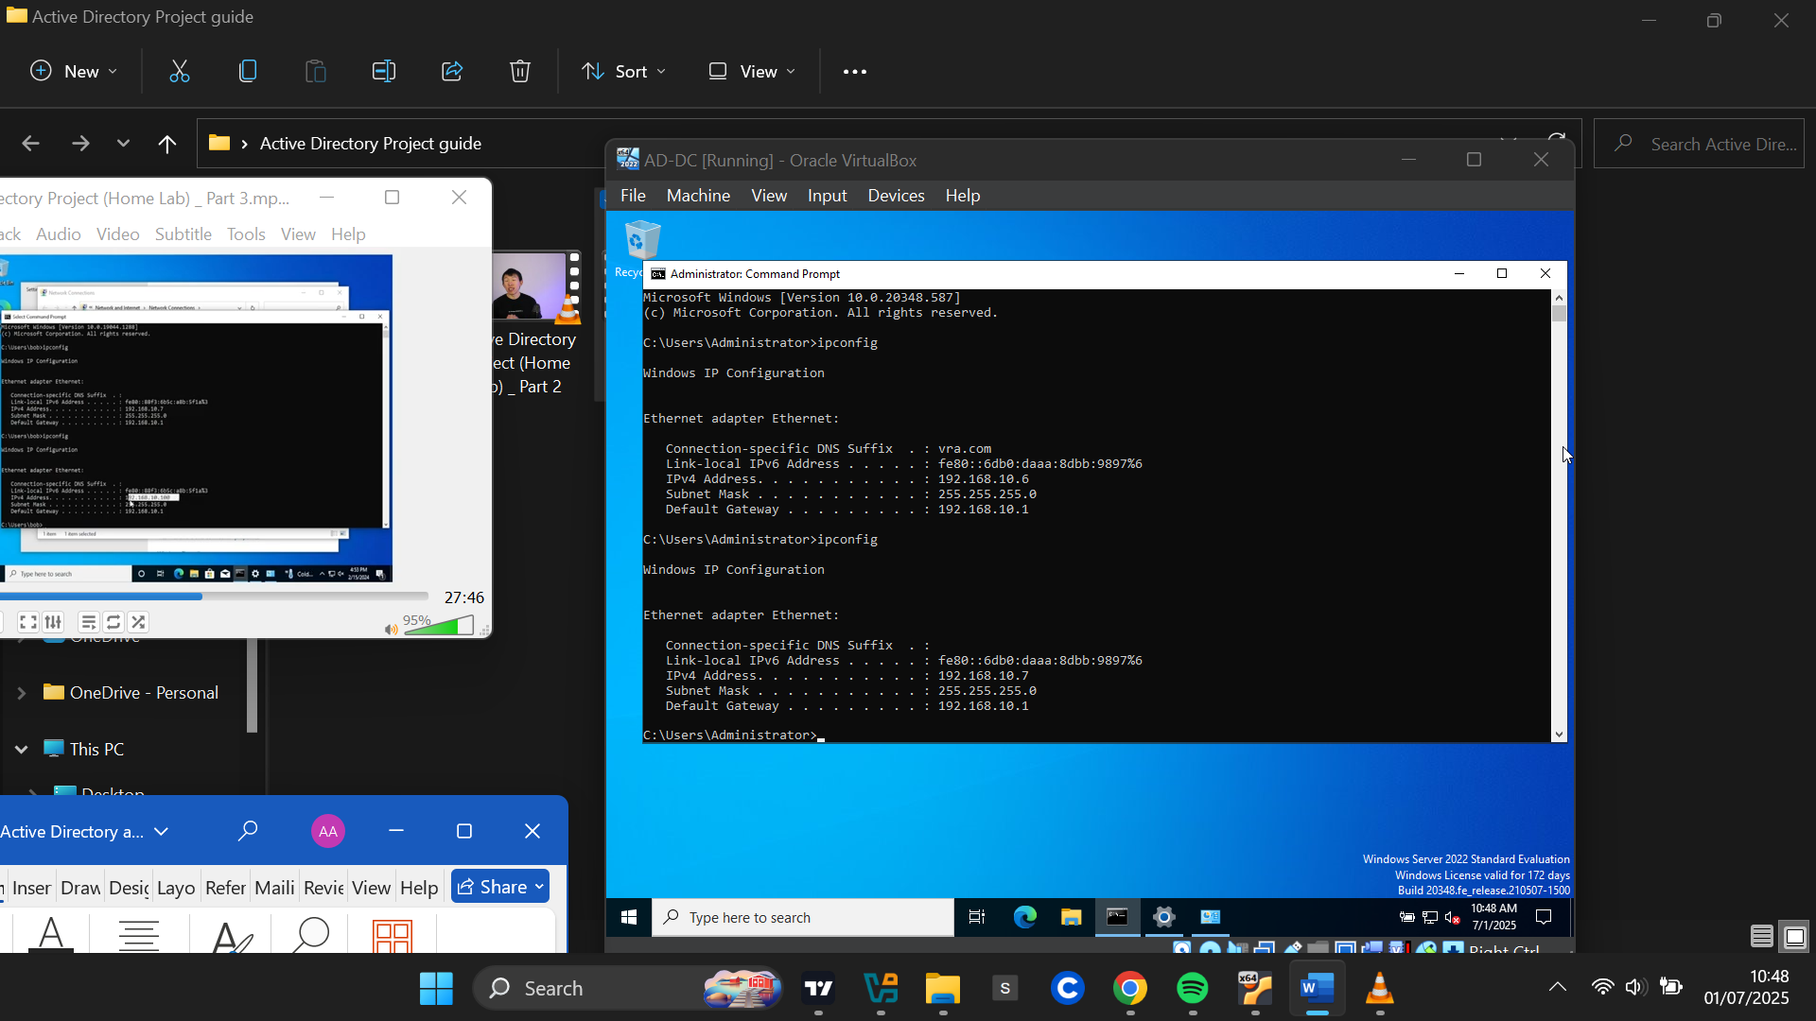

**Installing Splunk Universal Forwarder**

I downloaded the Splunk Universal Forwarder for Windows and followed the same installation steps as with TARGET-PC, including the receiving indexer and port settings.

**Installing Sysmon**

I downloaded Sysmon and the same configuration file used earlier from Olaf Hartong’s GitHub repository ([GitHub - olafhartong/sysmon-modular: A repository of sysmon configuration modules](https://github.com/olafhartong/sysmon-modular)). I then installed Sysmon on the AD server using that configuration.

**Configuring the Splunk Forwarder**

C:>Program Files>Splunk Universal Forwarder>etc>system>local

I created a new inputs.conf file with the same configuration used for TARGET-PC, ensuring all event types were forwarded to the **"endpoint"** index. I then restarted the Splunk Universal Forwarder service.

**Confirming Telemetry from AD Server**

Back in Splunk, I queried the endpoint index. This time, the data showed two hosts: ADDC01 and TARGET-PC, confirming both systems were forwarding telemetry to the Splunk server.

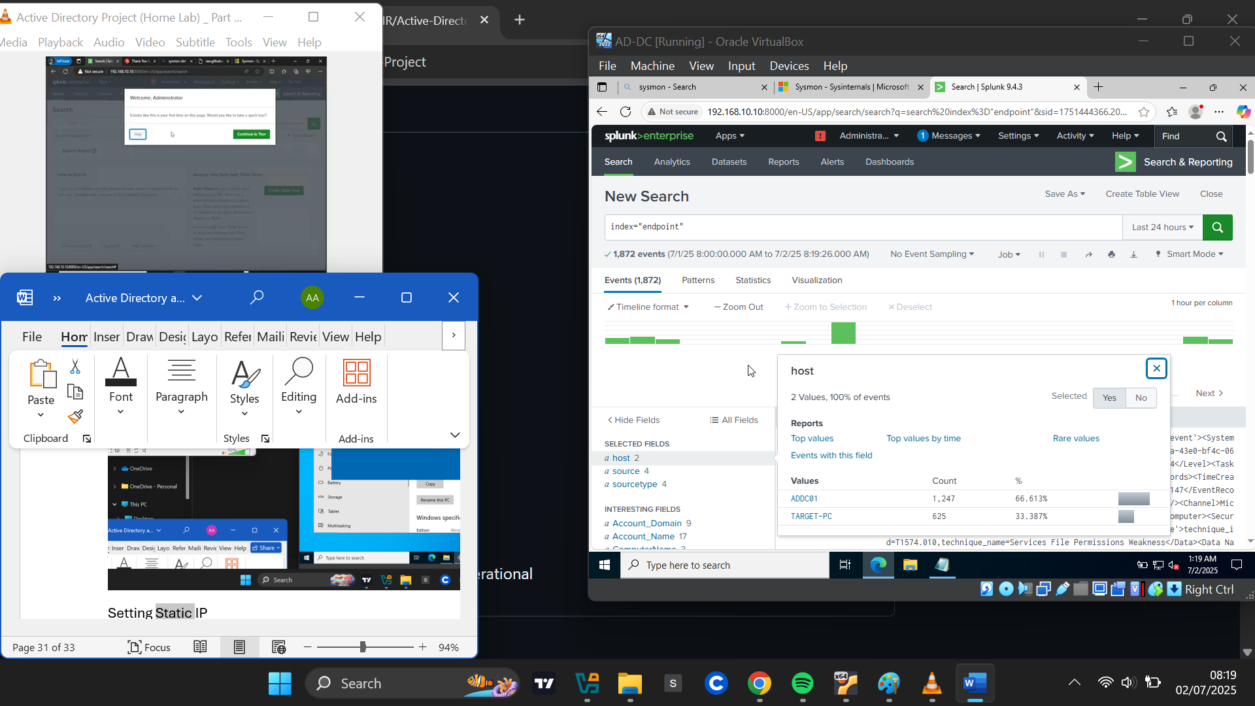

**Installing And Configuring Active Directory on Windows Server**

**Installing Active Directory Domain Services (ADDS)**

I opened the **Server Manager** app. At the top-right corner, I clicked **Manage** and selected **Add Roles and Features**. In the wizard, I chose **Role-Based or Feature-Based Installation**, and for the server selection, I selected my server, **ADDC01**.

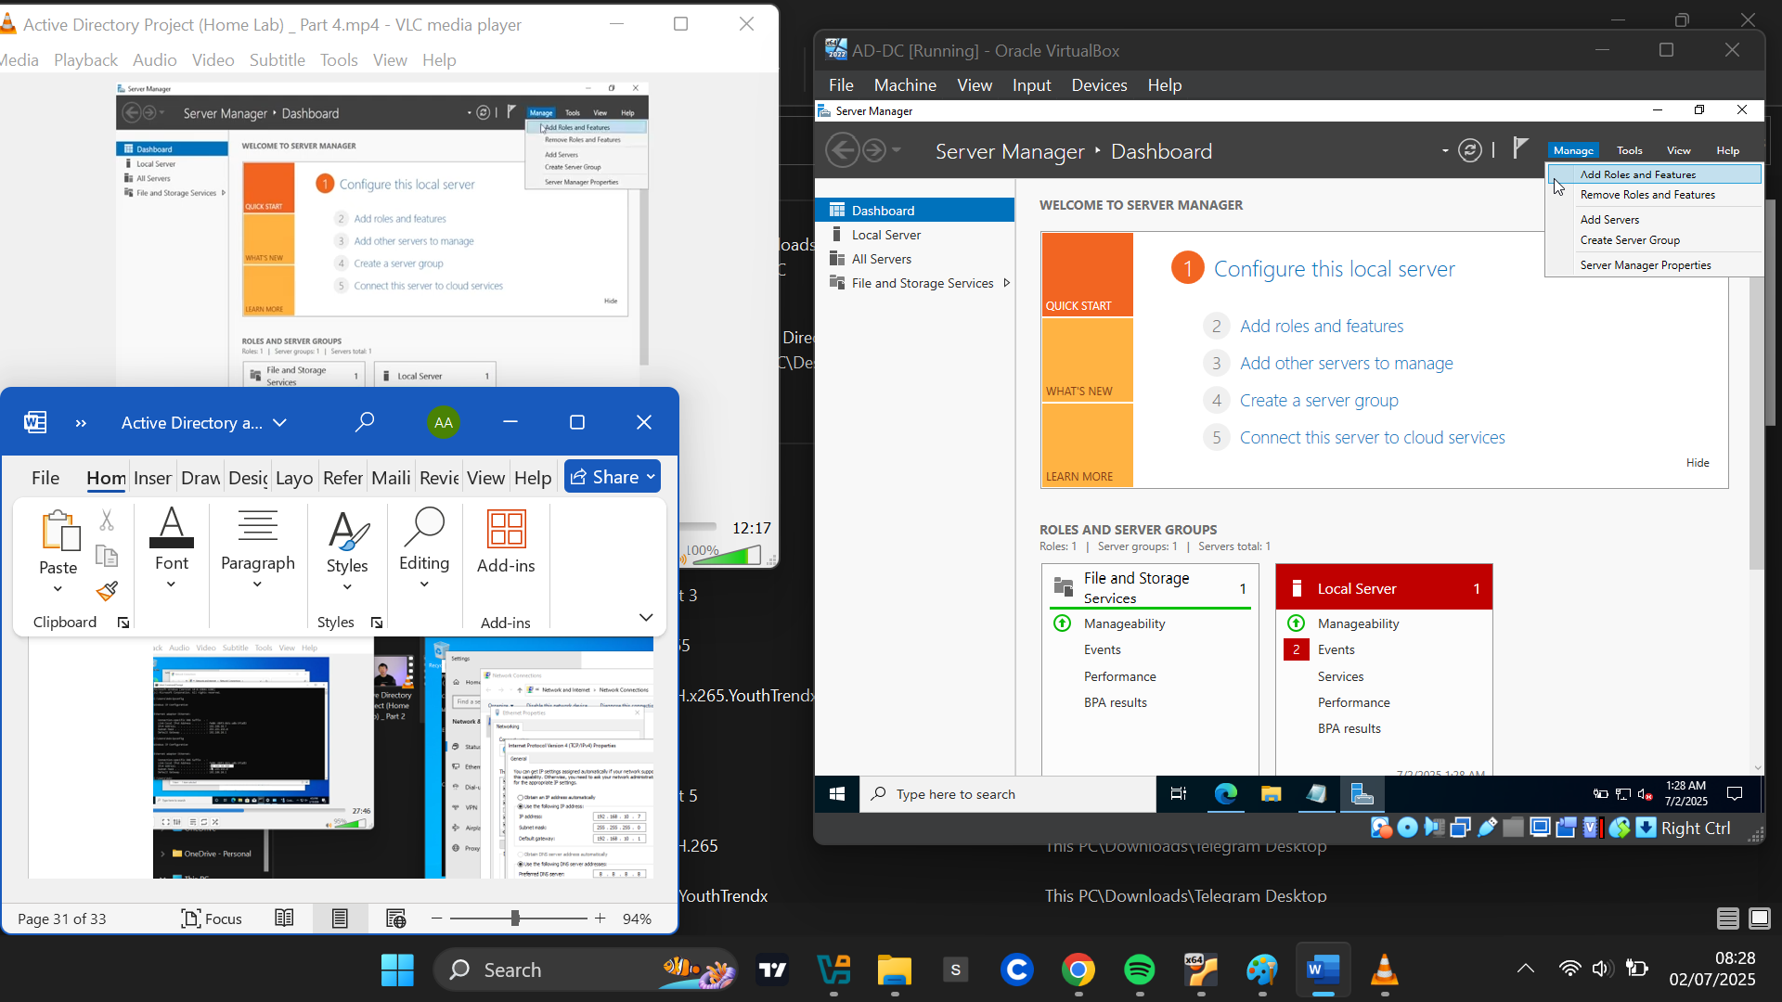

For server roles, I selected **Active Directory Domain Services**, clicked **Add Features**, and proceeded with the installation.

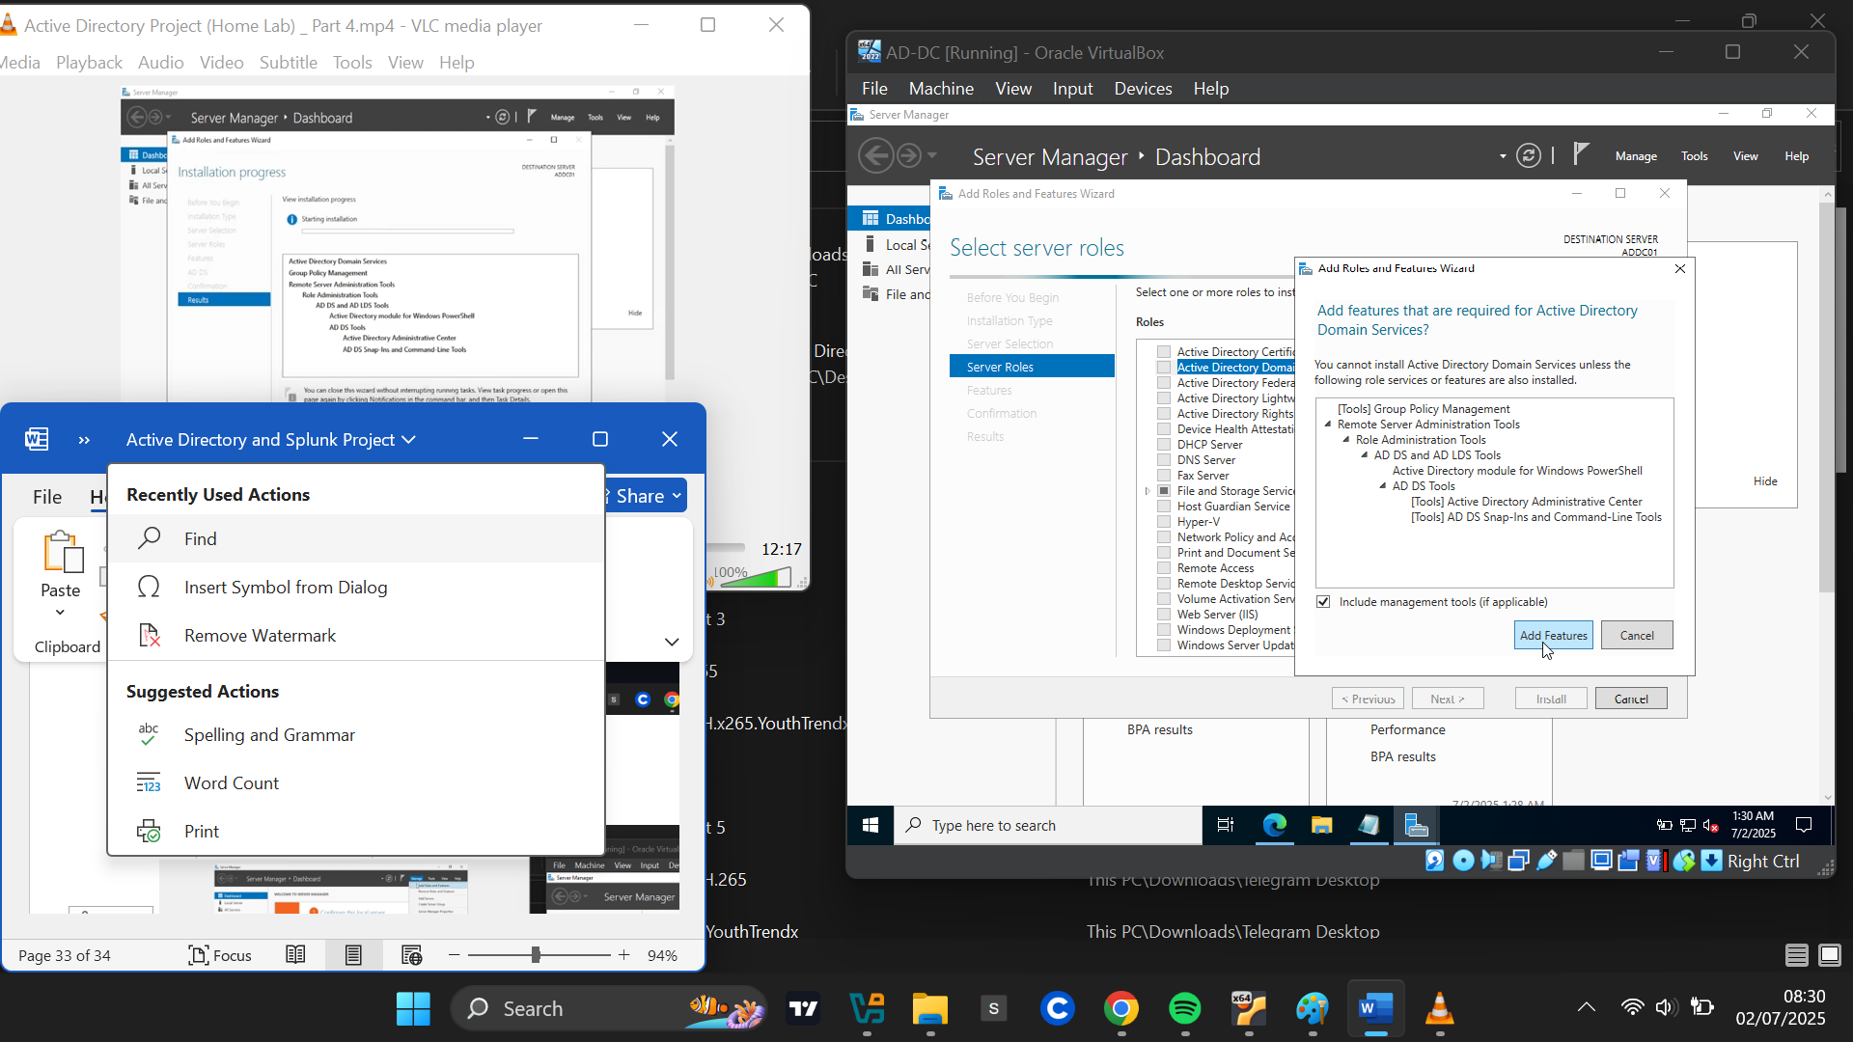

Once completed, a message appeared: **"Configuration required. Installation succeeded on ADDC01."**

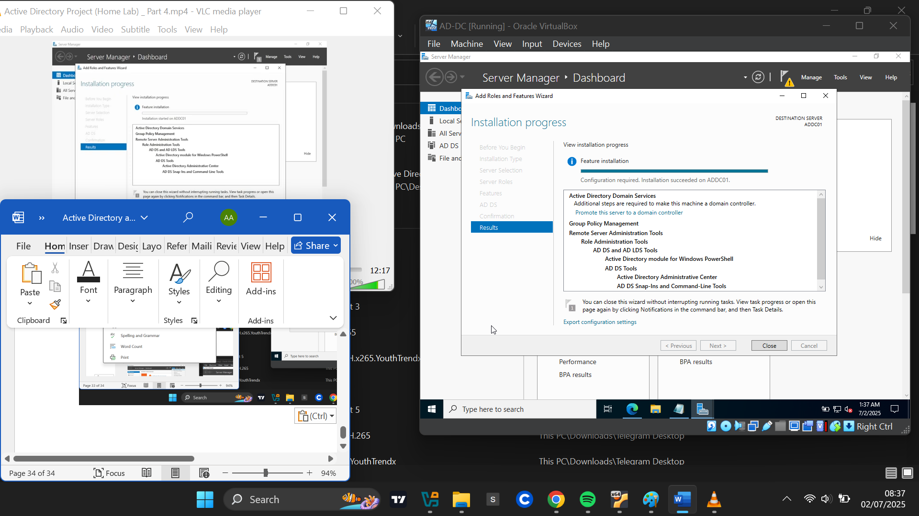

To configure ADDS, I clicked the yellow flag icon beside **Manage** and selected **Promote this server to a domain controller**.

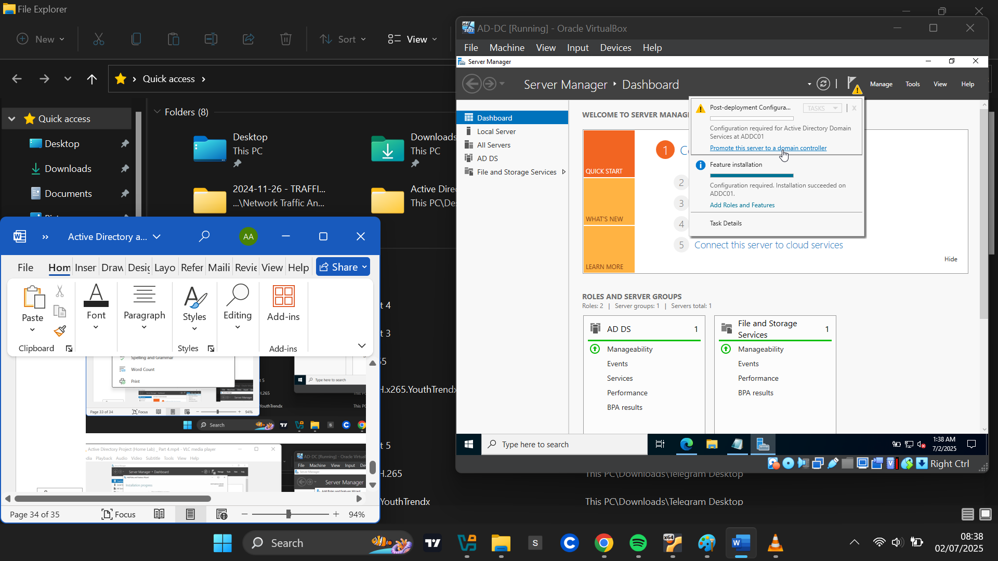

In the **Active Directory Domain Services Configuration Wizard**, I selected **Add a new forest** (since I was creating a new domain), and set the domain name to **AbedLab.test**.

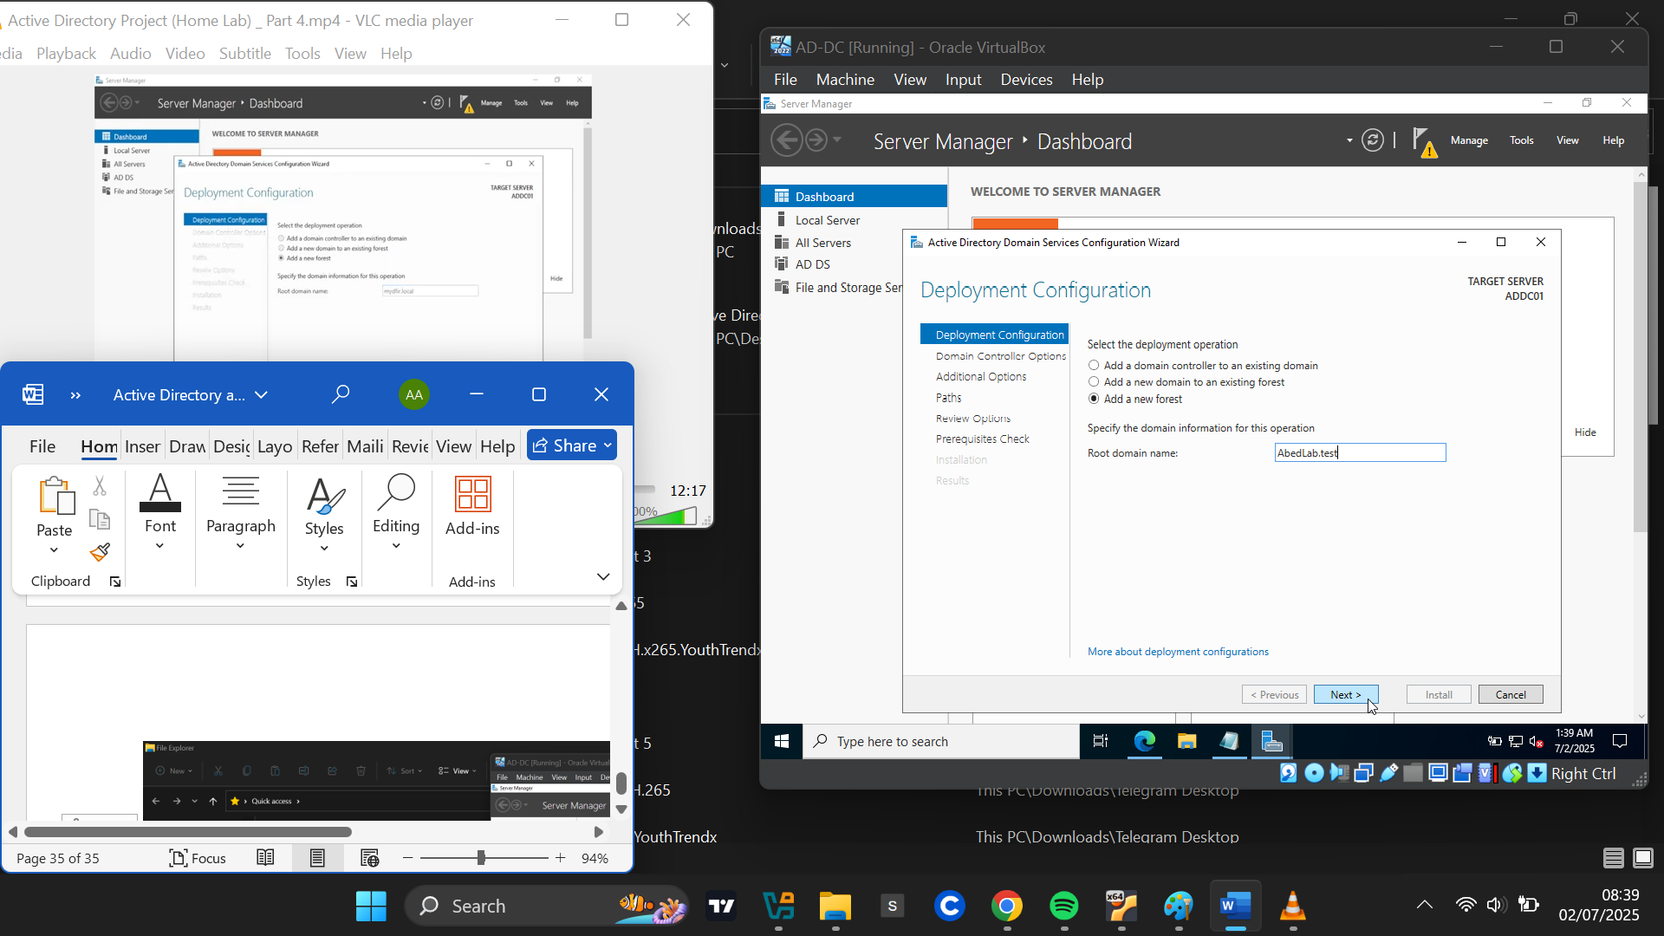

On the Domain Controller Options page, I left the default settings and set a password for Directory Services Restore Mode. After verifying prerequisites, I proceeded with the installation.

On the Domain Controller Options page, I left the default settings and set a password for Directory Services Restore Mode. After verifying prerequisites, I proceeded with the installation.

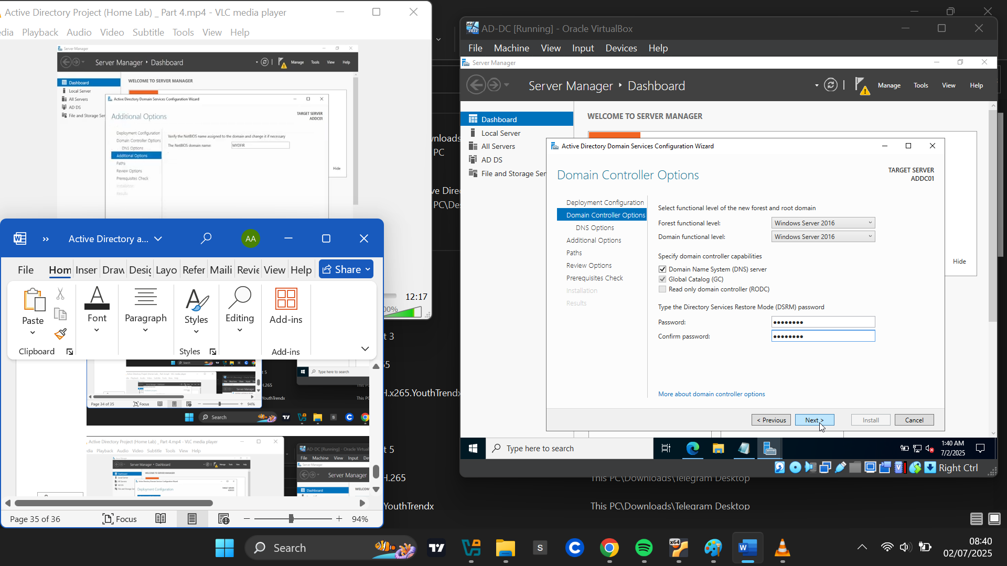

Upon completion, the server automatically restarted. The login prompt now displayed **ABEDLAB\Administrator**, indicating that ADDS was successfully installed and the server had been promoted to a domain controller. I logged in using the password I had created.

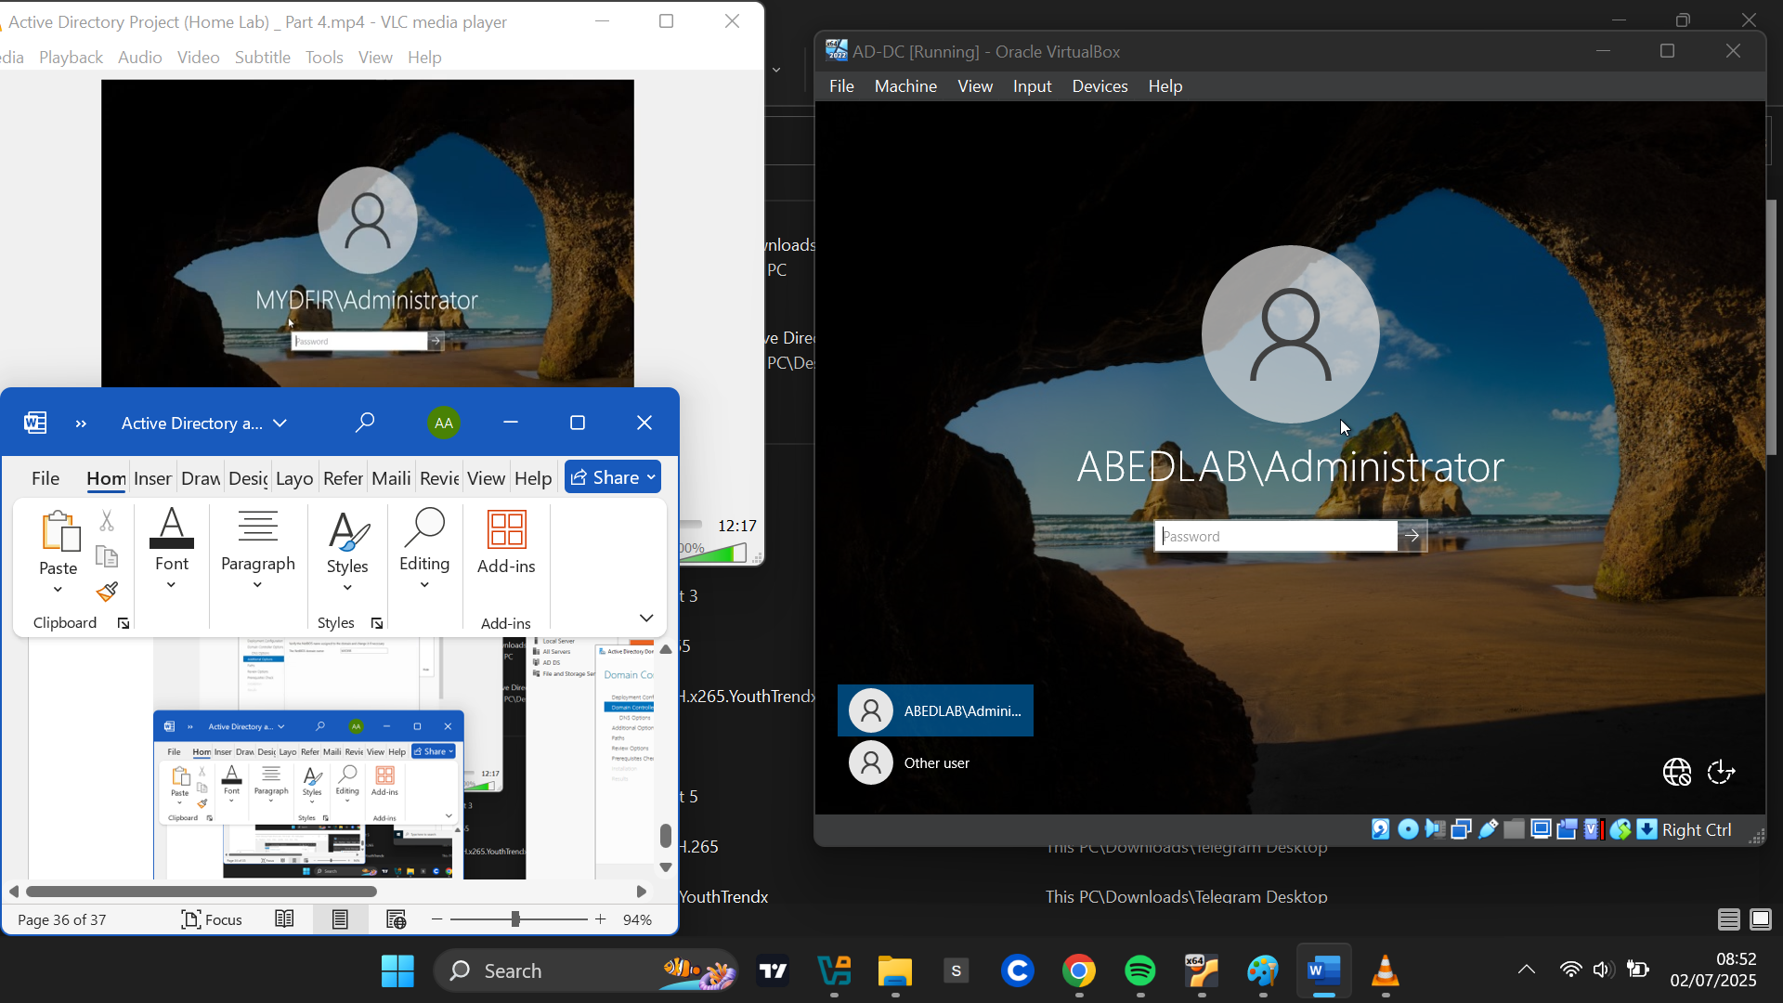

**Creating Organizational Units and Users**

From **Server Manager**, I clicked **Tools** > **Active Directory Users and Computers**.

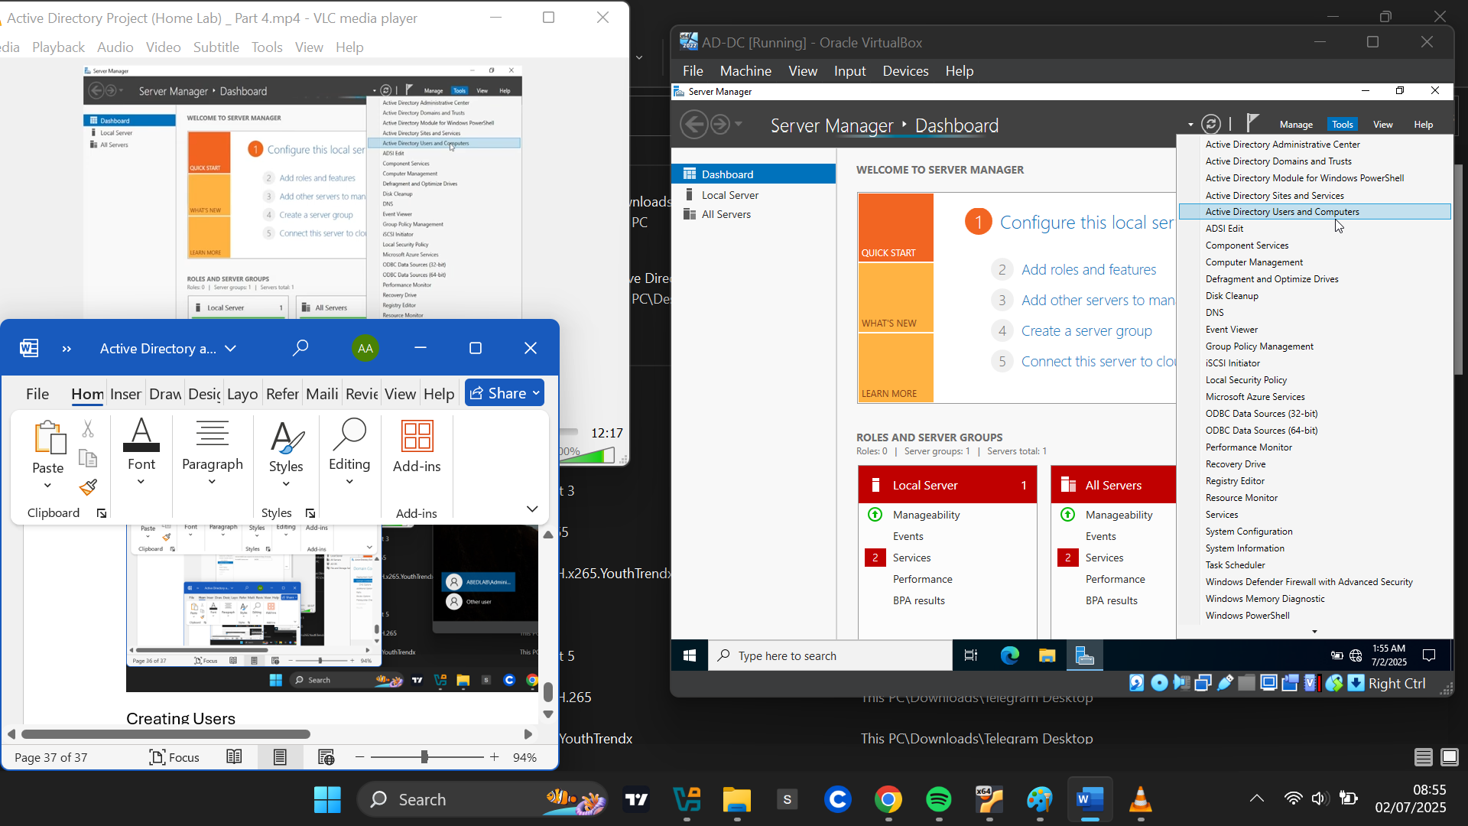

I right-clicked my domain and selected **New > Organizational Unit**, creating a new department called **IT**.

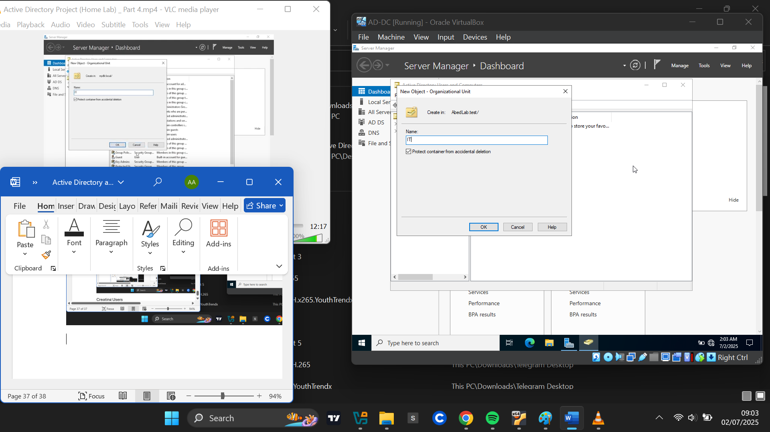

I then went on to add a new user to the IT department. To add a new user:

* I right-clicked the **IT** Organizational Unit
* Selected **New > User**

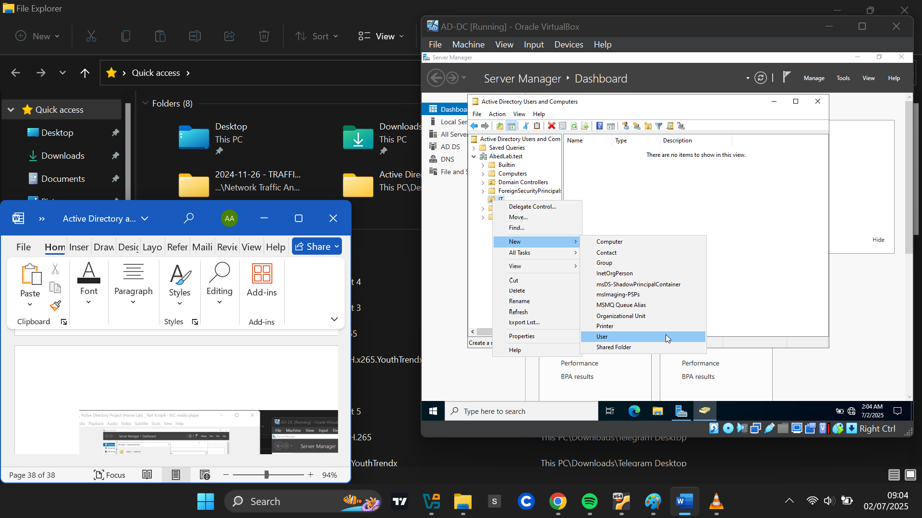

I entered user details:

First Name: *Abednego*, Last Name: *Achim*, Username: *AAchim*

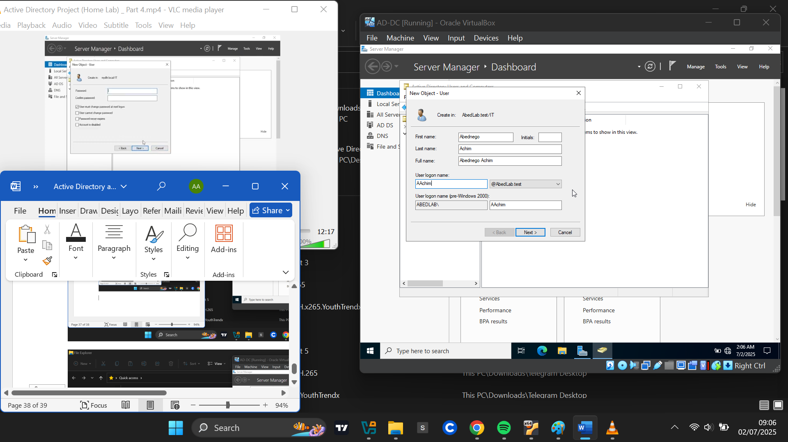

I assigned a password and unchecked **User must change password at next logon** (since this is a lab environment). Then I completed the user creation.

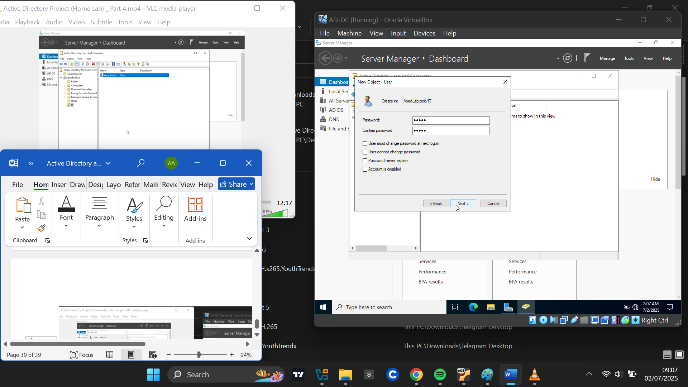

The user was successfully created in the IT department.

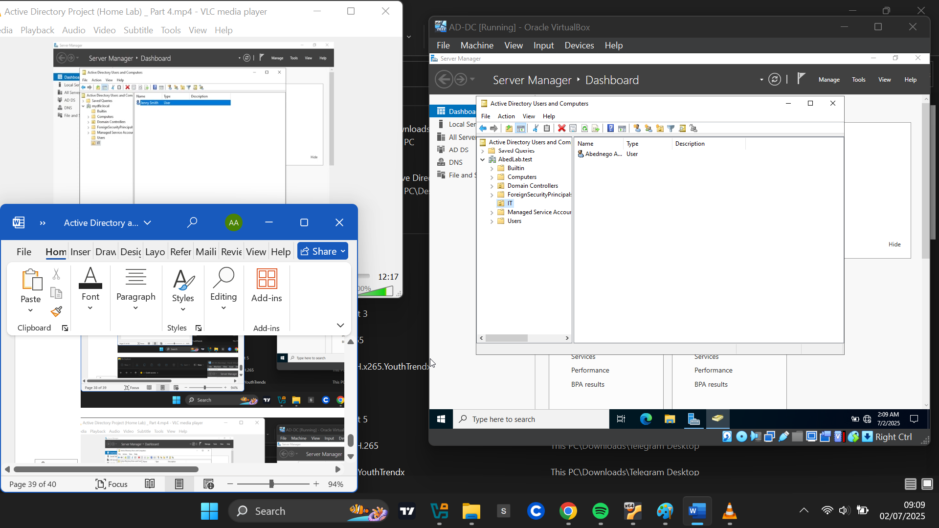

I created another Organizational Unit called HR using the same steps from above.

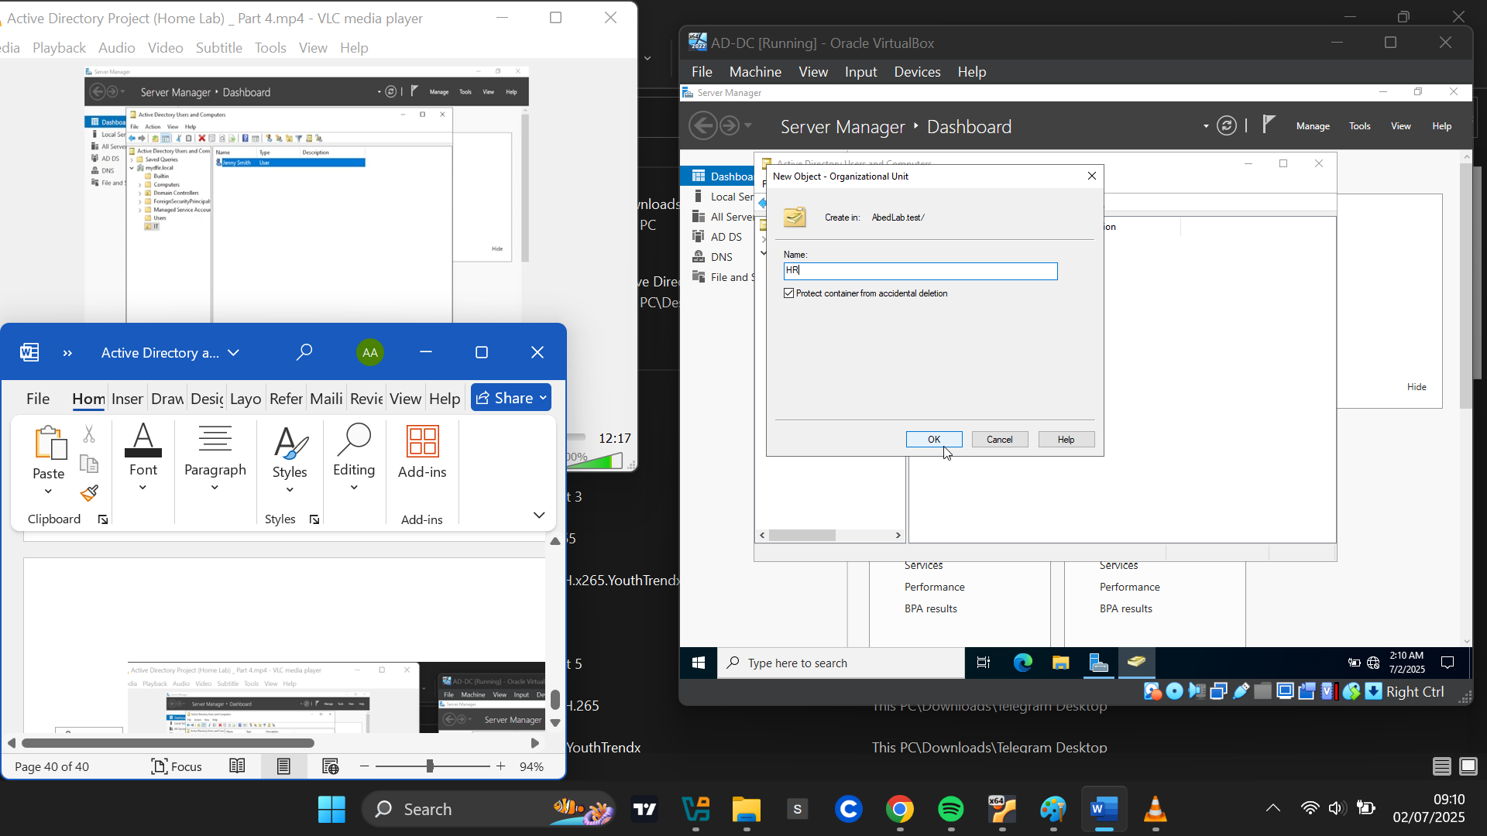

I entered user details for second user:

First Name: *Jonathan*, Last Name: *Bruce*, Username: *JBruce*

I assigned a password and finalized the setup.

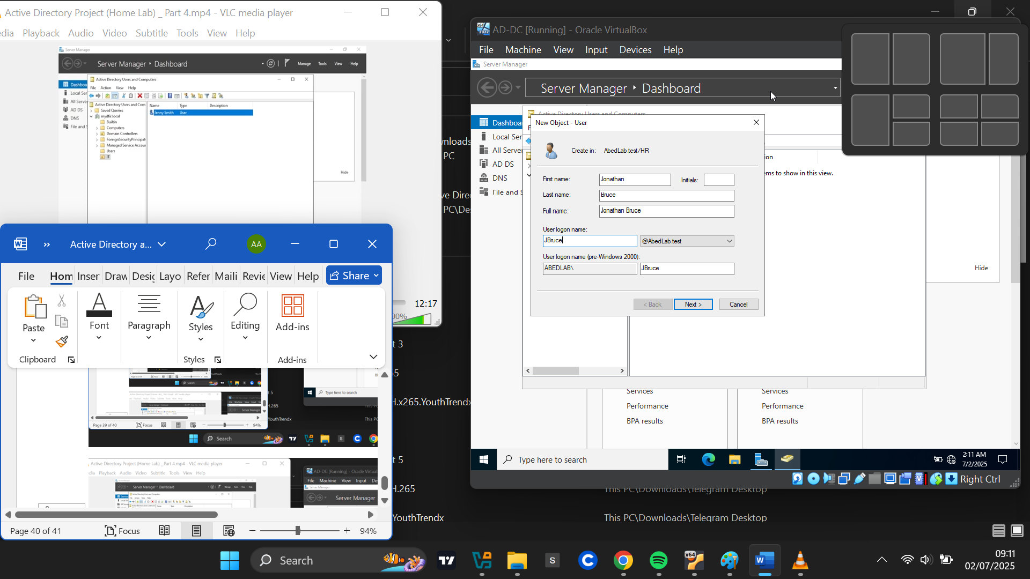

The second user was successfully created into the HR organizational Unit

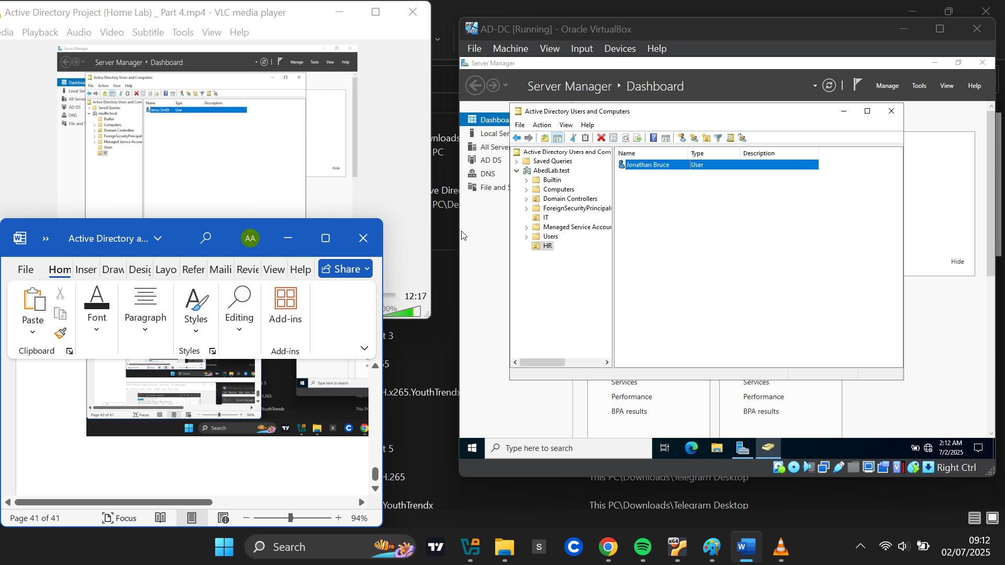

**Adding Windows Machine (TARGET-PC) to Domain**

Before joining the domain, I needed to update the DNS settings on the target machine. If the machine’s DNS is not set to the domain controller, it will return an error stating that an Active Directory domain controller for **AbedLab.test** could not be contacted.

**Steps to update DNS:**

* Opened **Network & Internet Settings** > **Change Adapter Options**
* Right-clicked on my network adapter > **Properties**
* Selected **IPv4** > **Properties**
* Changed the DNS server from Google DNS to the IP of the domain controller: **192.168.10.7**
* Applied the changes.

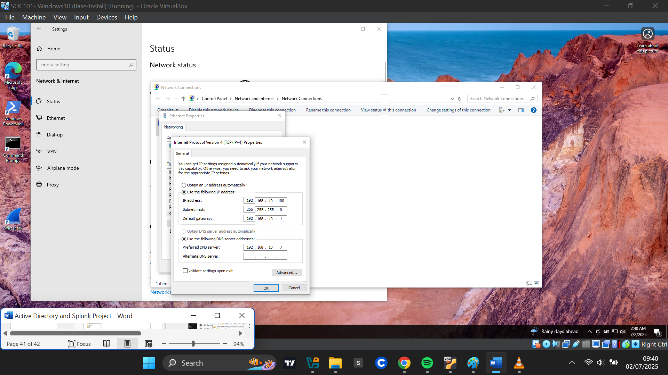

**Joining the domain:**

This PC>Properties>Advanced System Settings

* I opened **System Properties**: *Search PC > Properties > Advanced System Settings*
* Under the **Computer Name** tab, I clicked **Change**
* I selected **Domain**, and entered “AbedLab.test”

When prompted, I entered the administrator credentials for the domain controller

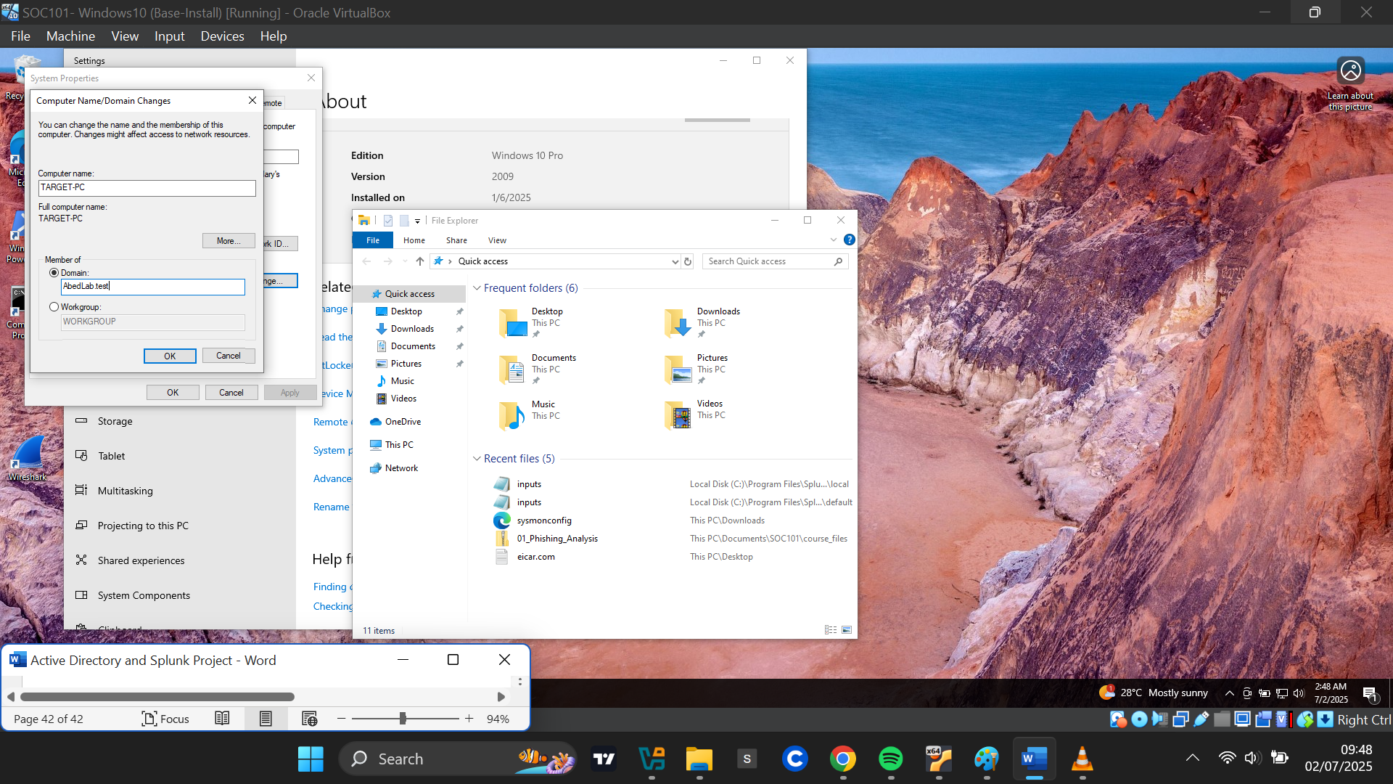

A pop-up message confirmed: **"Welcome to the AbedLab.test domain."**

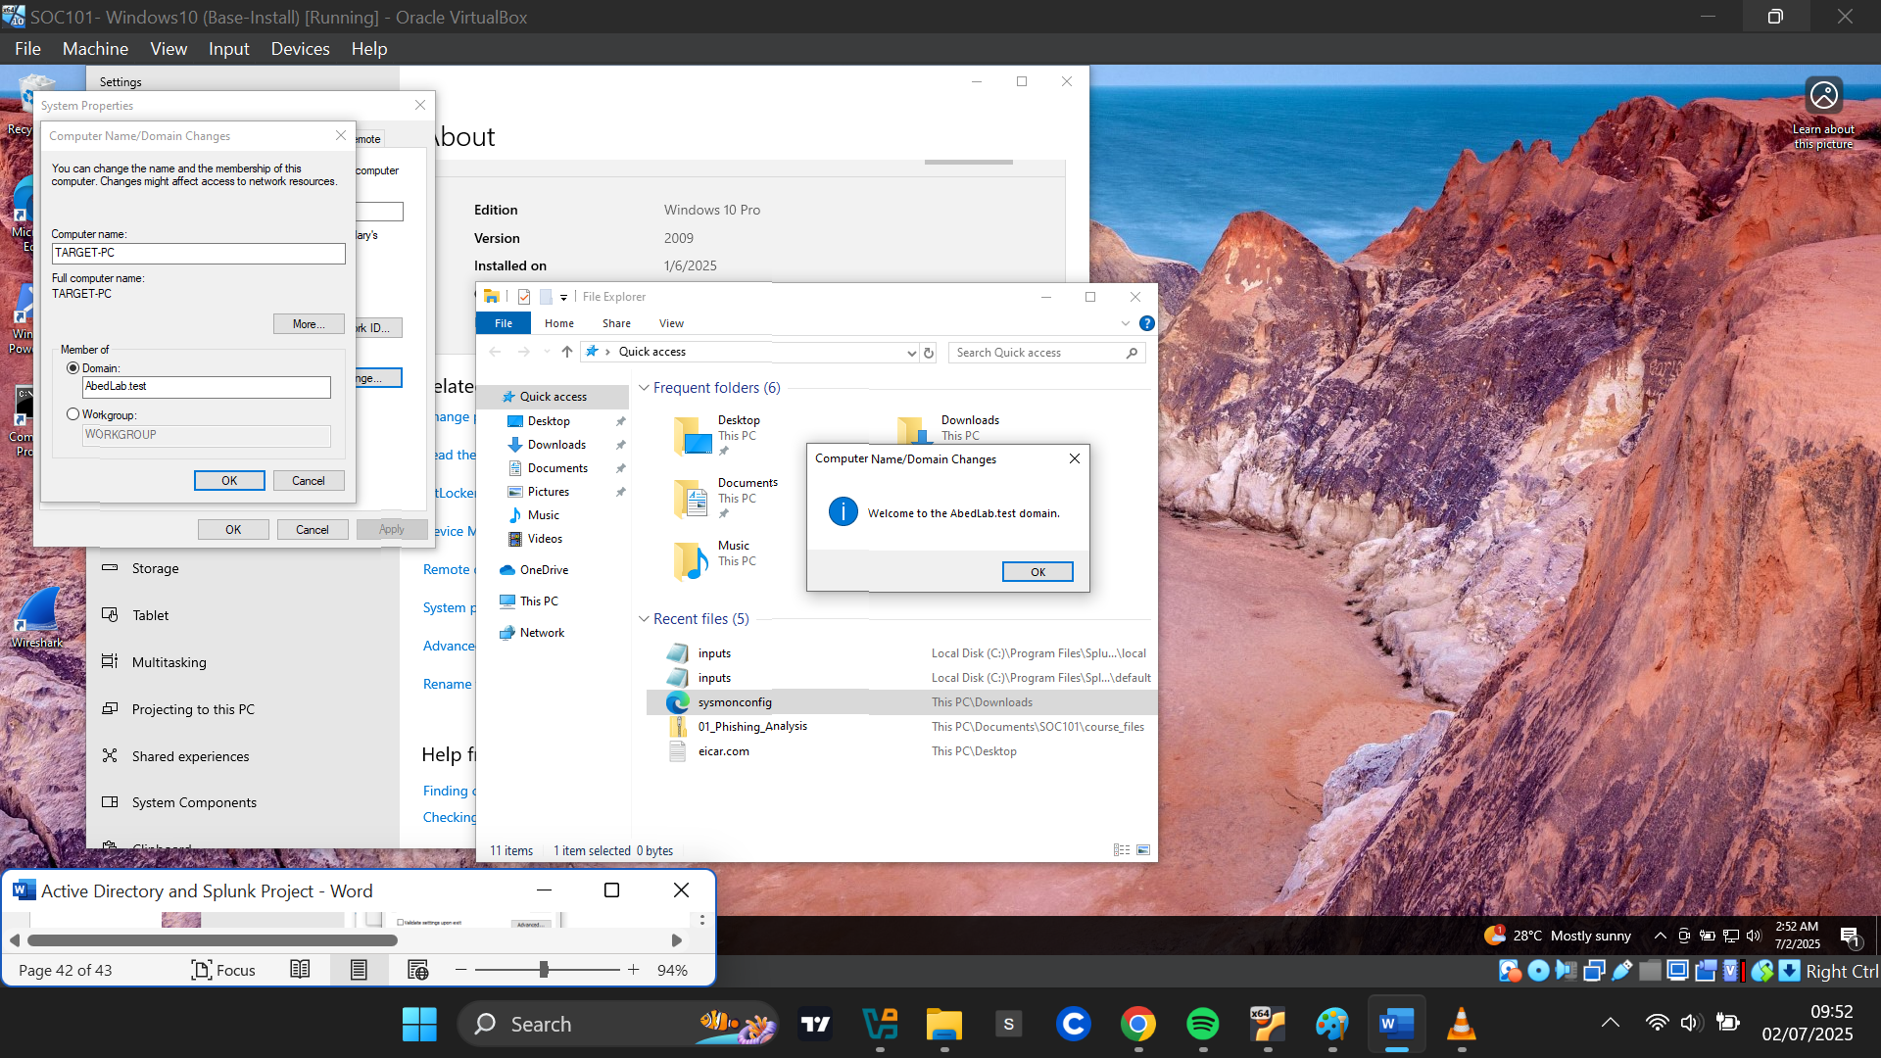

The computer then asked for a restart to make all changes take effect, and I confirmed the PC name changed to “ TARGET-PC.Abedlab.test”

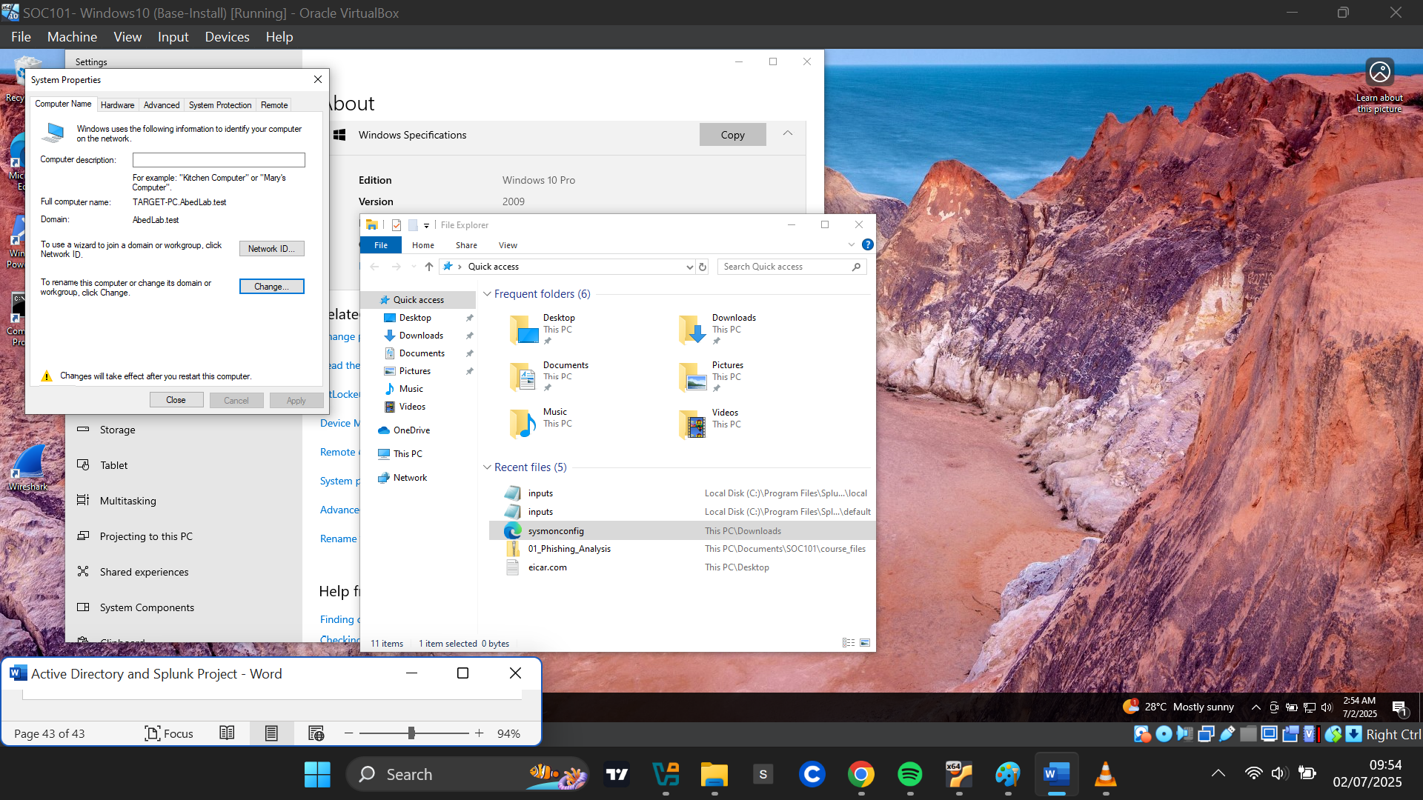

**Logging in with Domain User to Test**

At the login screen, I selected **Other User**. The sign-in prompt now showed **"Sign in to: ABEDLAB"**. I logged in using the credentials of the domain user **Abednego Achim**, confirming successful authentication to the domain.

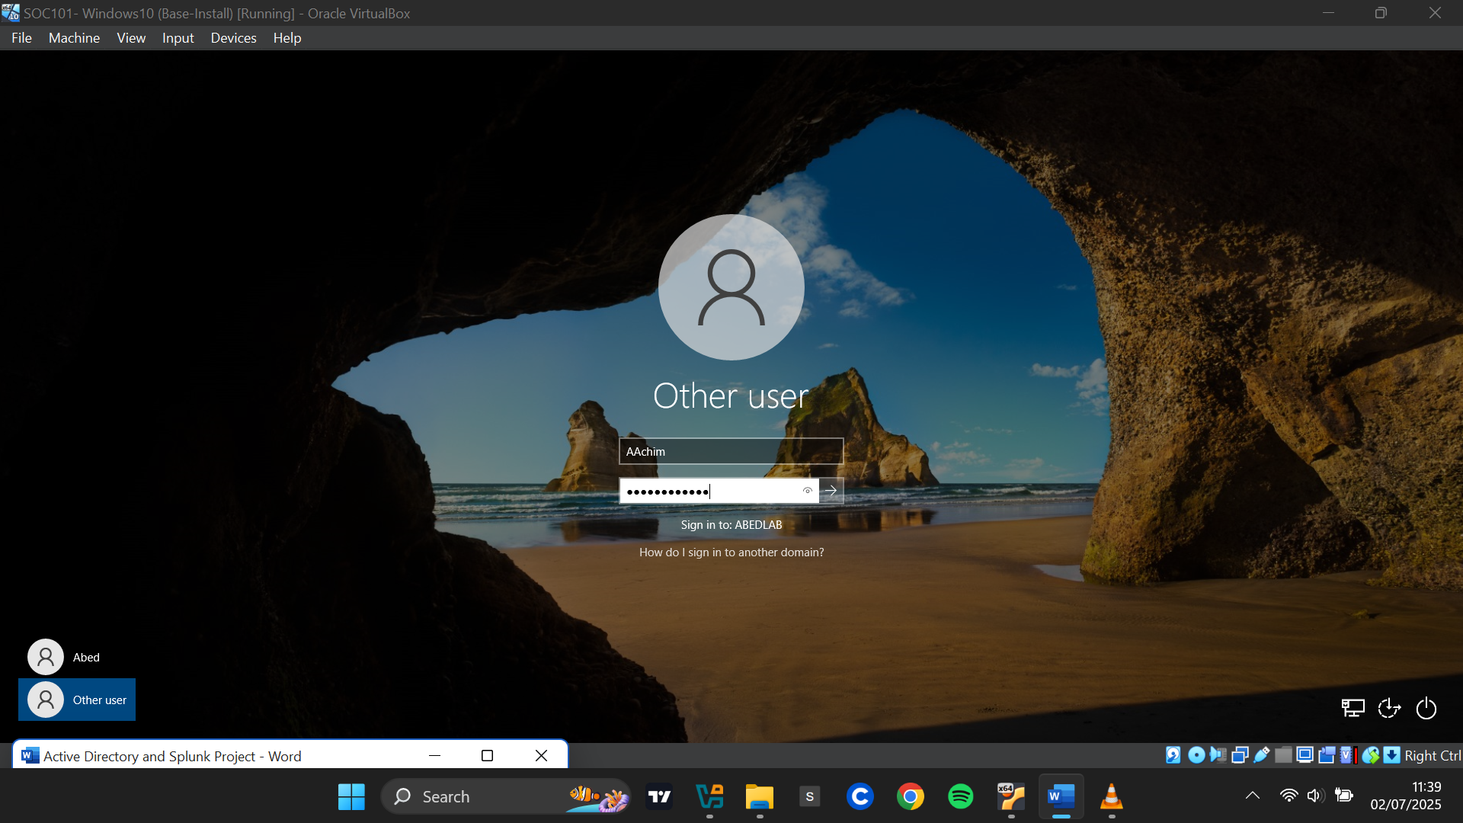

**Simulating Brute force Attack**

**Setting static IP address on Kali Linux**

Click ethernet icon on top right >Edit Connections>

To begin, I set a static IP address for the Kali Linux machine:

I clicked the **Ethernet** icon on the top-right corner > **Edit Connections.** I Selected the active connection (**Wired Connection 1**) and clicked the **gear icon** to edit. Under the **IPv4 Settings** tab, changed the method from **Automatic (DHCP)** to **Manual**. I clicked **Add** and entered the following:

* + IP Address: 192.168.10.250
  + Gateway: 192.168.10.1
  + DNS Server: 8.8.8.8

Then I saved the settings.

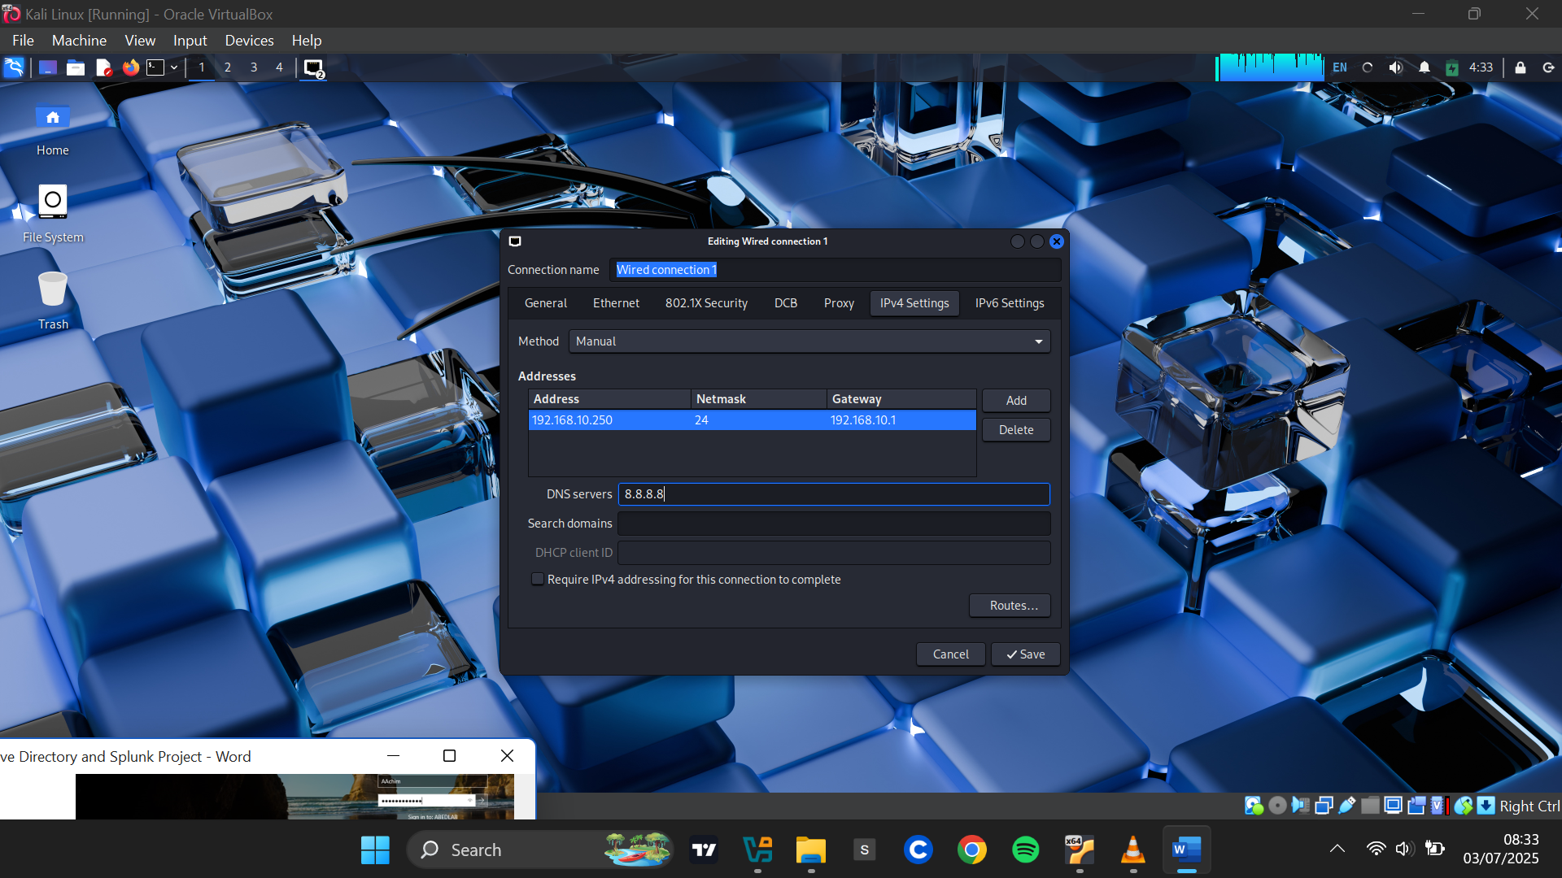

To confirm the change, I disabled and re-enabled the Ethernet adapter. The IP address was correctly set to **192.168.10.250.**

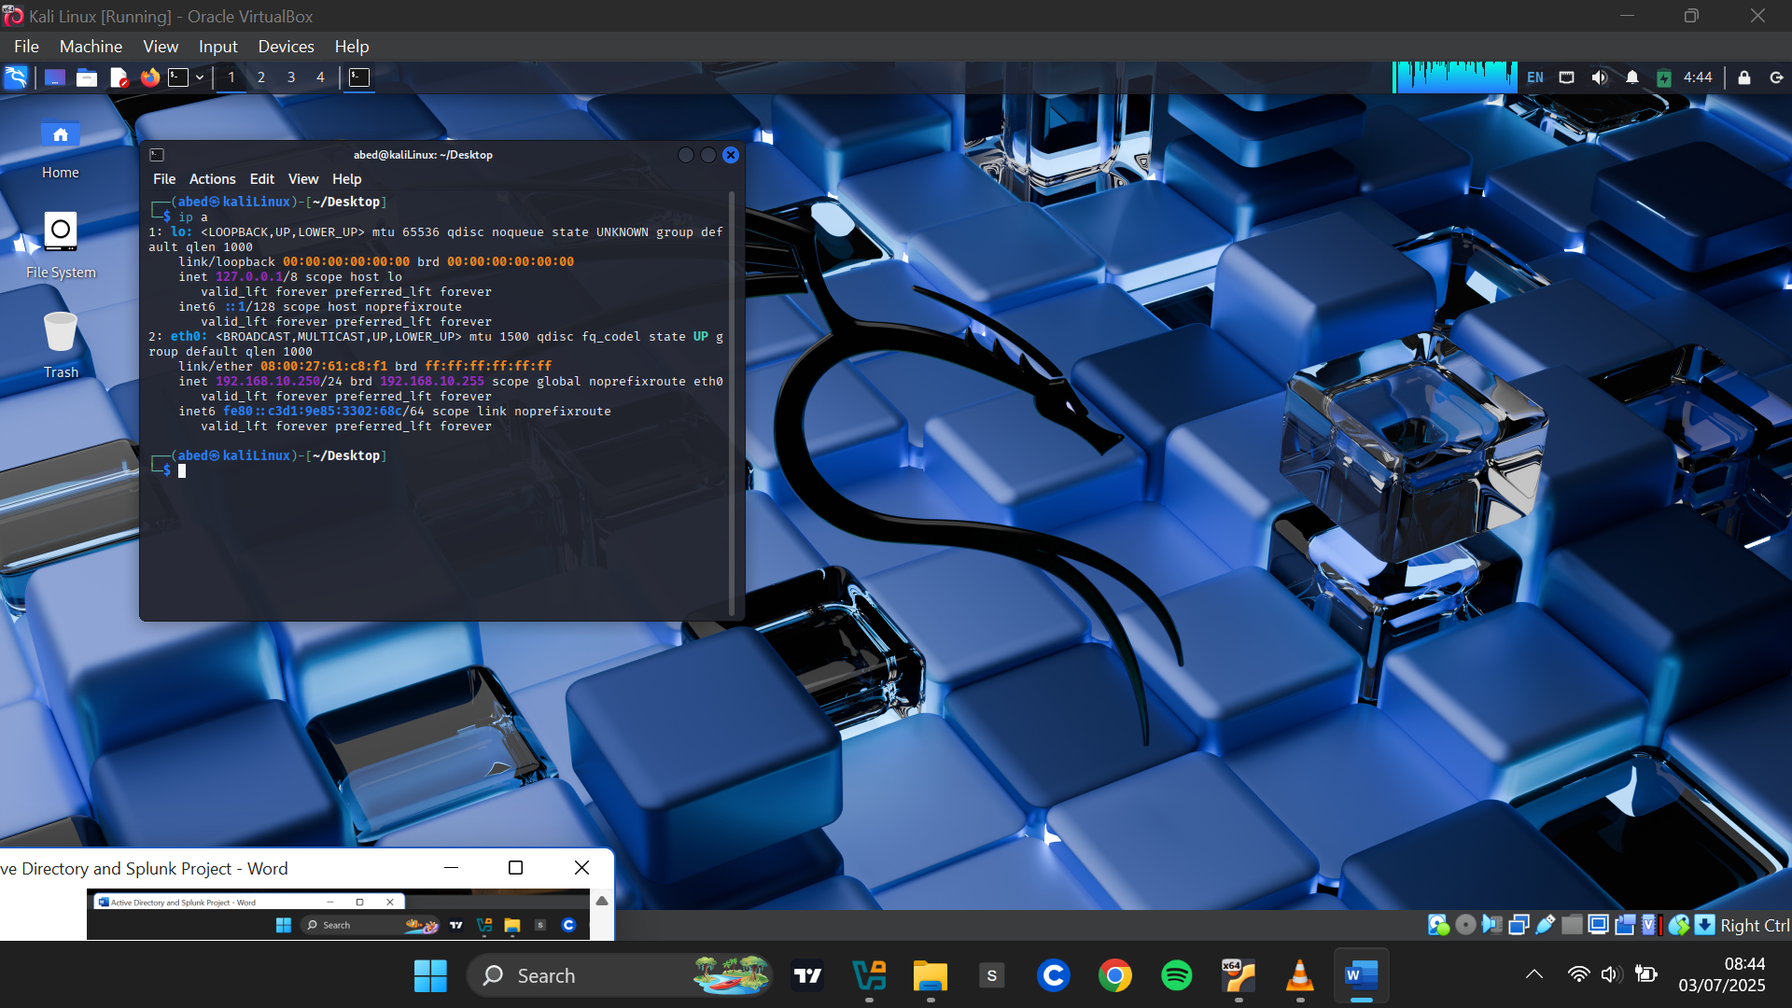

**Creating a New Directory**

I created a directory named ad-project to store all files and tools related to the brute-force attack.

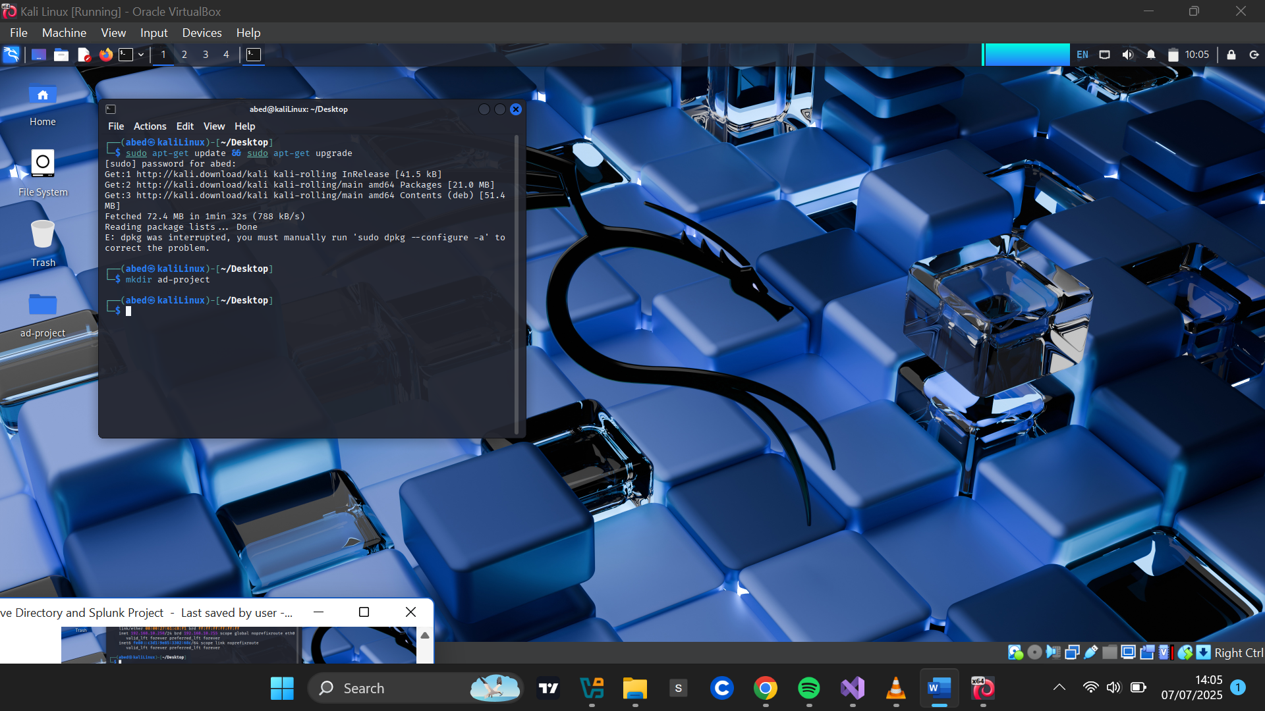

**Installing the Brute-Force Tool**

I installed **Hydra**, a fast and flexible network login cracker used to perform brute-force attacks on various protocols including RDP, SSH, FTP, and HTTP.

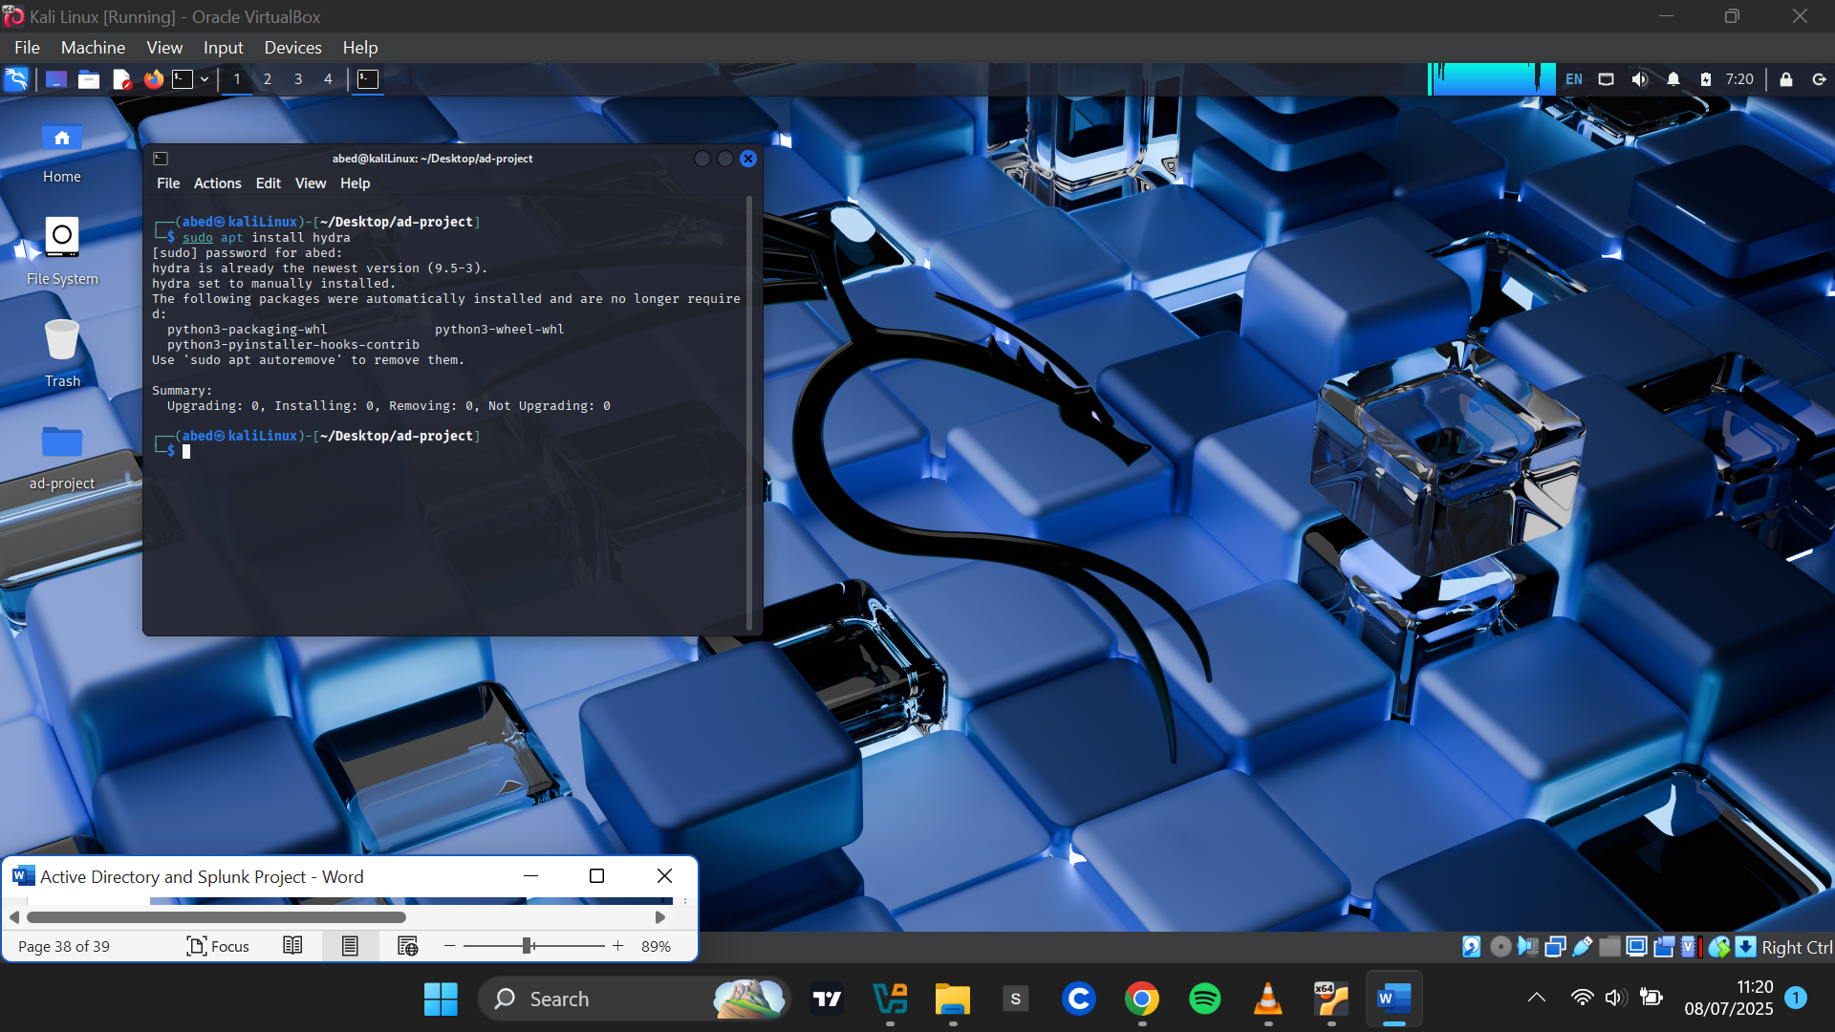

**Crafting a Wordlist for the Attack**

The brute-force tool required a wordlist. I used the popular rockyou.txt, which is preinstalled with Kali Linux.

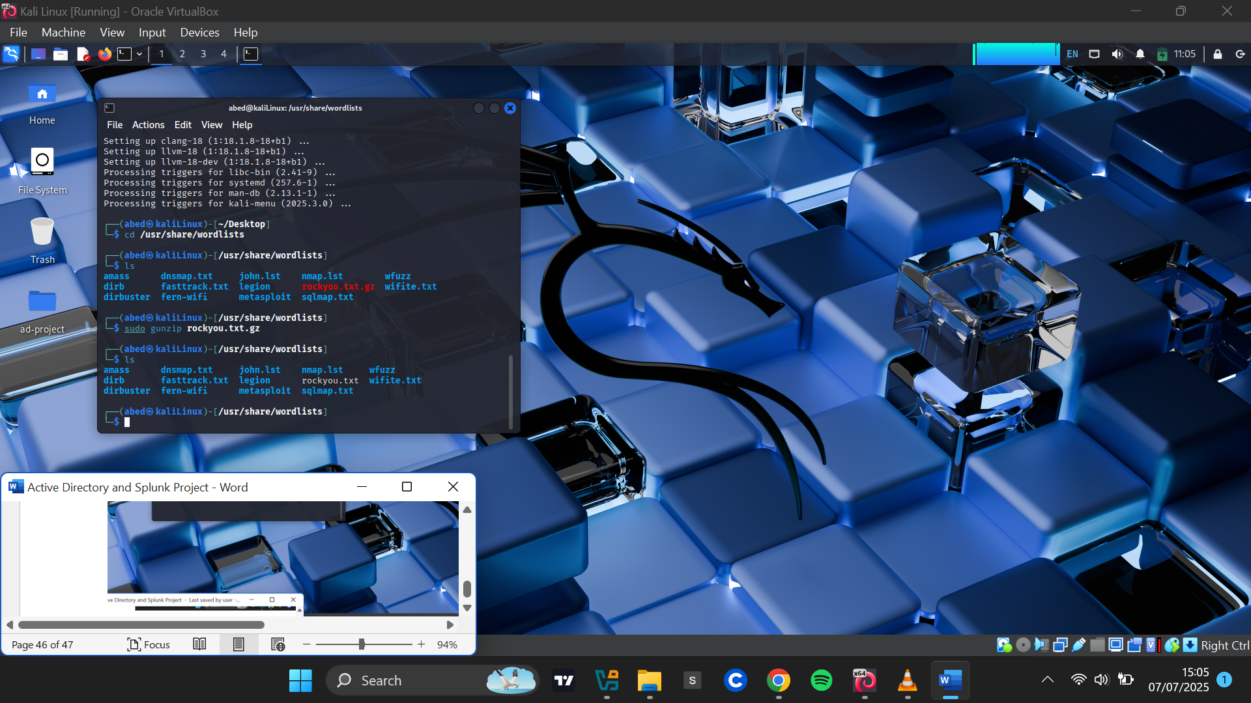

I extracted the file and moved it into the ad-project directory

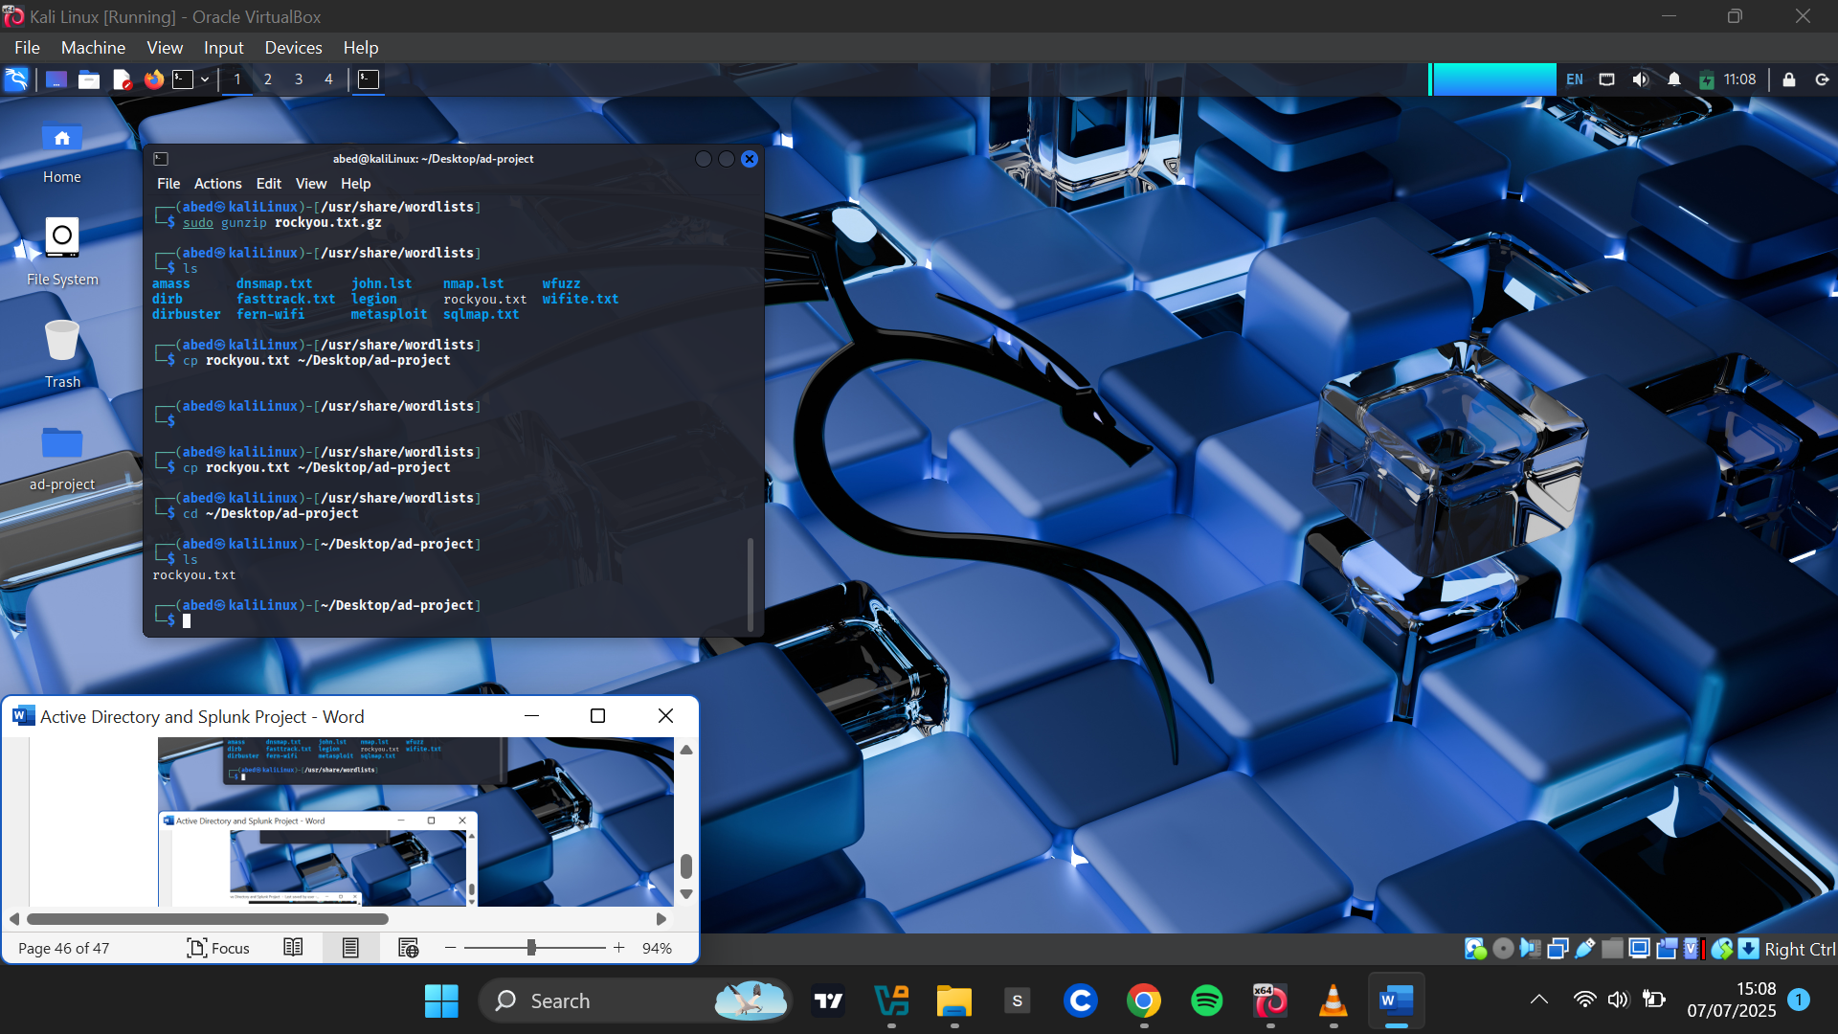

Since rockyou.txt is over 130MB and contains thousands of passwords, I used only the first 20 lines for the purpose of this project and saved them into a new file named passwords.txt.

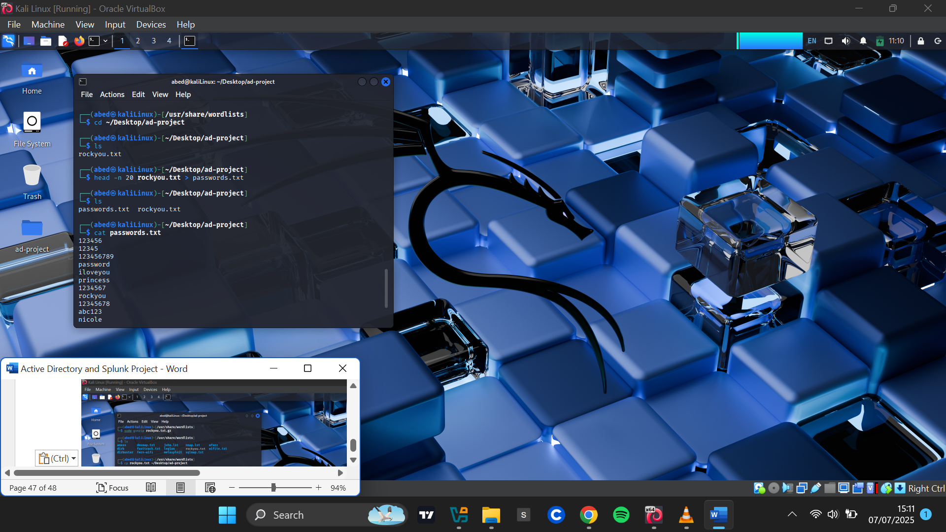

I then edited passwords.txt to include the actual password of the domain user I intended to compromise, ensuring the brute-force attack would eventually succeed.

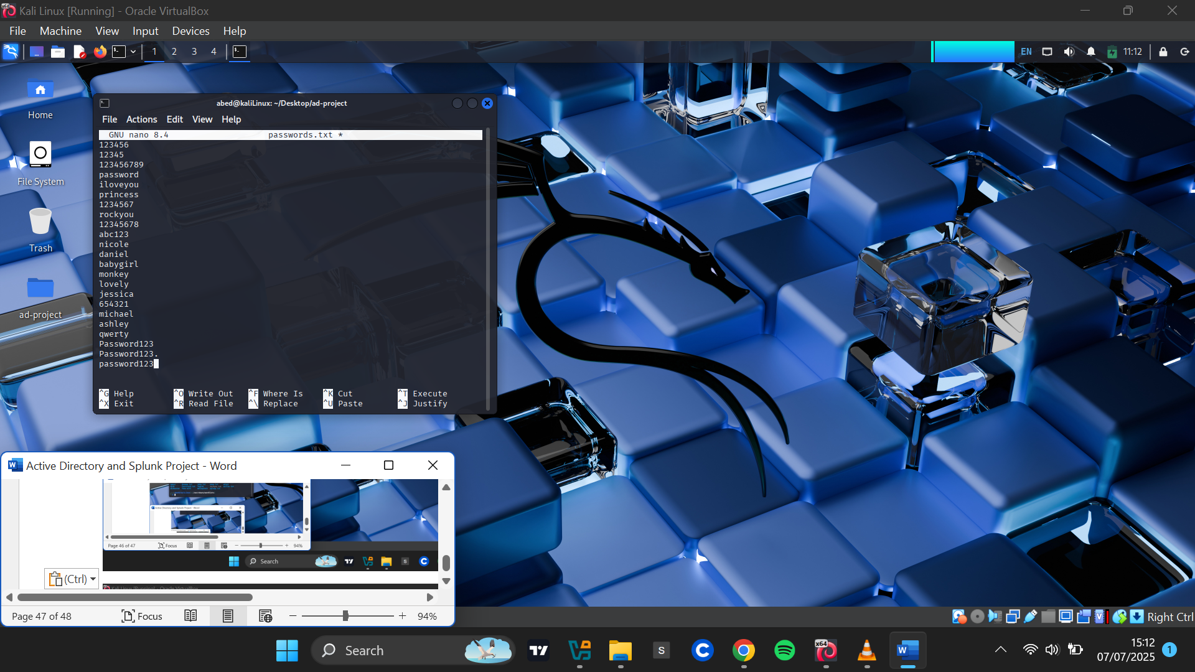

I confirmed that the correct password was present in the file.

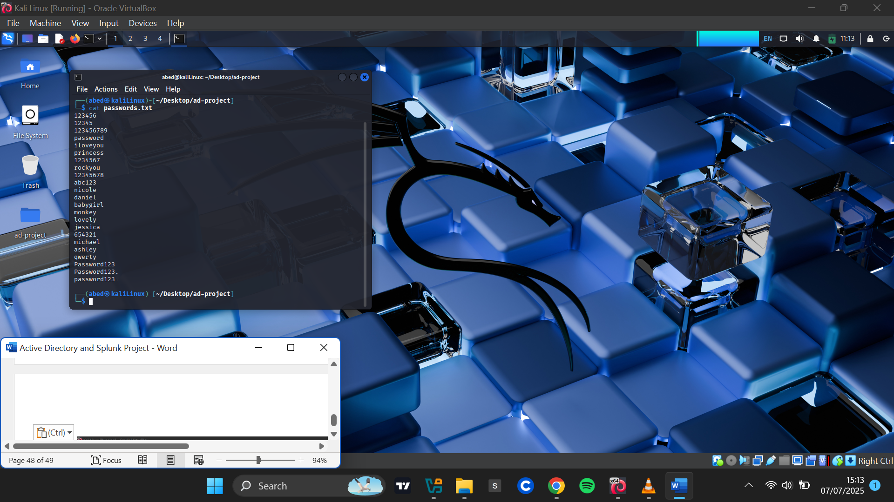

**Enabling Remote Desktop on the Target Machine**

Before launching the attack, I enabled Remote Desktop Protocol (RDP) on the Windows target machine

This PC>Properties>Advanced System Settings

I Navigated to **This PC > Properties > Advanced System Settings** I provided the administrator credentials when prompted. In the **System Properties** window,I opened the **Remote** tab then checked **Allow remote connections to this computer.**

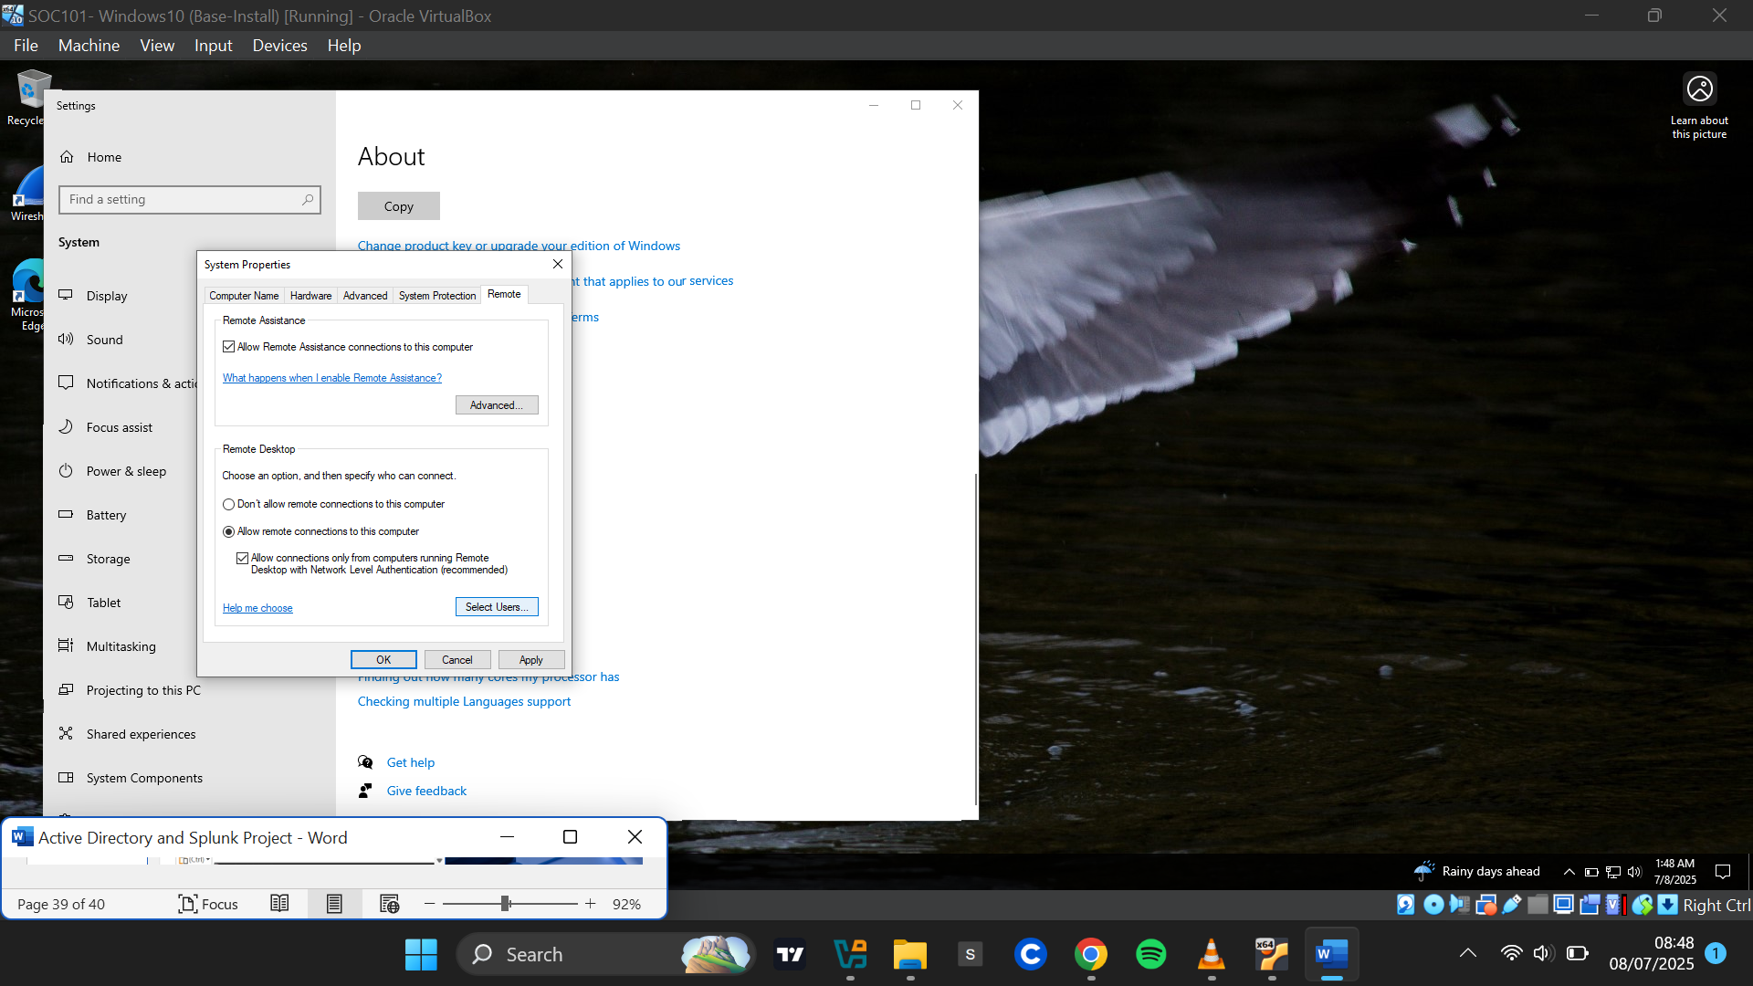

I clicked **Select Users** > **Add**, and entered the two user accounts: Abednego Achim and Jonathan Bruce.I clicked **OK**, then **Apply** to confirm the changes.

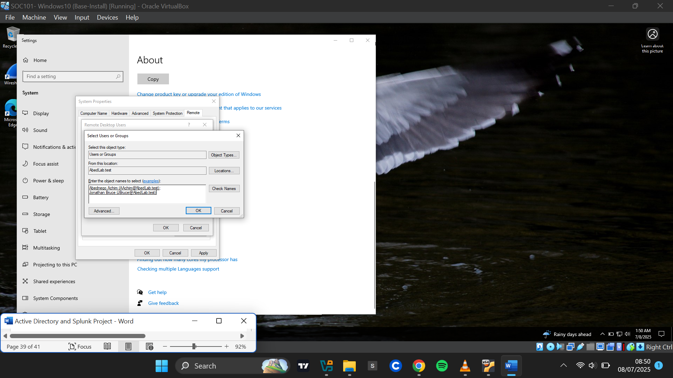

**Initiating the Attack**

On Kali Linux, I initiated the brute-force attack against user **AAchim**, using the passwords.txt wordlist and targeting the RDP protocol.

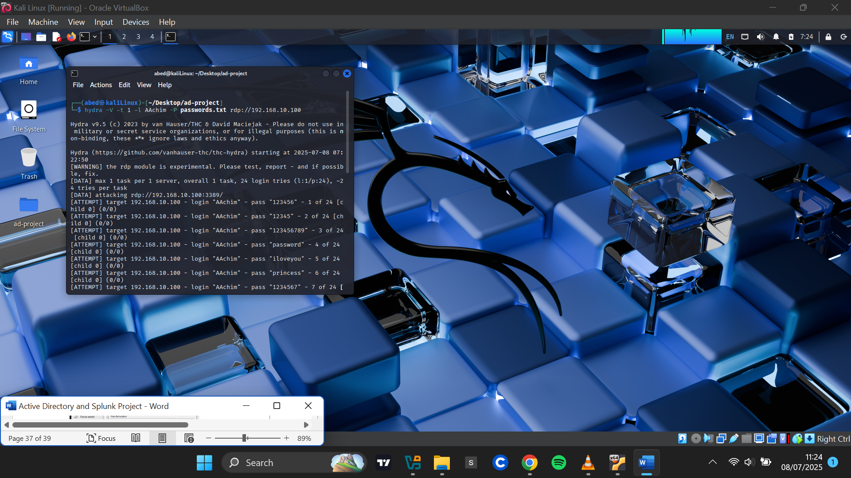

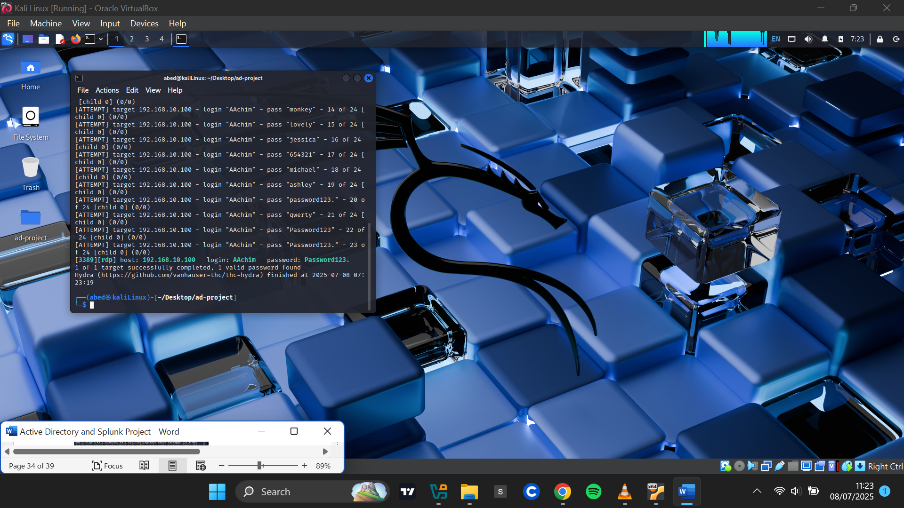

**Logging in Remotely with the Discovered Password**

After Hydra successfully discovered the correct password, I used **FreeRDP** to remotely log into the TARGET-PC. FreeRDP is a command-line client for accessing remote desktops over RDP.

I used the following command:

[ xfreerdp /u:AAchim /p:'Password123.' /v:192.168.10.100 ]

This successfully established a remote session with the target machine.

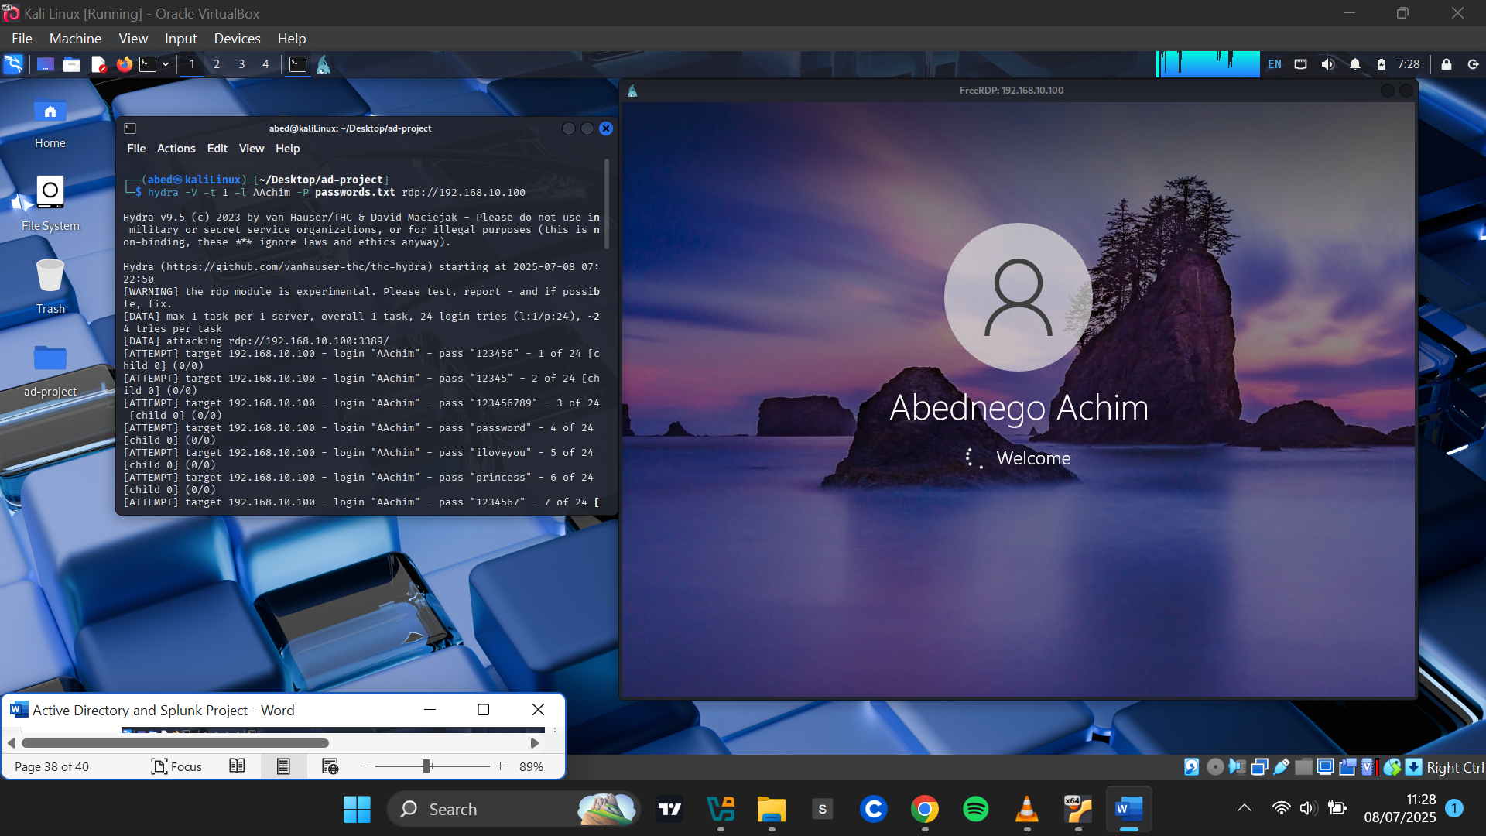

**Investigating Attack Logs in Splunk**

**Accessing Splunk**

In the Splunk web interface, I navigated to **Apps > Search & Reporting**. I queried the endpoint index, filtered by the user **AAchim**, and selected a **24-hour time range**.

*(Note: I used 24 hours due to host performance issues that delayed immediate access to Splunk after the attack. Under normal conditions, a 15-minute range would have been ideal.)*

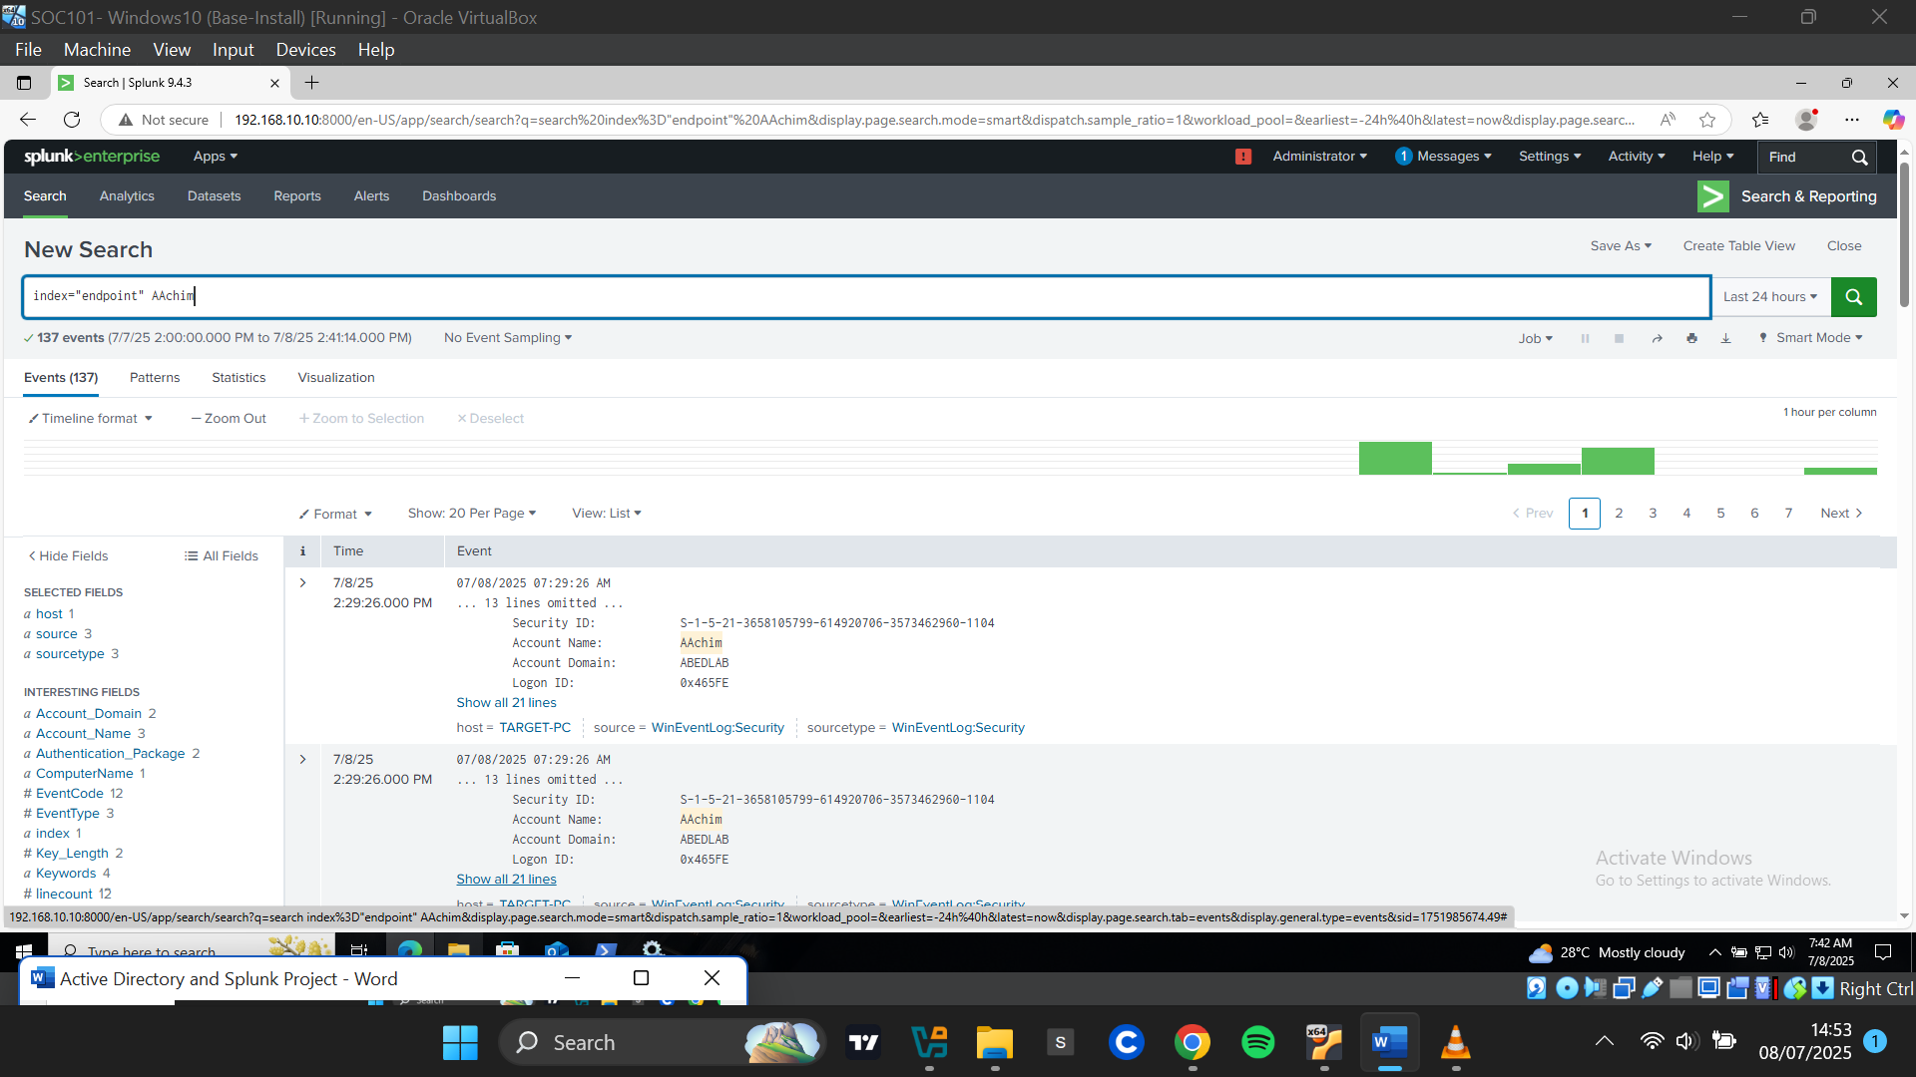

A variety of events were returned. Under **"Interesting Fields"**, I examined the EventCode field and identified several relevant Windows event IDs:

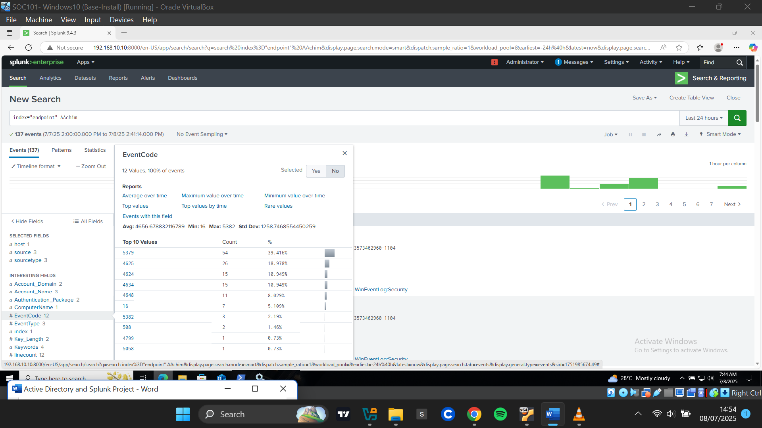

**Event ID 5379** (54 counts) - Credential Manager credentials were accessed. Likely triggered by repeated RDP logins using xfreerdp after Hydra successfully brute-forced the account however ,this event may also occur during normal logons when Windows retrieves stored credentials.

**Event ID 4625**(26 counts) - Failed logon attempts. Indicates 26 failed attempts to log in to the **AAchim** account.

**Event ID 4624** (14 counts) - Successful logons.

**Event ID 4634 -** Logoff events, indicating terminated logon sessions.

**Event ID 4648 (11 counts)** - logon attempt using explicit credentials. This is logged when a user or process manually specifies credentials (username and password) instead of using cached or inherited ones. It's common during RDP connections, Scheduled tasks, Remote logins via scripts or tools.

**Analyzing Failed Logons (Event ID 4625)**

Event ID **4625** was particularly suspicious. I clicked it to update the query. One interesting thing I spotted was that all these events happened at the same time at 11:23 AM, seconds apart. This was a clear indication of brute force activity.

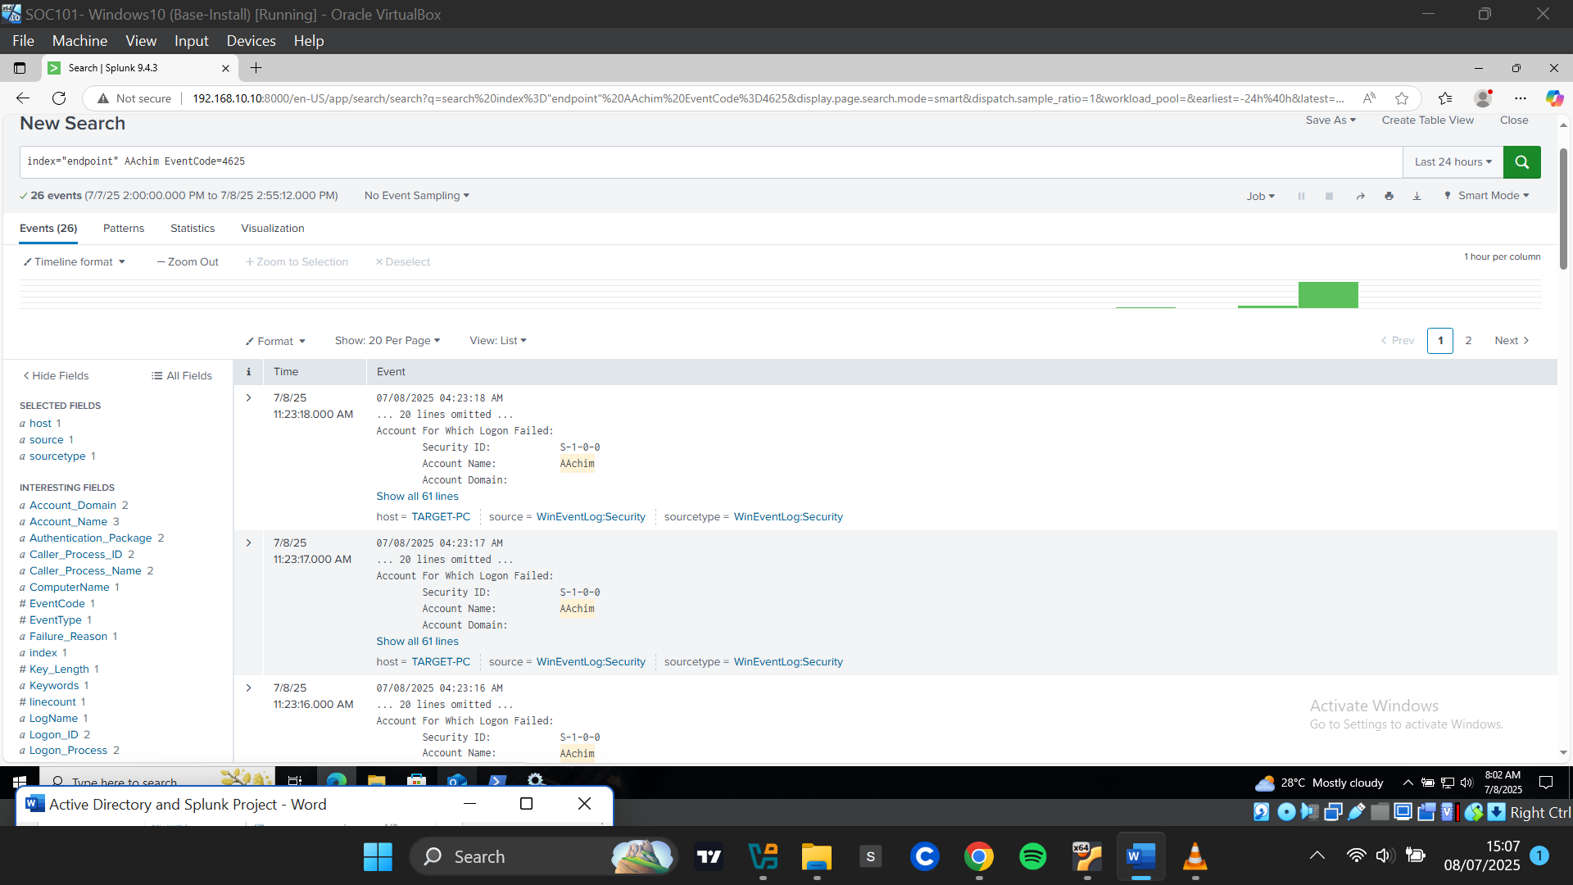

Upon examining the details of the failed logon events, the key details from the logs:

* **Logon Type: 3** – Indicates a network-based logon rather than a local session
* **Workstation Name:** KaliLinux
* **Source IP:** 192.168.10.250

All events within this timeframe shared the same details, confirming the brute-force attempt originated from the attacker machine.

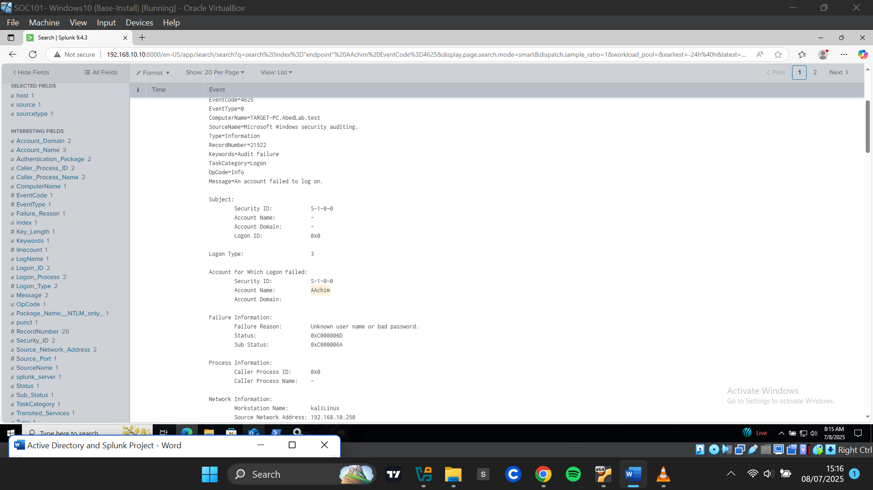

**Confirming Successful Logon (Event ID 4624)**

I filtered for Event ID 4624 to check if the attacker successfully logged in. Among 15 logon events, I focused on those that occurred during the brute-force window.

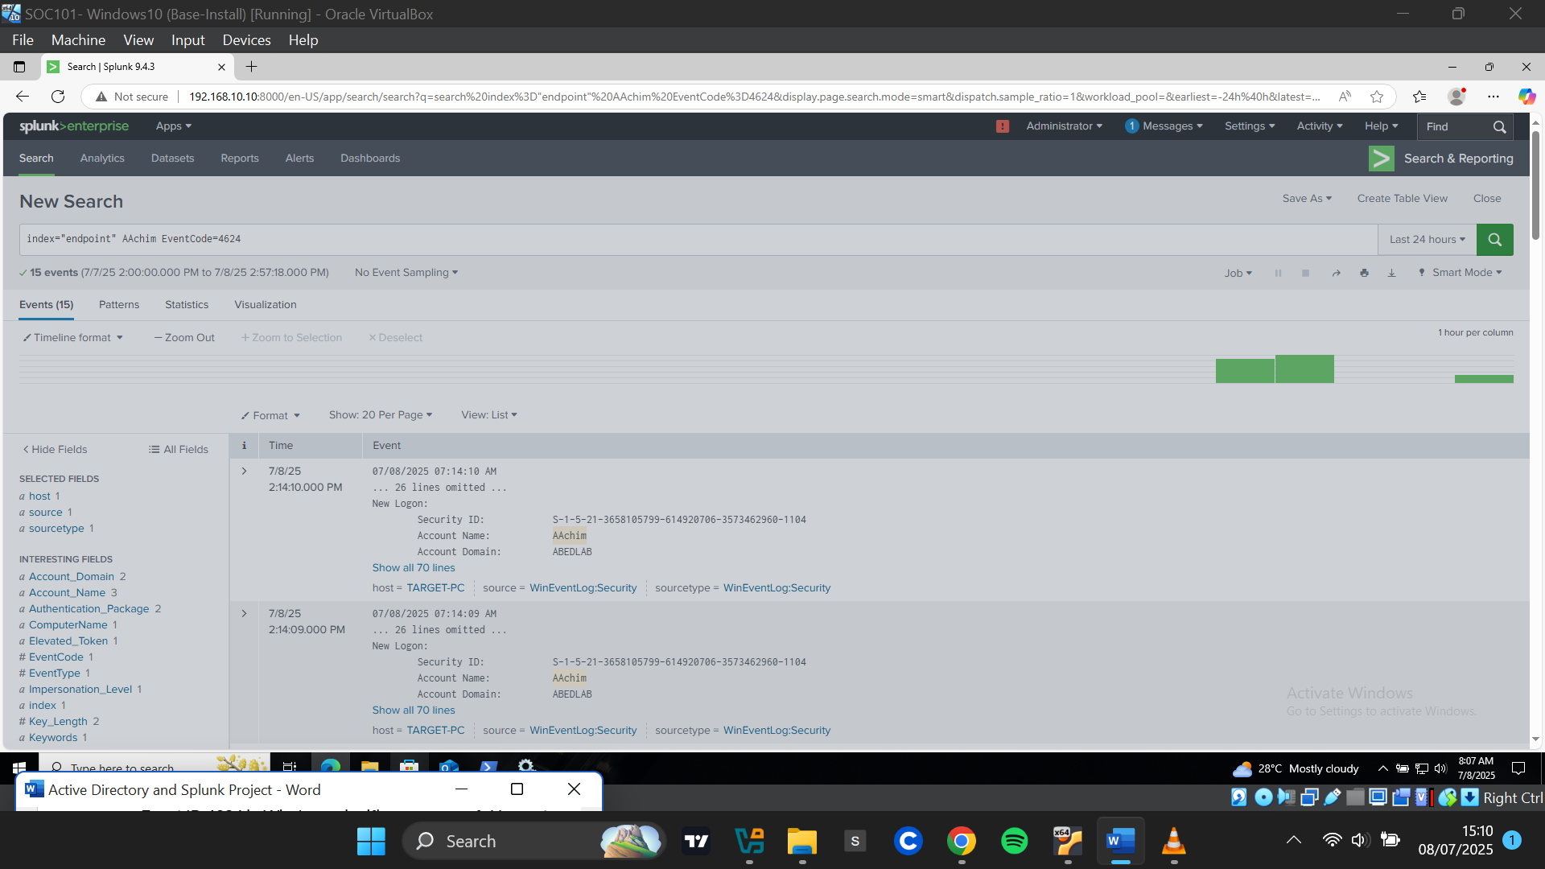

I clicked to see the details of a successful logon attempt that happened in the attack timeframe. Details from one of the successful logon events:

* **Workstation Name:** KaliLinux
* **Source IP:** 192.168.10.250
* **Logon Type: 3** – Network-based
* **Logon Process: NTLMSSP** – Indicates NTLM protocol was used, common when Kerberos is unavailable, such as in remote logins from non-domain machines or brute-force tools

This confirmed that a successful unauthorized login had occurred during the attack from the suspected attacker “**KaliLinux**” with IP address **192.168.10.250.**

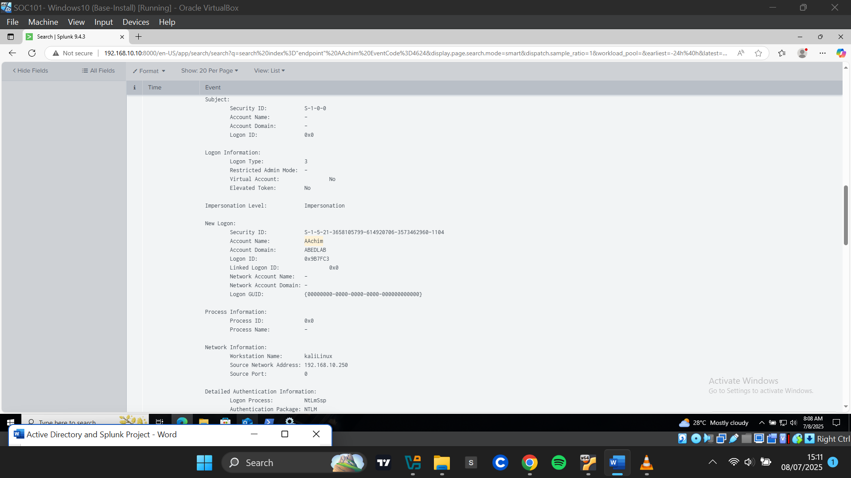

**Reviewing Explicit Credential Use (Event ID 4648)**

I investigated **Event ID 4648**, which indicated that the attacker explicitly specified the account **AAchim** under the domain **ABEDLAB**. The event originated from the attacker’s IP 192.168.10.250, confirming use of stolen credentials.

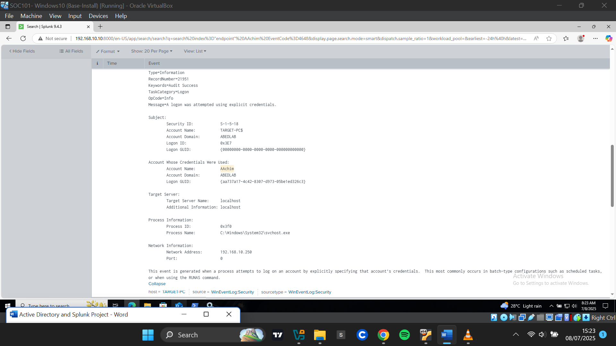

**Visualizing Brute-Force Activity in Dashboards**

**Creating Dashboard**

Apps > Search & Reporting

From **Apps > Search & Reporting**, I clicked **Dashboards** on the menu bar.

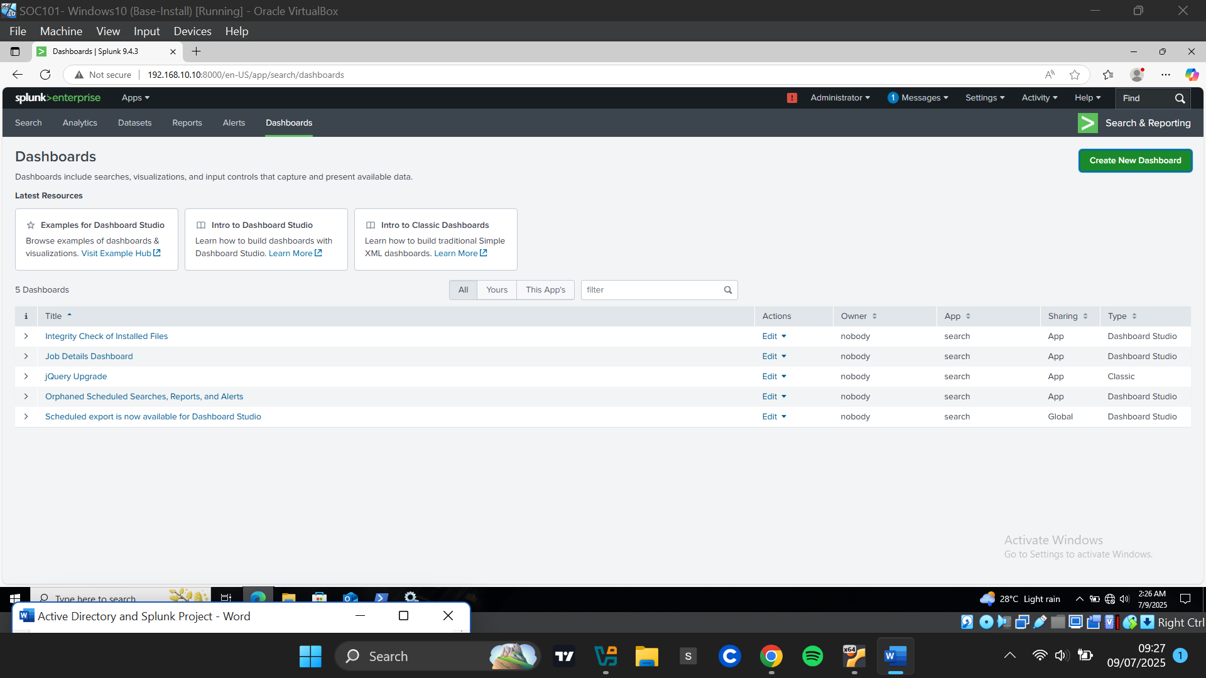

On the dashboards page. I clicked **Create New Dashboard button** at the top right corner. I provided the Dashboard Titleand a description. I Selected **Dashboard Studio** and chose a **Grid Layout** and clicked Create**.**

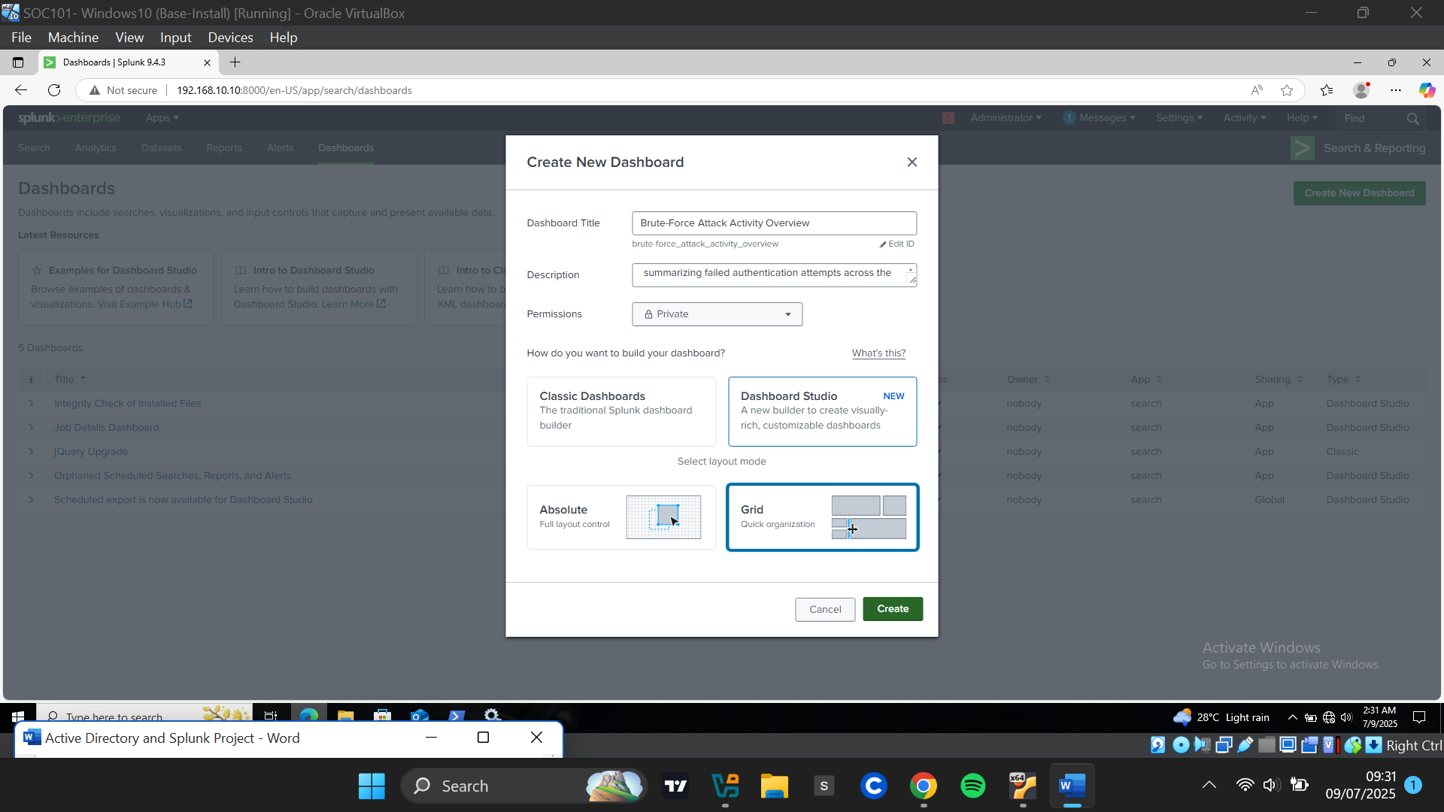

**Panel 1: Failed Logon Attempts Over Time**

I proceeded to add my first panel which was a time chart of Failed logons. I clicked on the “Add Charts” icon and selected “Line”

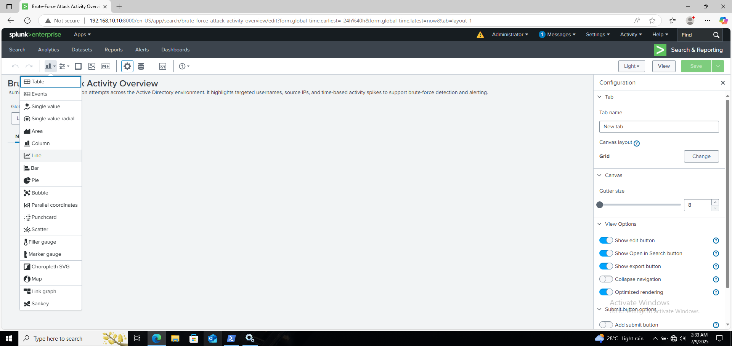

I highlighted the panel and added a search in the **Data Source** section. The SPL query used:

*Index=endpoint EventCode=4625*

*| timechart span=5m count by src_ip limit=10*

(Groups failed logon events into 5-minute intervals, counts per source ip, and limits to top 10 IPs.) I clicked **Apply and Close.**

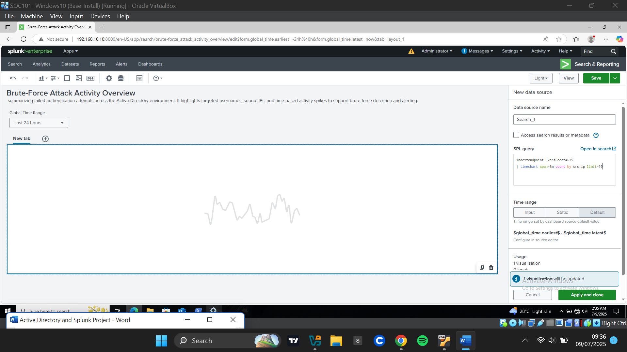

The time chart was populated and I highlighted the panel to include the panel title in the configuration’s menu at the right side. I renamed the panel to **"Failed Logon Attempts Over Time"** and Saved changes.

.

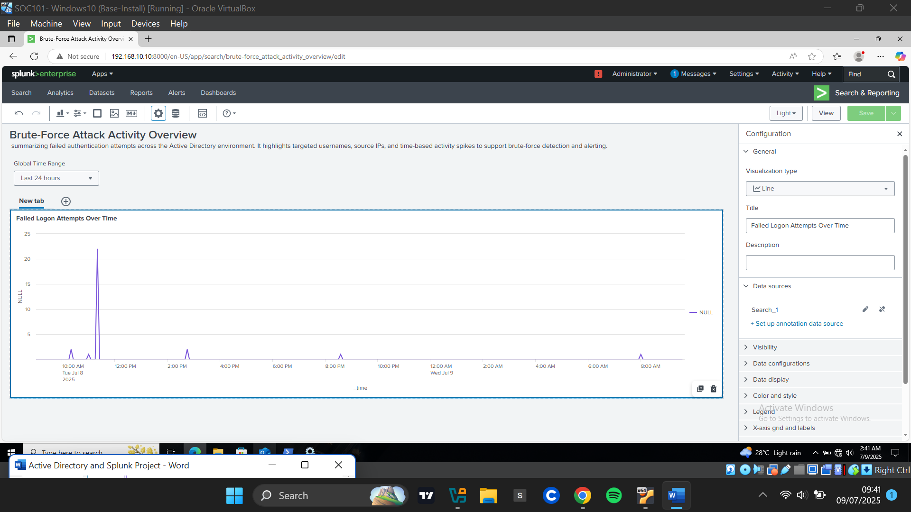

This panel visualized which IP addresses were generating the most failed login attempts over time, helping detect brute-force behavior.



**Panel 2: Top Targeted Usernames**

The second Panel was a bar chart of targeted Usernames. I clicked on the “Add Chart” and selected Bar Chart. I added a new SPL query into the search bar:

*Index=endpoint EventCode=4625*

*| top Account_Name limit =10*

(returns the top 10 most targeted usernames, showing count and percentage). I clicked “Apply and Close” to create the panel.

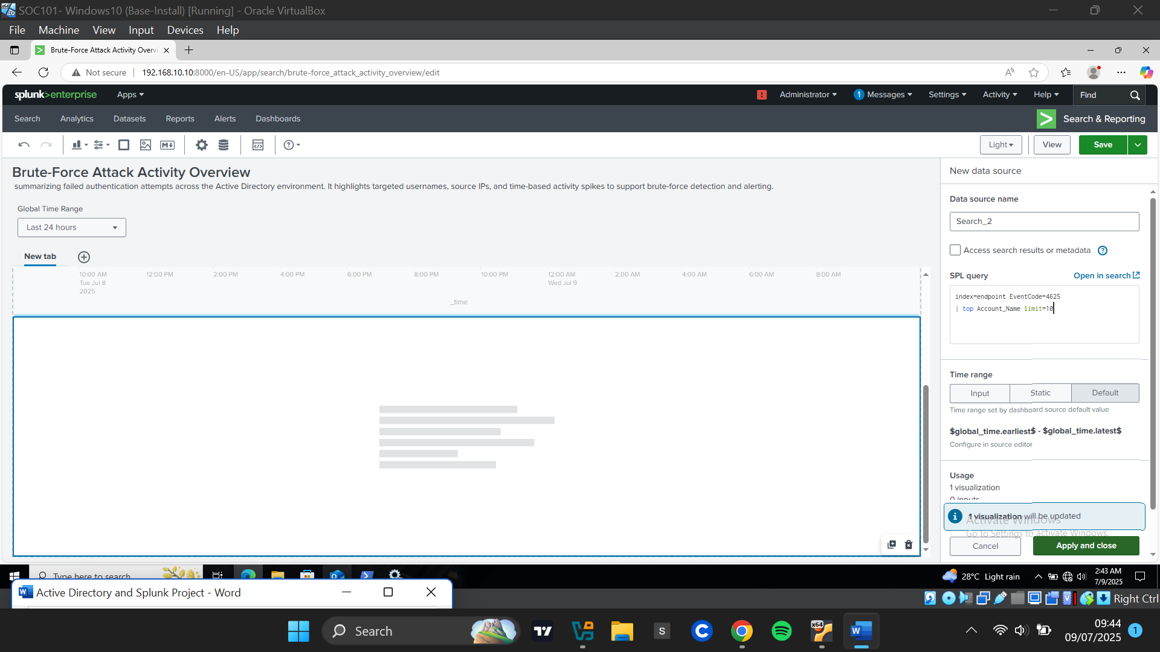

The bar chart was populated and I renamed the panel “Top Targeted Usernames”. I clicked save to apply the changes.

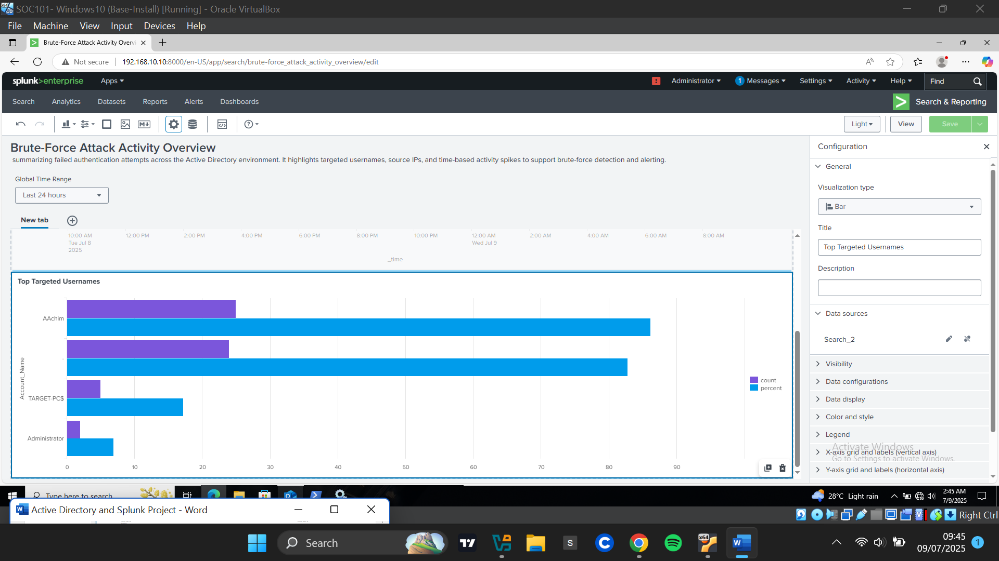

This panel helped identify the most frequently targeted accounts.



**Panel 3: Top Source Ips**

The third Panel was a bar chart of Top Source IPs. I clicked on the “Add Chart” icon and selected Bar Chart.

I highlighted the panel and added a new search in the New Data source Menu. I entered the SPL query into the search bar:

*Index=endpoint EventCode=4625*

*| top Source_Network_Address limit=10*

(Lists the top 10 source IPs generating failed logons with count and percentage). I clicked “Apply and Close” to create the panel.

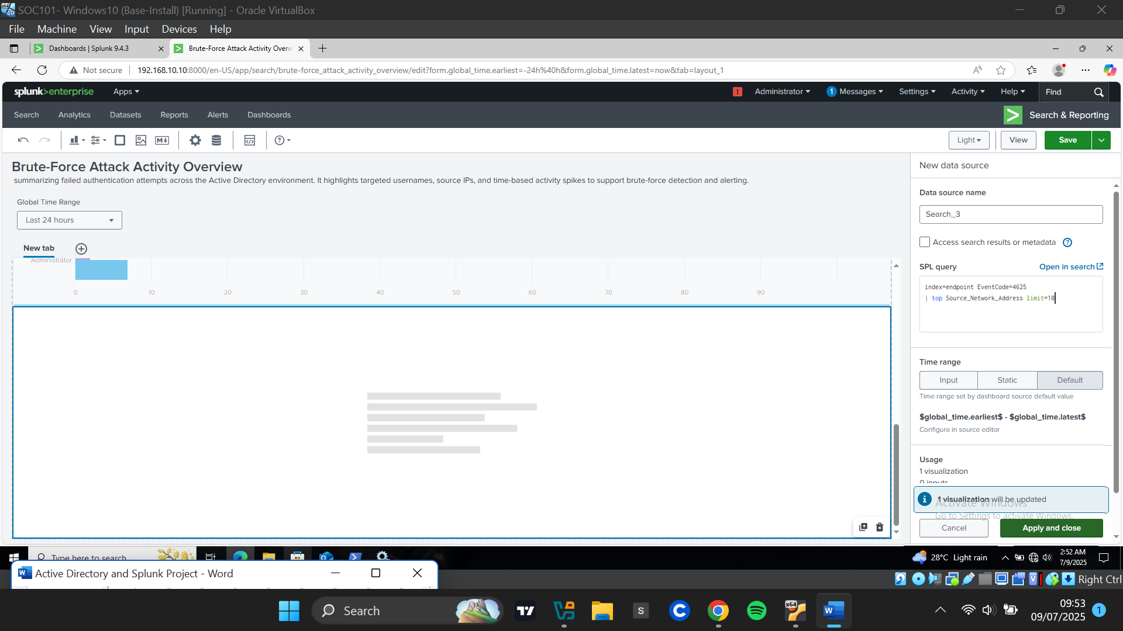

The bar chart was populated and I renamed the panel to **"Top Source IPs"**. I clicked save to apply the changes.

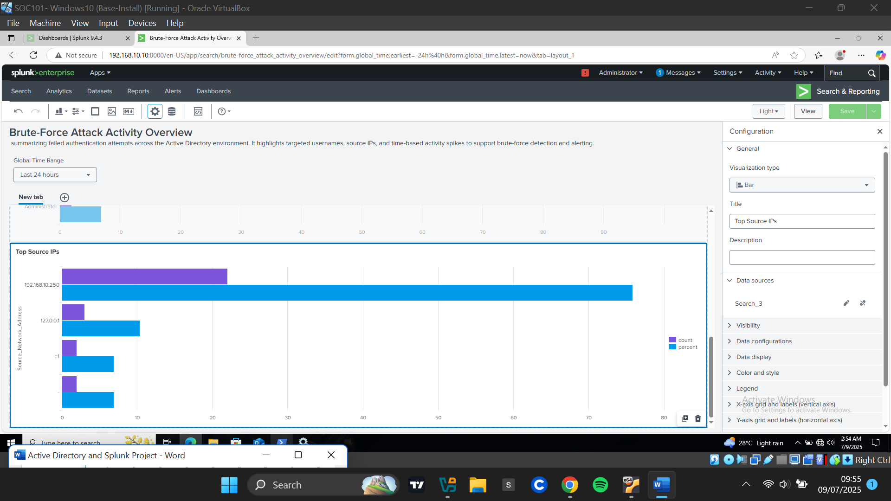

This panel revealed the most active attacker IPs.



**Panel 4: Failed Logons by IP and Username**

The fourth panel was a table of Failed Logon Attempts by IP and Username. I clicked on the “Add Chart icon” and selected table.

I highlighted the panel and added a new search in the New Data source Menu. I entered the SPL query into the search bar:

*Index=endpoint EventCode=4625*

*| stats count by Source_Network_Address, Account_Name*

*| sort -count*

(Counts failed logons by source IP and account name, sorted by highest count). I clicked “Apply and Close” to create the panel.

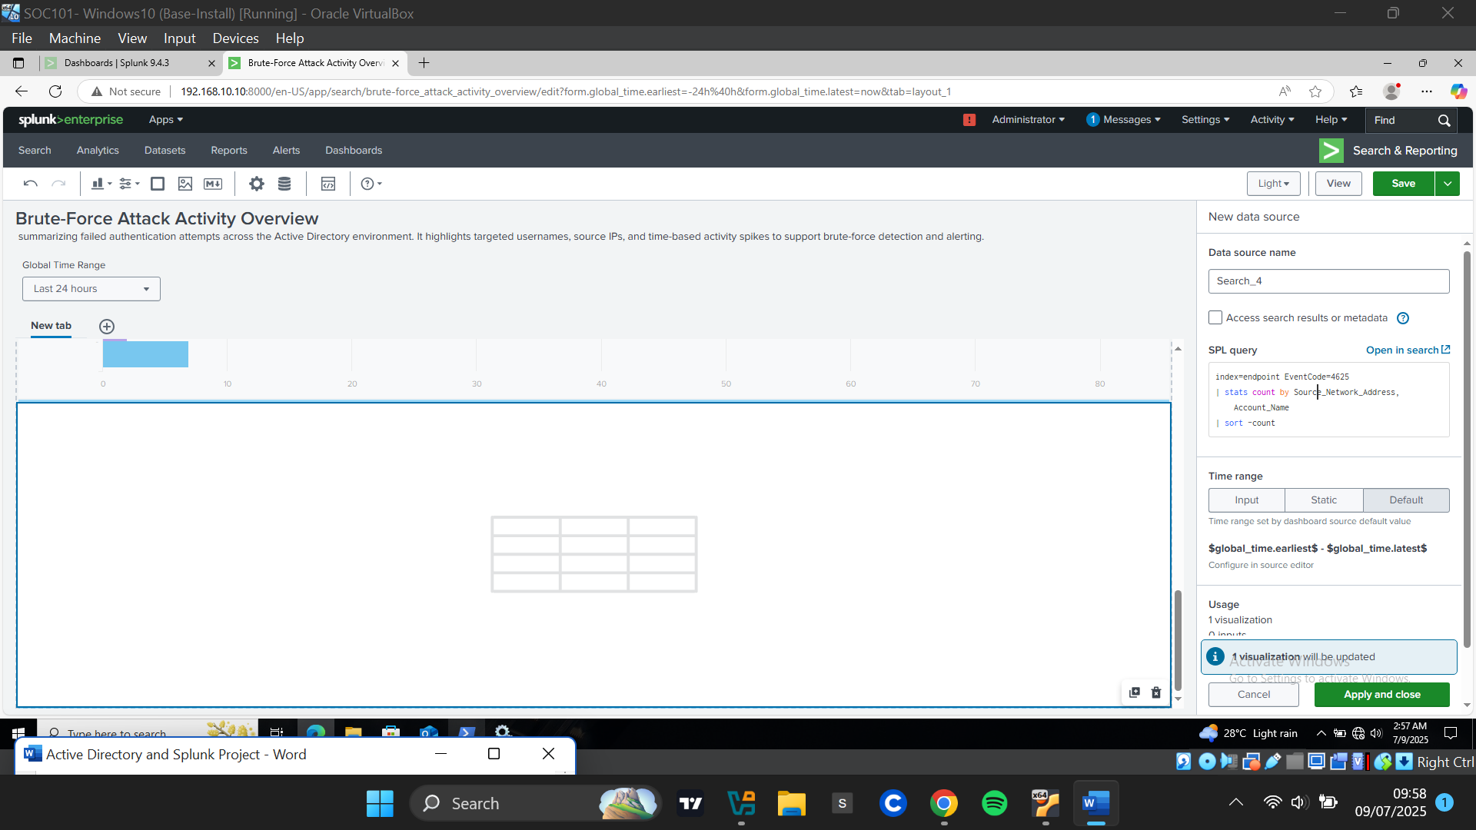

The table was populated and I renamed the panel to **"Failed Logons by IP and Username"**. I clicked save to apply the changes.

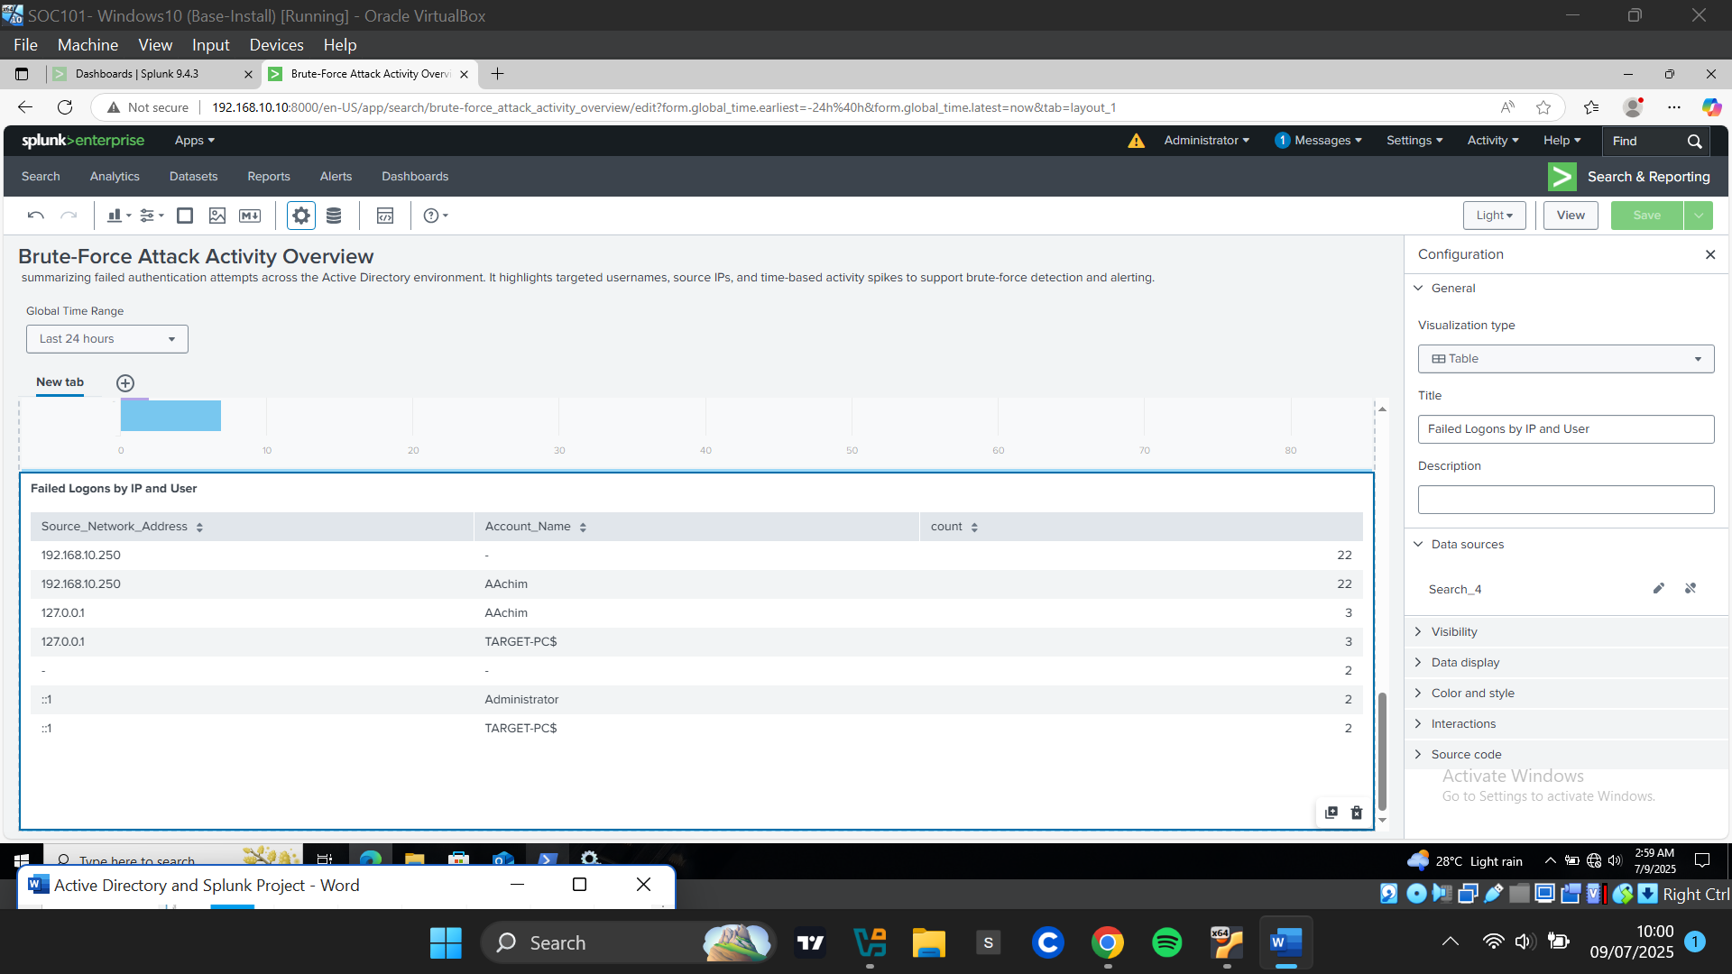

This panel showed which attackers were targeting which user accounts and how frequently.



**Creating and Implementing Custom Alerts**

**Testing Detection Logic**

I wrote an SPL query to detect more than 5 failed logons (EventCode 4625) from the same IP within 2 minutes. The query returned a result, confirming the logic worked.

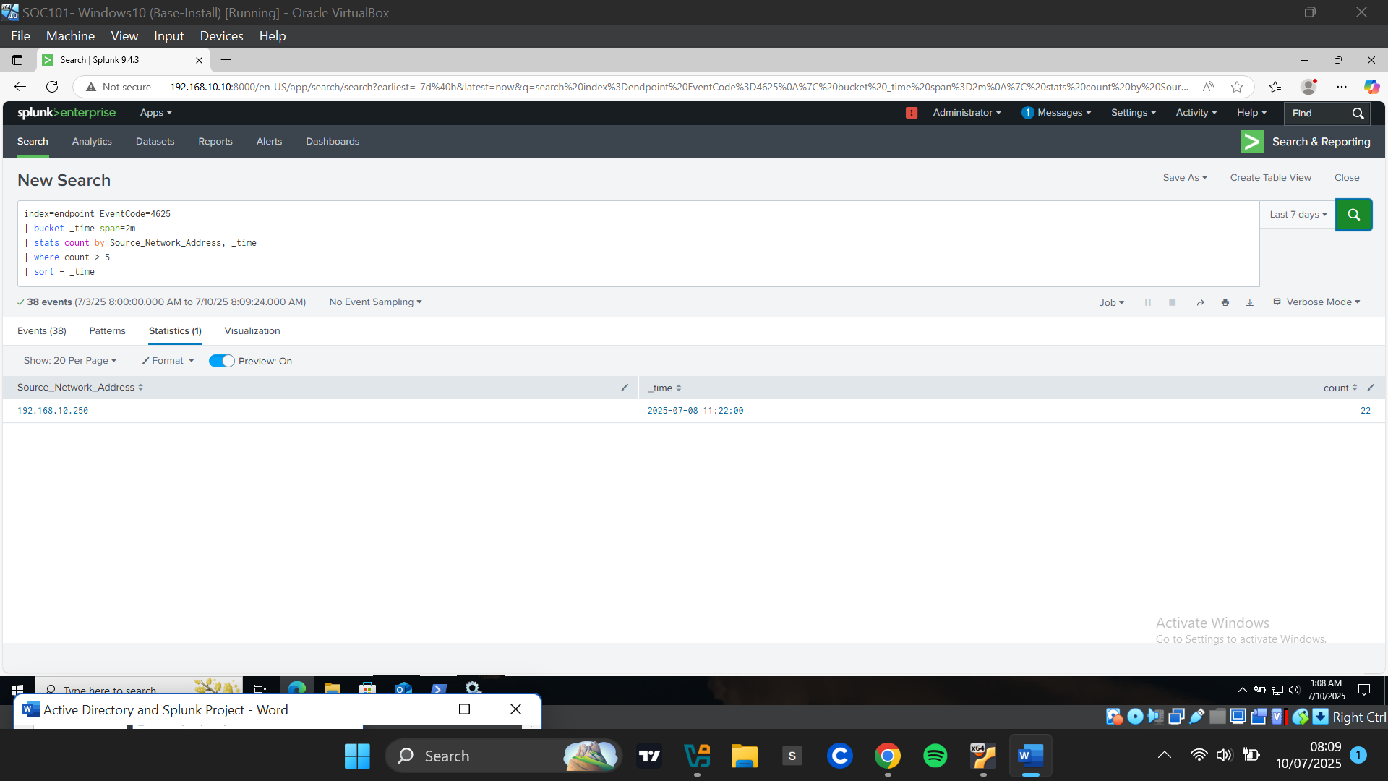

**Creating Alert**

Next, I clicked on “Save As” and selected Alert to save the query as an Alert.

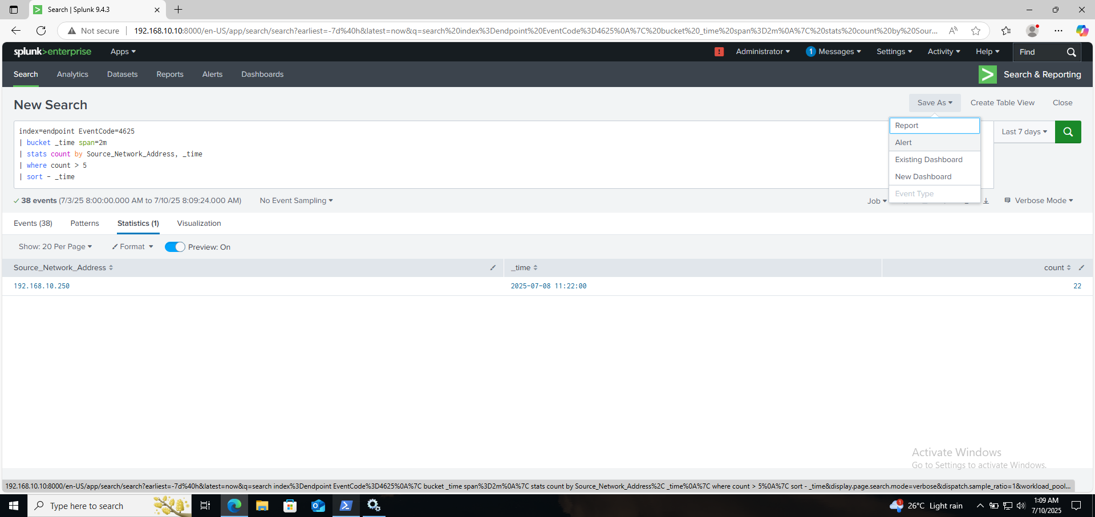

On the Save As Alert form, I gave the alert a title “Brute-Force Detection (Failed Logons)” and a description. Selected **Scheduled Alert** (instead of real-time to reduce resource usage and due to Splunk Free limitations). I Set a **cron schedule** to run every 2 minutes using **\*/2 * * * \***

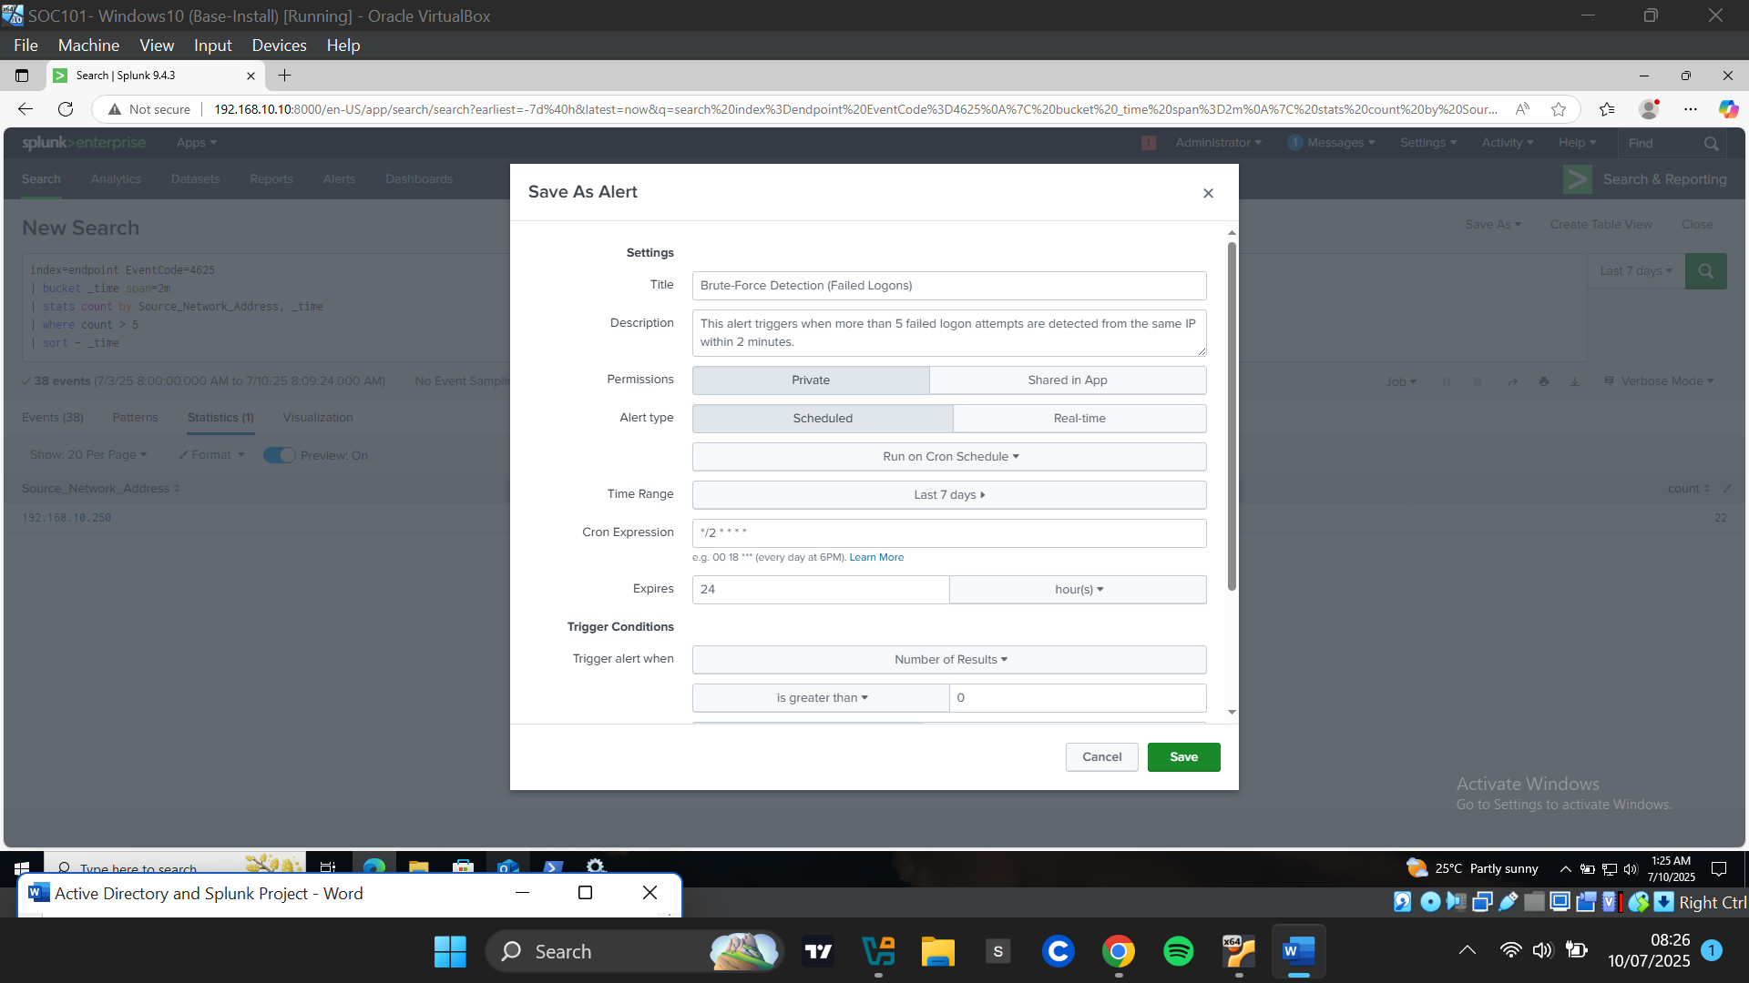

I configured trigger conditions for the alert to be triggered when **number of results > 0,** added to Triggered alerts**,** and I enabled **throttling** to prevent alert spam.

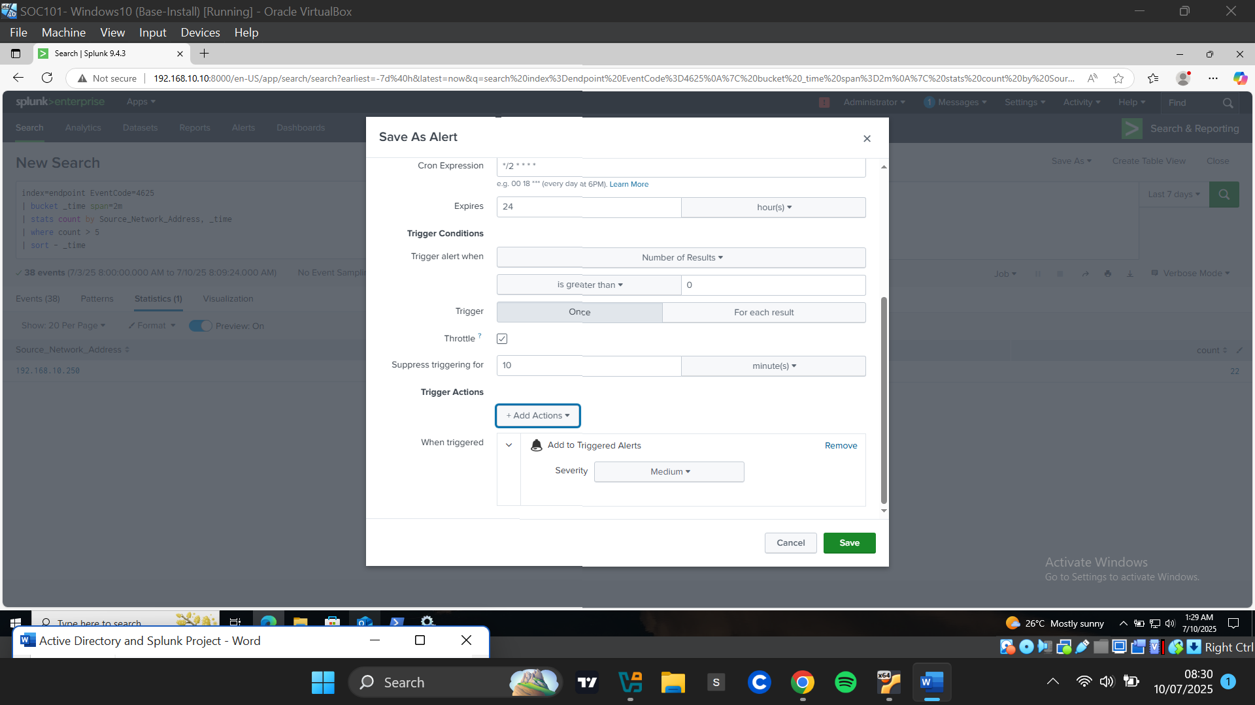

**Testing Alert**

I clicked on Alerts on the menu bar an confirmed my alerts was successfully created and active.

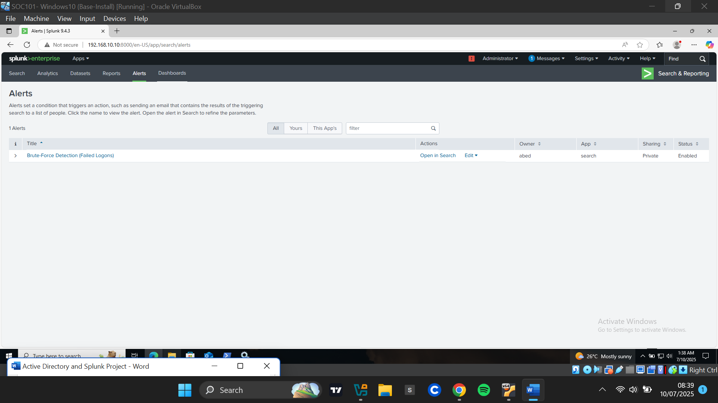

I manually triggered the alert to simulate detection. It returned results at the expected times, accurately capturing the brute-force activity including source IP, time, and event count.

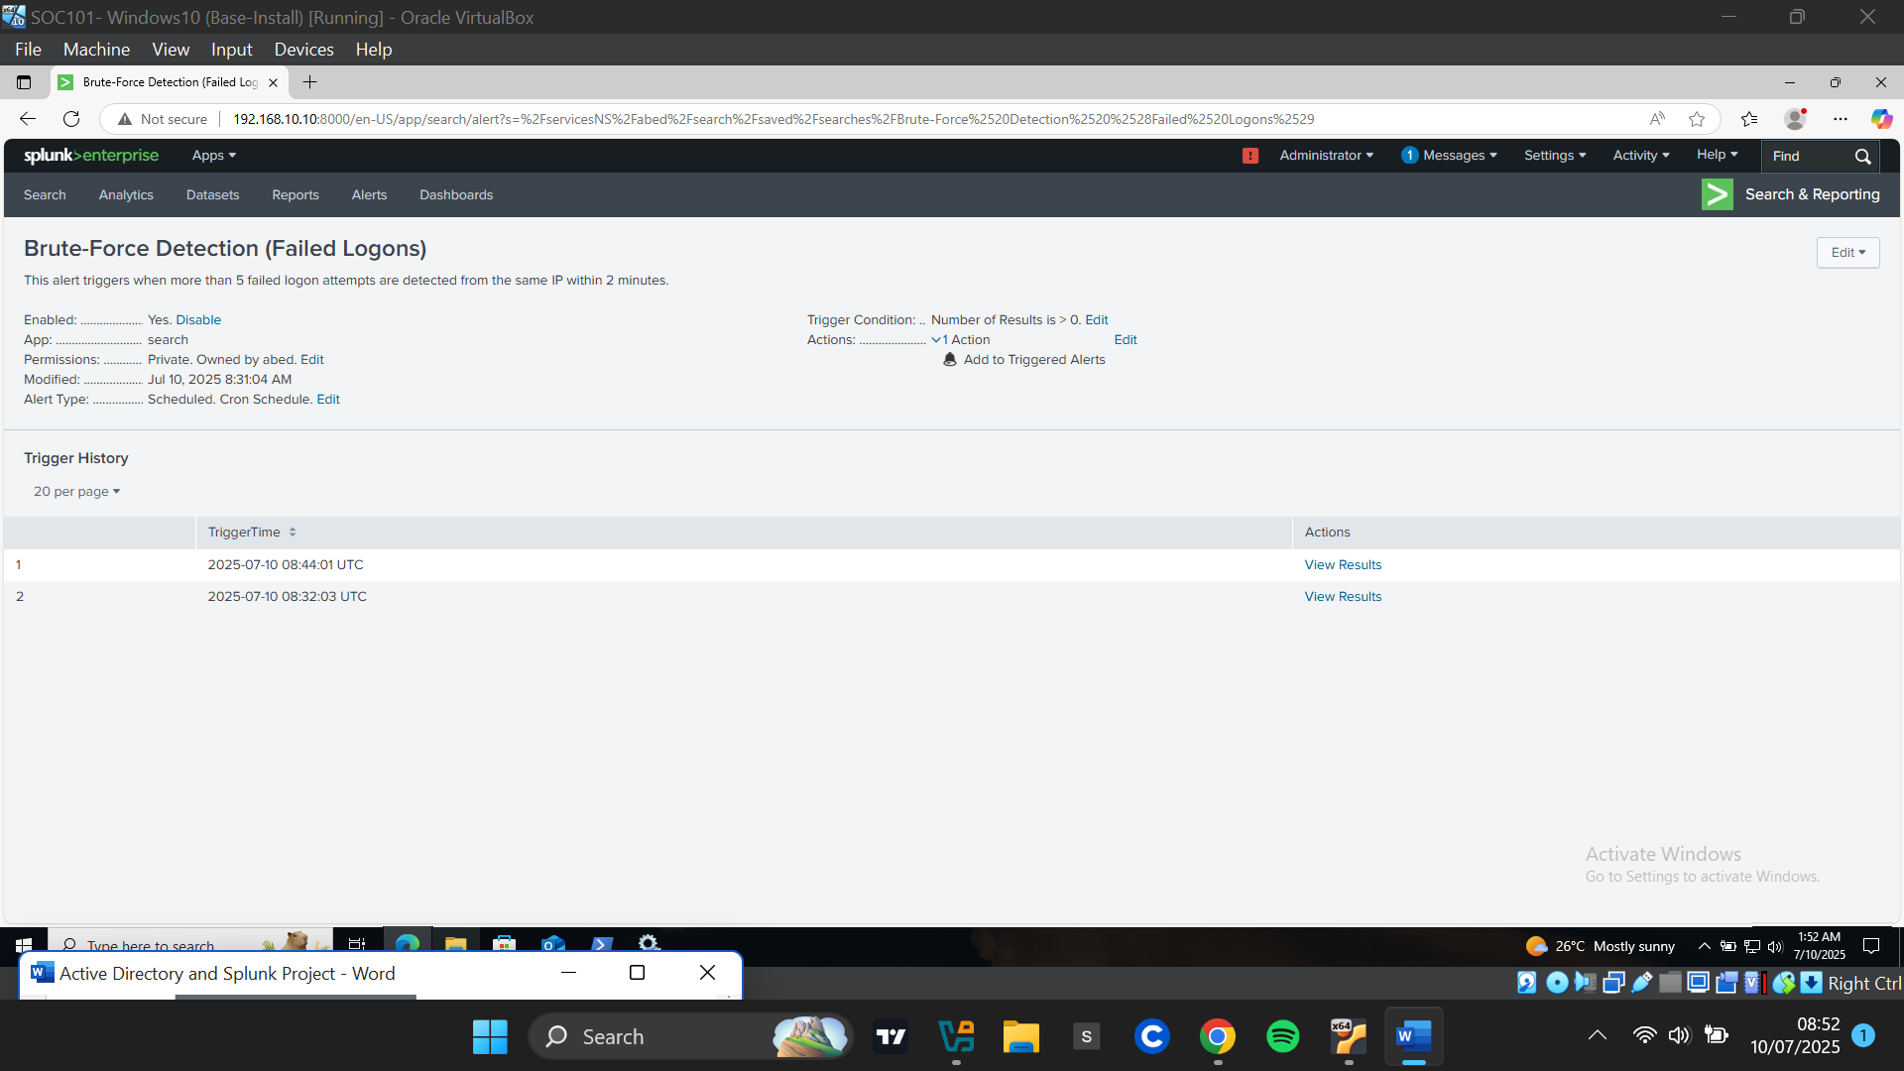

I clicked to verify the results of the alert and it perfectly captured the brute-force attempt with the source IP address, time and count of the event. This validated the effectiveness of the alert configuration.

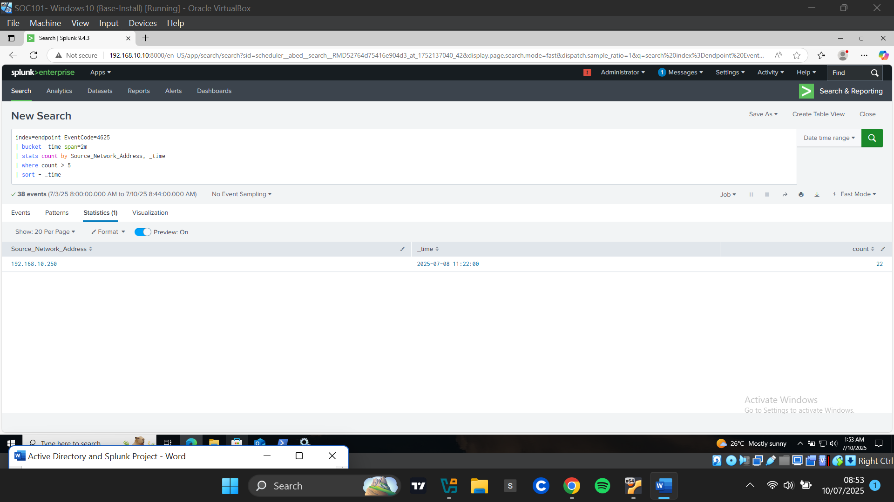

**Challenges Faced**

During the implementation of this project, several technical challenges were encountered and resolved:

1. **Domain Join Failure Due to DNS Misconfiguration**  
   Initially, the target Windows machine could not be joined to the domain. This was traced to a DNS misconfiguration. The target PC was using an external DNS server instead of the local Active Directory DNS. Since Active Directory relies on DNS to locate domain services (e.g., domain controllers), the client system needed its DNS settings pointed to the IP address of the AD server for successful domain resolution and authentication.
2. **Brute-force Tool Compatibility Issues**  
   The initial brute-force attempt using Crowbar failed to authenticate, despite the correct password being present in the wordlist. The issue stemmed from Crowbar's inability to properly handle RDP's certificate negotiation or trust prompts. To resolve this, Hydra was used instead, which successfully executed the attack using RDP credentials without requiring additional certificate handling.
3. **Host System Resource Limitations**  
   Running four virtual machines (Active Directory server, target PC, Splunk server, and attacker machine) on a single host system caused performance degradation. This led to periods of lag and unresponsiveness, preventing immediate access to Splunk after the simulated attack. As a result, some log data initially fell outside the default search time window, requiring retrospective analysis.
4. **Splunk Free Edition UI Limitations**  
   While Splunk provided the necessary functionality for log collection and analysis, the Free Edition limited certain dashboard features. Notably, it lacked advanced layout controls in Dashboard Studio, preventing Spls from snapping to a true grid layout and forcing a stacked display. Additionally, features like real-time alert previewing, triggered alert history, and manual "Run Now" testing were unavailable, requiring workarounds such as force-running alerts.
5. **Data Field Inconsistencies Across Events**  
   Some event fields, such as src_ip, were not consistently named across log sources (e.g., Source_Network_Address was used instead). This initially caused empty visualizations in dashboards and required field mapping adjustments for accurate reporting.